**Heuristic Evaluation & Final Project Report**

*BottomLineTelecommunications*

**INF 132 Project Assignment #5**

Monday 6:00 P.M Discussion - Group 7:

Alonso De La Torre Vega

Matthew Morales

Phillip Nguyen

Jason Hing Lun Tam

Juwan Michael De Jesus

Table of Contents

**Executive Summary** **3**

**Introduction** **4**

**Competitive Analysis** **5**

**User Research (Surveys & Interviews)** **12**

Background 12

Description of Study Objectives 12

Description of Target Population 13

Comparison of Target Population & Participant Sample 13

Description of Methods 14

Findings 14

**Identifying Usability Issues** **19**

Background 19

Description of User Population 19

High Level Summary 20

Surveyed Population 20

Methodology and Goals: 21

Participant Recruitment 21

Data Analytics 22

Usability Test 23

Cognitive Walkthrough 23

Findings 24

**Redesign** **28**

Methods 28

Report 28

Prioritized Design Targets 29

Big Targets 29

High Fidelity Mockups & Design Documentation 33

Customer Support and Contact Information 33

Product Discovery, Visibility, and Listings 36

Product Filtering 40

Product Check Out 43

Search Bar 48

**Heuristics Re-Evaluation** **50**

**Conclusion** **52**

**Appendix:** **53**

Accessibility Evaluation Report 53

Individual Heuristic Evaluations 54

User Research and Usability Report Supplemental Information 110

Survey Questions 113

Informed Consent Documents 120

Personas 122

Identifying Usability Issues Reporting Supplemental Information 125

Additional Usability Issue: 125

Usability Tasks 125

Cognitive Walkthrough Tasks 132

Subsequent Usability Test Questionnaire Template 137

Redesign Report Supplemental Information 140

Problem Space 140

Consolidated Designs 149

# Executive Summary

**Goal:** The goal of this assignment was split into three parts. The first part was to individually conduct a heuristic evaluation on our redesign report, then come together as a team and produce a final heuristic evaluation on the report. The second part was to conduct an accessibility evaluation on the original system, based on the WebAIM (Level A) checklist, and briefly describe the results of the evaluation. And the third part was to amass all our collective findings from our ten week user experience project, into one final report.

**Methods:** Each team member, individually, conducted a heuristic evaluation on the redesign report. For each of our proposed redesigns, we followed Jakob Nielsen’s “Ten Usability Heuristics for User Interface Design.” After thorough analysis from each group member, we all came together and synthesized our results to produce a final heuristic evaluation on our proposed redesigns. After conducting heuristic evaluations, the team moved on to conducting the accessibility evaluation on the original system. We picked up where we left off in class, determining whether or not the system followed the WebAIM (Level A) checklist. After using different methods to ensure complete coverage of the checklist, we produced a one-page final report on the accessibility of the original system. The final step we took into completing this report was to gather our previously recorded data, and put it into a document. We placed our collective findings in the order they were completed; we didn’t include all the aspects of our findings, just the important and necessary information.

**Deliverable:** Following below is the consolidation of our research artifacts. We have provided compilation of research methods that detail the timeline through which we developed an approach to redesigning the user experience for the e-commerce system shopBLT. The document will consist of information regarding our target user base, the usability concerns of actual users, our team’s own evaluation, suggestions for redesign, and our own re-evaluation of the implementation of our suggestions. Basically what we did for the heuristics re-evaluation was average out the scores we gave each redesign, and then see which we considered to be most substantive in its contribution to the user experience of the system. Our methods, guidelines, and implementations follow in the document touching on points such as: search functionality, filtering functionality, approach to indirect customer service, and product visibility and discovery. Our re-evaluation is in favor to the new changes but does acknowledge fault in the implementation for some elements. The accessibility of the initial system meets most of the success criteria based on our evaluation, our suggestions are noted in the appendix.

# **Introduction**

Initially started as a systems design and consulting firm, BottomLineTelecommunications (BLT) is now an e-commerce website that provides its customers with over 300,000 hardware and software solutions manufacturers all over the world. Started in 1991, the latest incarnation of its website feels outdated and user-unfriendly. Competing with the likes of established competition such as Amazon, Best Buy, and Newegg, BLT could greatly benefit from a UX/UI overhaul.

Our team chose to redesign shopBLT.com, focusing on these aspects:

* **Customer Support and Contact Information Page**
* **Product Discovery (Homepage, Search Listings)**
* **Product Filtering**
* **Product Check Out**
* **Search Bar**

We found these aspects to be the most crucial parts of the purchasing experience and sought to improve the usability of each one. The site as it currently stands has a user experience that is unfriendly to newcomers and the less tech-savvy alike. Our redesigns allow for newer users to use the platform comfortably without alienating the aesthetic and familiar feel seasoned users are used to.

Through heuristic evaluation, our team has evaluated the effectiveness of our redesign. We have improved much of the site’s usability from our conclusions and have also remarked the many more future improvements that we can implement as well. Critiquing our own designs allows us to further explore the options that could improve shopBLT.com in the future.

# Competitive Analysis

Evaluated System:

**Bottom Line Telecommunications** (<https://www.shopblt.com/>)

* BLT is an e-commerce website that specializes in selling computer related products and services.

Direct Competitors:

**Amazon (**<https://www.amazon.com/>**)**

* Amazon is an e-commerce site that sells a wide variety of products ranging from kitchen appliances to expensive electronics.

**eBay (**<https://www.ebay.com/>**)**

* eBay is an e-commerce site that is similar to Amazon however it is less popular even though it provides almost the same goods and services. It allows everyday users to buy and even sell their products without setting up a formal business.

Indirect Competitors:

**Best Buy** (<https://www.bestbuy.com/>)

* Best Buy is a physical and online retail store that specializes in electronic related goods. They typically carry big brand names and target the general public for their audience.

**Fry’s Electronics** (<https://www.frys.com/>)

* Fry’s Electronics is also a physical and online retail store that specializes in electronic items as well. They carry a wide variety of electronic goods.

Systems are compared and contrasted in terms of the following:

1. **The Problem Being Addressed:**
   1. **BLT**
      1. The product we have decided to evaluate and redesign is a system called “Bottom Line Telecommunications” (BLT). Bottom Line Telecommunications originally began as a systems design and consulting firm, but has since evolved into a global e-commerce “product and solution provider” (shopblt.com). The system itself is a website similar to other e-commerce websites, such as Amazon and eBay; however it does not possess as extensive a catalog as its competitors. The website sells over 300,000 items that fall under the category of modern computing technology; items such as computers, computer parts, accessories, etc. It can be accessed through a normal web browser via desktop and mobile.
   2. **Amazon**: Providing an online platform for customers (or users) to find and discover desired products they wish to purchase.
      1. **Searching for a product**: Amazon uses categorical drop down menus that allow for organization of products beyond that of our system. Amazon possesses a much wider selection of products than BLT, resulting in a wider user base and thus more customer traffic.
      2. **Purchasing**: Amazon utilizes several forms of payment methods once an item or set of items have been discovered and allocated to the shopping cart. Standard credit card information collection is used for less frequent customers and one time sales: however Amazon also offers “one-click” purchasing, streamlining the checkout process for more frequent customers.
      3. **Finding information regarding shipping and logistics**: Amazon offers several links to information regarding their services. Most information is posted online for users to find on their own. Customer support can also be contacted via phone, which are similar locations to how information can be found about BLT.
      4. **UI**: The User Interface is cluttered with advertisements of Amazon owned products, products offered based on user activity and trending and products under price reduction. Amazon tends to use a lot of images to provide visual support for product identification, this differs dramatically from BLT given that most of the product listings do not offer visual aid.
   3. **eBay**: eBay works to provide a global online marketplace that is centered around providing users the opportunity to buy, sell, and trade any items they wish.
      1. **Searching for a product**: eBay like most other e-commerce websites has a search engine that indexes the products located in the eBay “inventory” and user listed marketplaces. This allows users to find and discover items that they may want to purchase. eBay offers an opportunity to find items, such as collectibles and gadgets that may not be offered by competitors like Amazon or BLT.
      2. **Purchasing**: eBay offers standard credit card information collection, allowing users to pay via credit card. eBay also supports other forms of third-party payment systems, such as PayPal. Some vendors even accept cryptocurrency which allows for greater variation and scope of payment methods. These other forms of payment may appeal to a niche user base that competes with BLT.
      3. **Finding information regarding shipping and logistics**: eBay offers many online resources for standardized information on eBay’s operations. User-based vendors have online portals that provide information on how operations work and how to get in contact with non-eBay affiliates.
      4. **UI**: Similar to Amazon’s user interface, eBay’s homepage is riddled with product images that signify the type of product to the user making it easier to identify and discover products. While eBay is more of a free market trading platform, the products advertised on the homepage are those that resemble newer products from more established vendors. In this way, eBay builds a customer base similar to that of Amazon, but differs from competitors such as BLT and Fry’s Electronics.
   4. **Best Buy**: Wishes to provide a central location for customers to acquire latest devices and services at competitive prices while educating customers with knowledgeable advice.
      1. **Searching for a product**: When at a Best Buy store the customer can look for specific sections that are labeled to make finding their desired item easy. Another option is to also ask an employee at the store to direct them to the product they need. Asking the employee also has the benefit of obtaining information for them to know if they are getting the best product for their needs or if there is a better alternative. This type of interaction allows users to have a more intimate interaction with Best Buy when compared to BLT which can be advantageous for future purchases.
      2. **Purchasing**: In store purchases will allow customers to pay with cash, check, credit card, or some sort of combination of these things. These are generic purchasing methods used by most users while BLT tries to provide more purchasing options to appeal more to their niche user base.
      3. **Finding information regarding shipping and logistics**: The Best Buy website gives clear information about their shipping and logistics. This information can also be found out in person or similar to BLT they can also make a phone call directly to the company to find out more information.
      4. **UI**: One of the first things to be noticed about Best Buy is that whether in person or on their website there will be an emphasis on the amount of savings that you can have by buying certain products. This is to entice people into buying these sale products even if it was not their first choice. On the other hand BLT has a focus on their most popular products on their website.
   5. **Fry’s Electronics**: Establishes a solid customer base with a broad selection of devices, services, and products relating to electronics, computers, and household appliances.
      1. **Searching for a product**: Searching for a product at Fry’s is like most other retail stores where you can either go onto their website to see if it is available in a store near you or available for shipping. The alternative to this would be to go physically to the store and look in their aisles or ask one of the employees to assist with finding the item. However, BLT is an e-commerce site so the user would only be able to see what they have on the website since no physical location exists.
      2. **Purchasing**: Fry’s uses all the major payment methods such as cash, check, and credit card while the BLT site will allow users to use credit card, cryptocurrency, or some other niche payment method. The Fry’s payment method focuses on the general public’s payment methods
      3. **Finding information regarding shipping and logistics**:Fry’s shipping and logistics information can be found on their website with an easy search. Another option is to go in the store and ask about it in person or to give a store a call about this information. BLT only has the options of checking the website or calling the company for the information.
      4. **UI**: In person and on their website Fry’s has an emphasis on the best deals they are currently offering and whatever sales are going on. They will also show their most popular products to entice users to buy them. On the other hand BLT focuses on their most popular products on their home screen and want to make the user feel comfortable by showing them that they are a trusted service.
2. **Functionality and Feature Set:**
   1. **BLT**: Like Fry’s and Best Buy, BLT plays to the strength behind its customer service. The platform itself has basic Boolean Search as its indexing functionality. Because of this, the user must enter word exactly related to the desired product, and related products are more difficult to find. Suggestions are not provided, nor are popular searches. BLT offers full access to customer service during business hours with minimal wait times.
   2. **Amazon**: Amazon’s feature set include functions that serve to streamline the purchasing process. Product suggestions are provided when the user is viewing a particular product. When searching for a product, related departments and products are suggested. Auto-fill suggestions and popular searches are also provided. As previously stated in another section, Amazon also provides the ability to save credit card, billing, and shipping information and also offers one-click purchasing.
   3. **eBay**: eBay offers similar product suggestions, a more advanced form of searching and indexing than BLT, and product bidding. Users don’t have to commit to a single price for a particular product. Less established vendors will sometimes put items up for bid, allowing other users to place bids on an item. This method usually allows users to purchase, semi-new previously owned, or even new products for less than the average market price.
   4. **Best Buy**: Best Buy’s on-site location’s primary functionality is its customer service. Customers can come in without knowing what they want and be greeted by a customer service representative who will help them identify or discover their desired products. This allows customers to acquire more information about products rather than scrolling through customer reviews online. They also have on-site consultations and servicing for computer and computer-related products and services.
   5. **Fry’s Electronics**: Like Best Buy and BLT, Fry’s Electronics focuses mainly on customer service. Unlike its competitors Fry’s has a string of superstores in Silicon Valley. The on-site locations provide free consultation for product inquiries. How users search for products differ from online methods. Users can search for products on their own or have a customer service representative assist them in finding the product. Fry’s also has servicing and repair for computer related products and some software services.
3. **Product User Base**
   1. **BLT**: BLT’s services are primarily online, thusly they foster a niche environment similar to Amazon. The customer base is served primarily through the website. BLT also has team members present during business hours taking calls from customers providing customer service, for customers with questions or inquiries on orders and processing.
   2. **Amazon**: Amazon is one of the most valuable public companies today and is one the biggest e-commerce marketplaces. Most of Amazon’s user base are consumers that wish to browse and buy online knowing that they have the ability to return the product if they are not satisfied. Amazon’s primary user base utilizes amazon due to low prices, free shipping options, and high product reviews. Although amazon is a global marketplace most of the user traffic comes from the United States.
   3. **eBay**: eBay is also a major e-commerce website, its users not only have the ability to buy but also to sell and trade. eBay appeals to sellers that may not necessarily want to start a business to sell products but only want to sell a few items. This allows for a broader user base that allows for a different kind of interaction among users. Users will use eBay over other sites and products for this ability to sell personally owned products and because of its long standing reputation.
   4. **Best Buy**: Best Buy sells similar products to its user base like Amazon and BLT but it also has a physical store. Best Buy is a huge contrast to Amazon in that a good number of people go to its physical store to explore its products and then its users decide to purchase it or not. Best Buy offers on site personal computer repair and computer related inquiries. On site customer support separates it from sites like Amazon or BLT, and its wide range of products in its catalog separates it from its direct competitors such as Fry’s Electronics.
   5. **Fry’s Electronics**: Fry’s is similar to Best Buy on the fact that they also have a physical store where most users have the ability to go into the store. Fry’s, like Best Buy has an on-site tech team that allows customers to go in and inquire about computer details or request to have their computer based products serviced. The user base of Fry’s varies as they continue to offer a wider selection of products, but remains relatively the same as BLT’s, being primarily interested in computed based products and services.
4. **Notable Similarities or Differences**
   1. **BLT**: BLT like eBay has a niche customer base. BLT differs from the other competitors due to the platform offering mostly tech based products, like software, computers, and computer related products and services.
   2. **Amazon**: Similar UI to that of eBay and BLT.
   3. **eBay**: While eBay may not have the same user base as BLT, they both foster a niche customer base. eBay offers a free market trading platform, and BLT offers a tech specific e-commerce experience that competes with Amazon’s customer service.
   4. **Best Buy**: Similar mission statement to Fry’s and Amazon. Similar user base and initiative to that of Fry’s
   5. **Fry’s Electronics**: Similar mission statement to Best Buy and Amazon. Similar user base to Best Buy. Similar to Best Buy in that they both offer on-site tech expertise on products carried.

# User Research (Surveys & Interviews)

## Background

Upon viewing BLT’s website, shopblt.com, it is easy to discern the many design choices (or lack thereof) that results in a difficult user interface to operate; these choices mainly affect the product search and purchasing process.

The purpose of this section is to provide an understanding as to how this interface could be improved through five main objectives, which are listed below. Through analysis of the data we gather from user interviews and surveys, BLT’s website could be improved to deliver a superior user experience to its customers around the world.

## Description of Study Objectives

1. Understand how customers select and order electronics.
   1. This is an objective used to gain a better understanding of processes customers deploy when actively shopping for electronic items. By understanding the underlying procedures for product selection, better design interaction will fall in line with real consumer behaviors.
2. Discover pain points, and pleasures, within search patterns for electronic products online.
   1. Pain points are a necessary consideration when gathering data for analyzing user search processes and applying them to a redesign of an existing web service. Exploring the aspects that prove to create difficulties for users will help with gaining a better understanding of key elements that make for a better user experience. Furthermore, it will also help to know what keeps users happy to further implement those elements and seek to adapt the pain points with the customer’s pleasures.
3. Discover what customers do to seek help, in terms of understanding the information about electronics online.
   1. Customers cannot always find the right information about a product they wish to purchase. This will lead some customers to searching for relevant product information via external sources. This objective aims to find out how much of a problem this is for consumers who want to purchase electronic products and how this problem (if it exists) could be alleviated.
4. Discover preferences for browsing within particular categories (electronics).
   1. This objective seeks to find common preferences among consumers for product discovery when browsing among electronic items online. Preferences vary based on the type of service and product a consumer may be using, however there may be common foundational themes among the variance.
5. Understand what product information is valuable to customers when they are searching for electronics.
   1. Information is key when a consumer is trying to make an informed purchase for any type of product, especially electronics. This objective aims to find what kind of information is most valuable to consumers when searching and shopping for electronics. Relevant information ranges from product price, description, and details to seller credibility, product reviews, and estimated shipping time.

## Description of Target Population

A detailed analysis shows that BLT’s target population consists of mostly males ranging from ages 20-40, from middle to upper class. These buyers are mainly from the United States, although some buyers are international. Most of this target population are people who prefer to shop online and do not have to visit a physical store before making a purchase. Thusly, competitors such as Fry’s Electronics and Best Buy will not prove to be as influential as direct online competitors such as Newegg and Amazon. Results from collected data have shown that of the individuals surveyed and interviewed, most participants have a clear understanding and idea of what product they want to purchase. It is expected that the target population will not seek personal assistance when identifying and purchasing their desired product, compared to those who would who shop in store. The data also shows that of the participants in the interviews and surveys, the majority of them value information like: product reviews, pricing, product visibility, ease of payment, and seller credibility. The results also indicate that many of the participants are comfortable with shopping online, in that they do not have difficulty finding the products they want, or the information they need.

# 

## Comparison of Target Population & Participant Sample

Using the information we gathered as a result of user research, a comparison was made between the user base of BLT and the participants we have gathered for interviews and surveys. Both usually have a particular product in mind when shopping on the website (for example, graphics cards). Information from the participants regarding technological skills such as, familiarity with interaction layouts, where to find information, and product details (when it comes to electronics) are also in line with BLT’s user base, making it more of a niche service than its competitors like Amazon. The conducted survey results suggest price was among the most important information to the consumer, leading more consumers to seek less expensive products first. Two of the most appealing advantages of BLT’s services for consumers are their lower prices and quality customer service. The transparency of BLT is another reason consumers would flock to their website, as the company provides a plethora of industry and product information. Of the information and services that are important to the participants, product visibility and ease of payment are not reflected by BLT’s service. BLT appeals to a user base similar to the participant pool, given most of the products are provided by big name manufacturers and the fact that BLT advertises its high credibility, which falls under seller credibility and trustworthiness.

## Description of Methods

Keeping the objectives in mind, the interview and survey questions were developed in collaboration with each other. For the interview questions, each team member selected two interviewees who were gauged to be fit to answer the questions. The interviews ranged from twelve minutes to forty-five minutes, averaging out to an intended goal of around a half-hour. For the survey questions, Google Forms was used as a means to administer the questions. To recruit participants, each team member shared the survey with friends through social media and messaging, and accumulated around sixty survey responses soon after. Data was observed using Google Spreadsheets and helped with making several charts detailing the observations; charted data included gender percentages, difficulty finding products, external sources used for product information, shopping preferences, customer satisfaction after online purchases, and favorite browsing method. (Both interview and survey questions were constructed to be straightforward and easy-to-comprehend).

## Findings

Ten interviews were conducted in all (two interviews each person) and sixty survey responses were completed and received. On February 1st, an affinity diagram based off the interview responses was constructed by the team to draw conclusions from what the respondents felt was most important about the interview objectives (Fig. A, B, C).

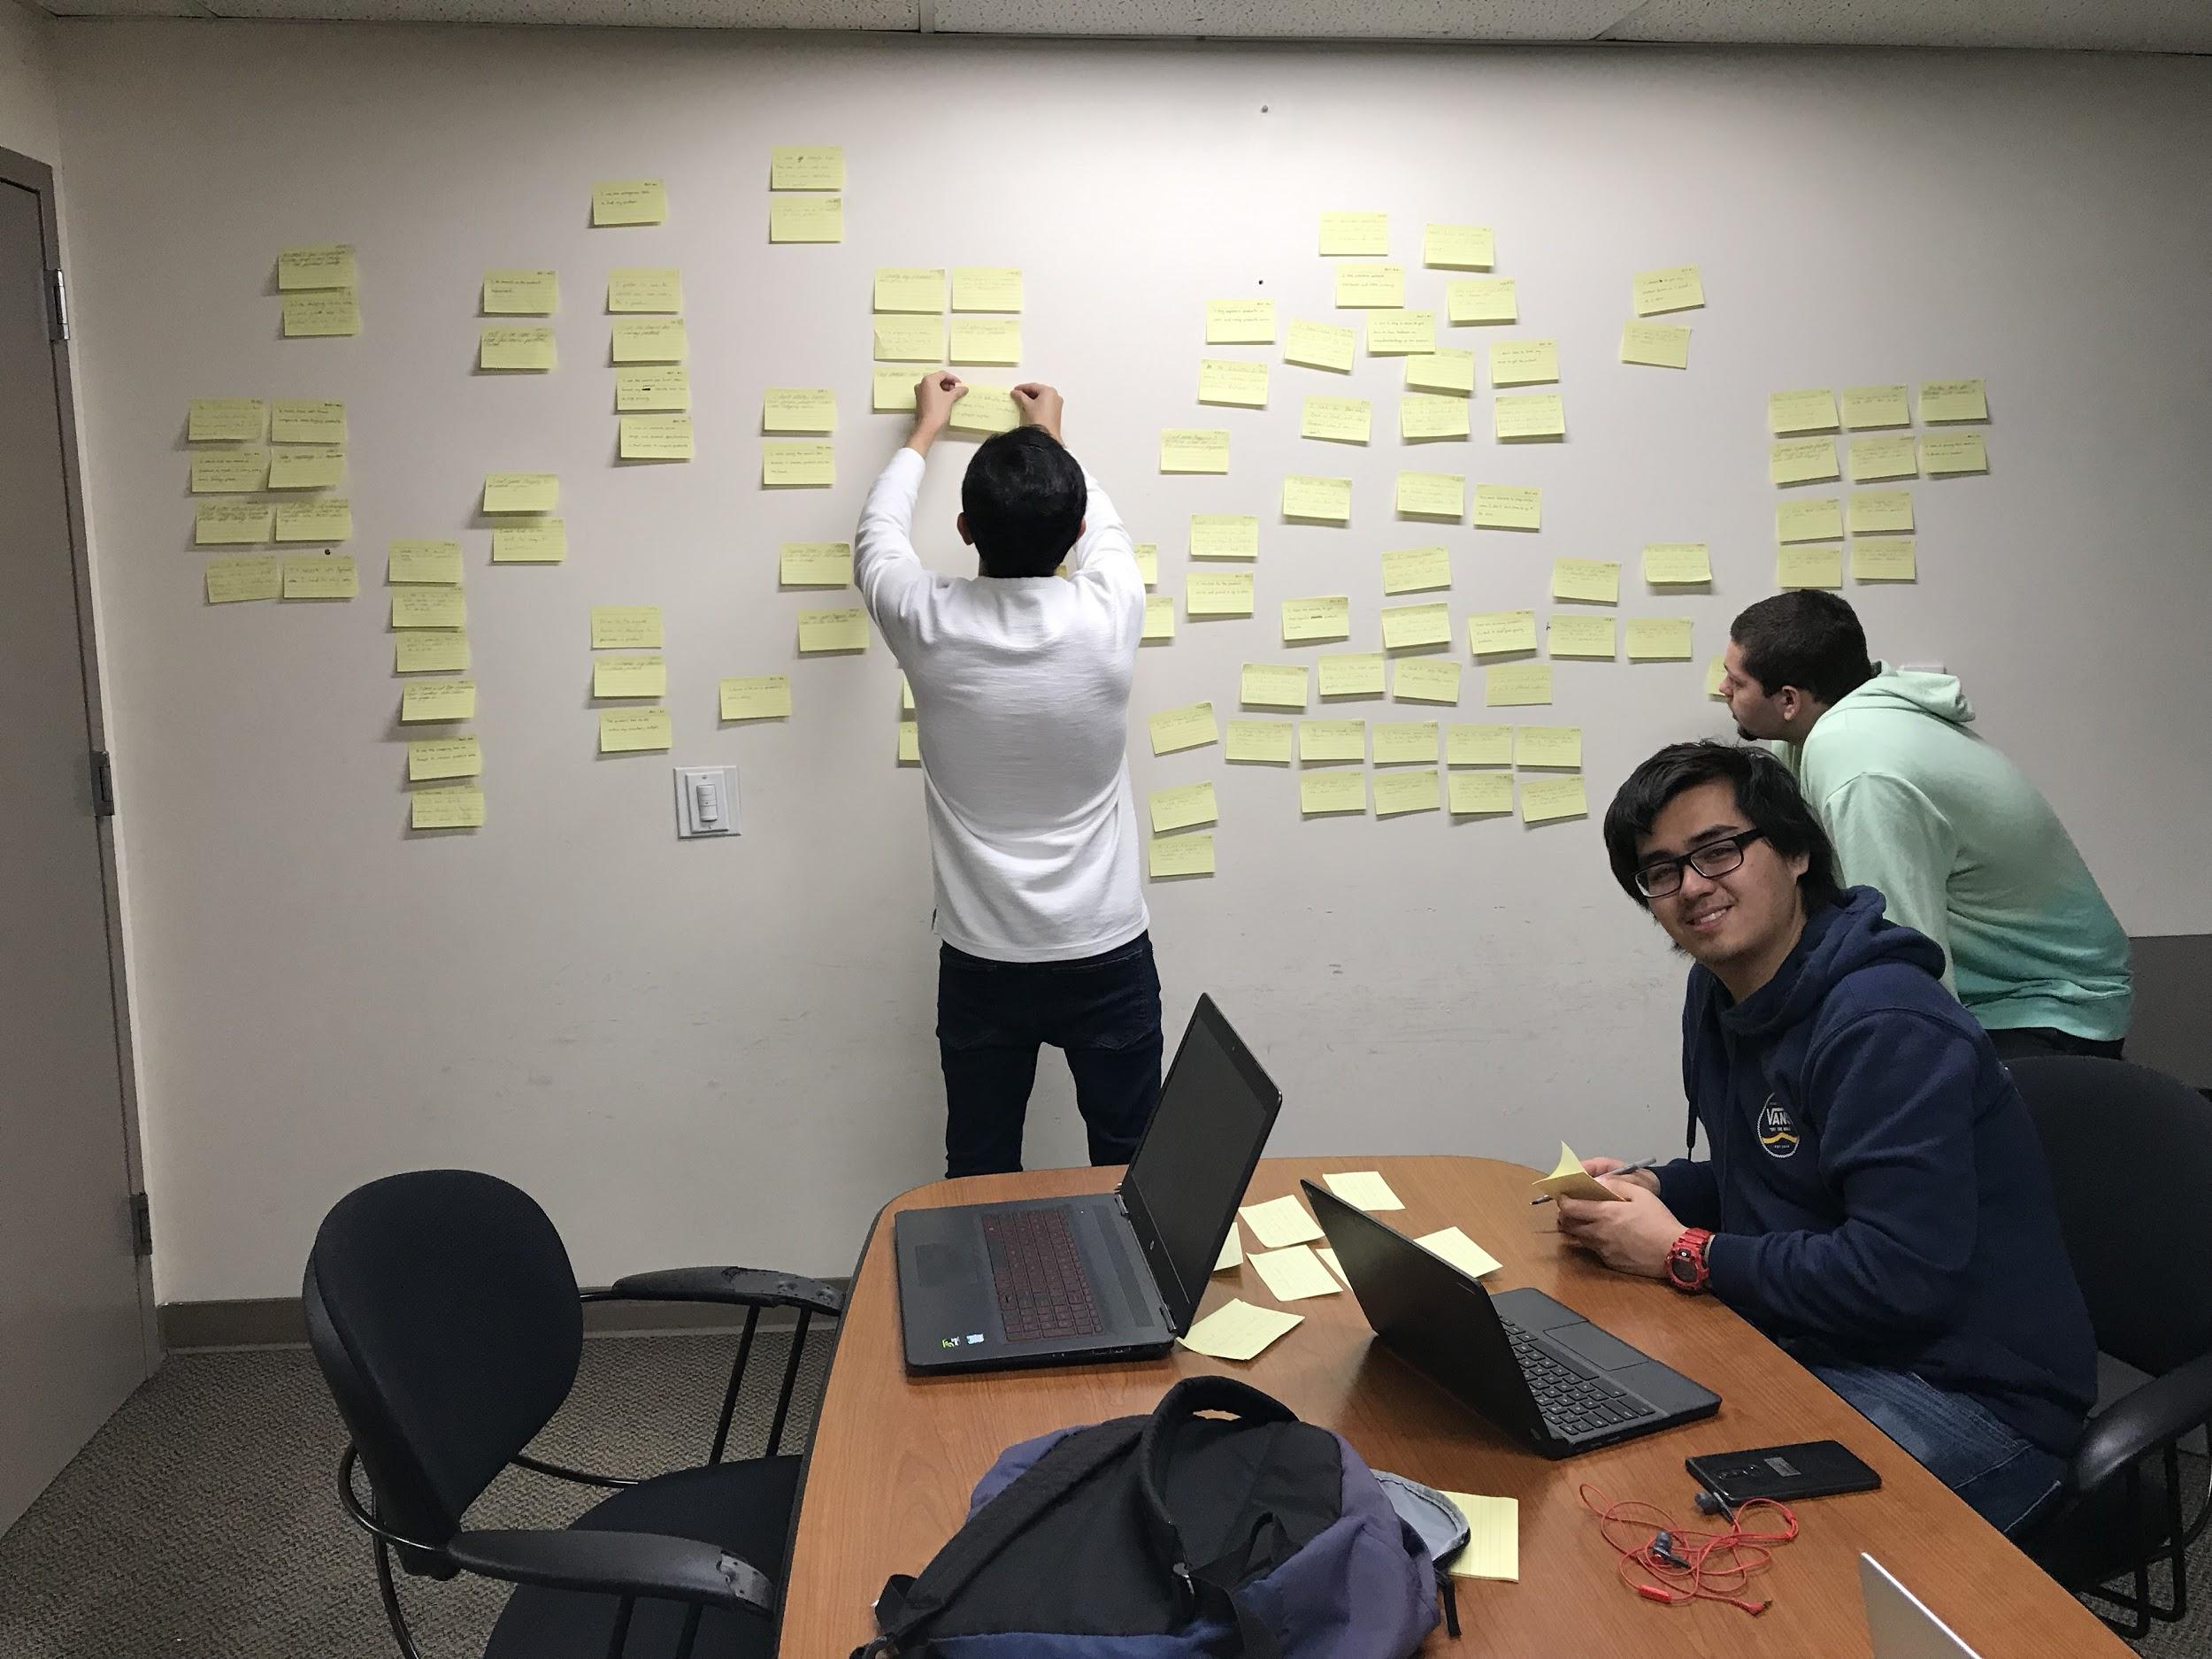

**Figure A: Juwan, Phil, and Matt creating the diagram alongside Alonso and Jason (not pictured).**

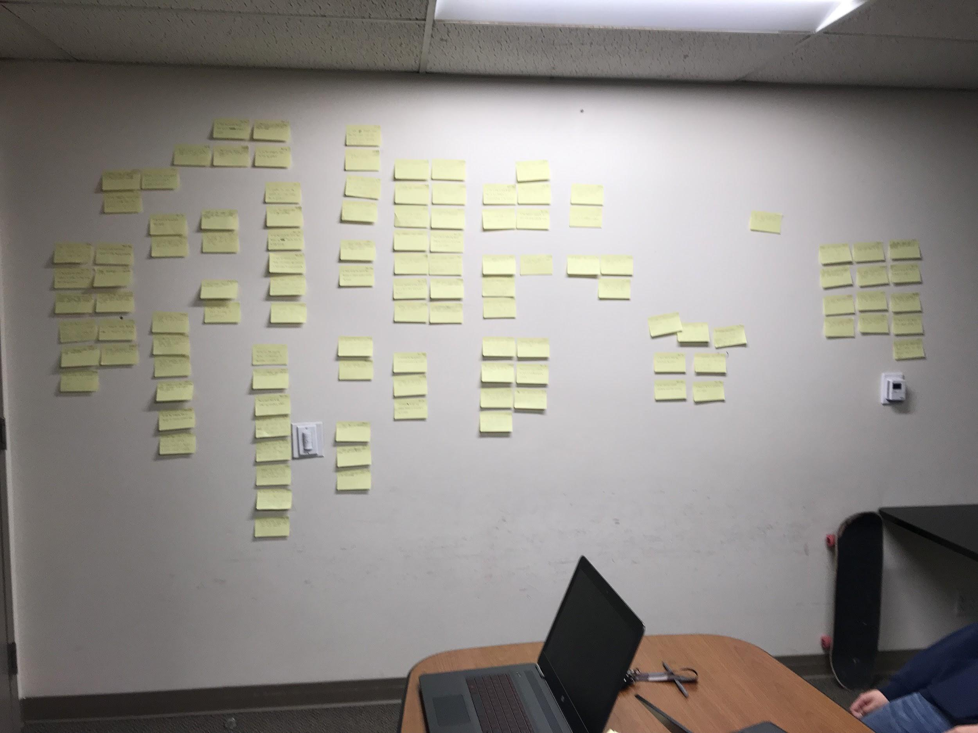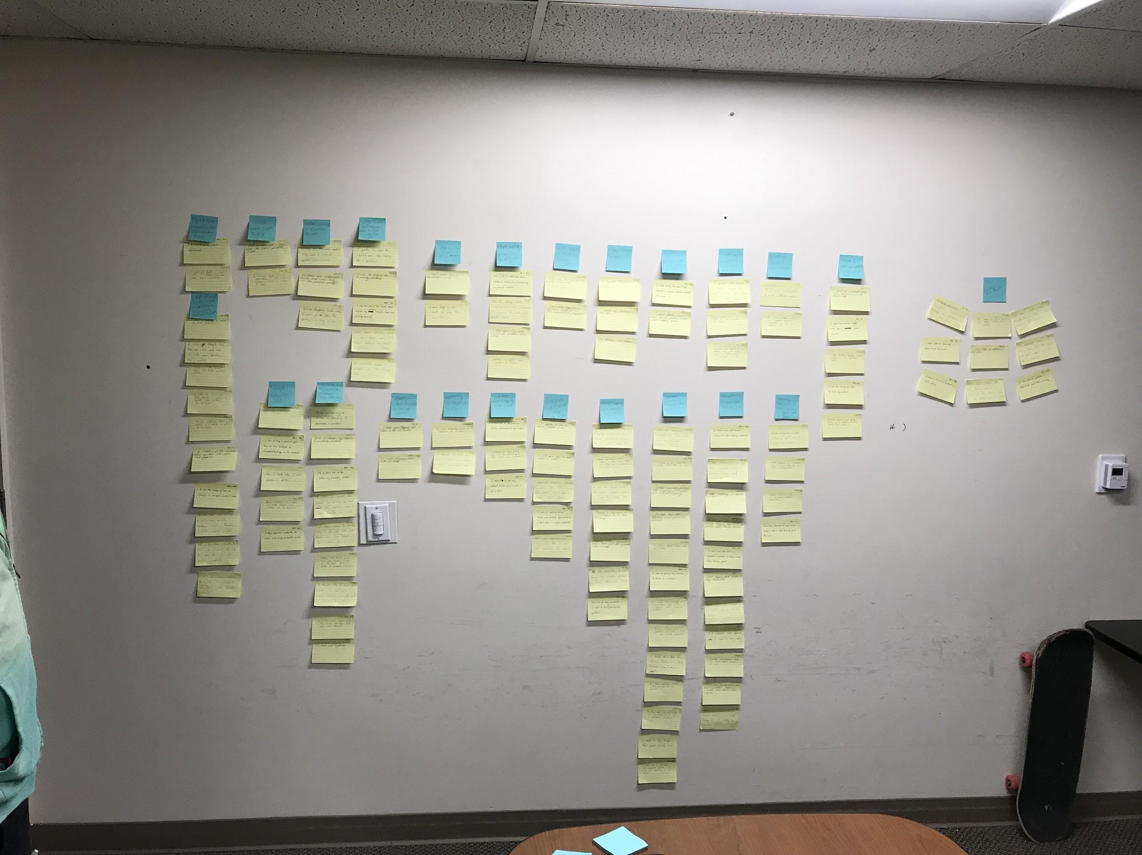

**Figure B & C: A before and after shot of the affinity diagram**

It was observed from the findings that the majority of survey respondents were male, sitting at 61.7%, while female participation was at 33.3%. Others genders included: one “attack helicopter”; one “Flying Spaghetti Monster, w/ extra sauce”; and one who did prefer not to state their gender. The youngest survey participant was born in the year 2000 while the oldest participant was born in the year 1975. Out of the surveyees, 10 had completed high school, 24 had completed 1-2 years of college, and 26 had completed 3+ years of college.

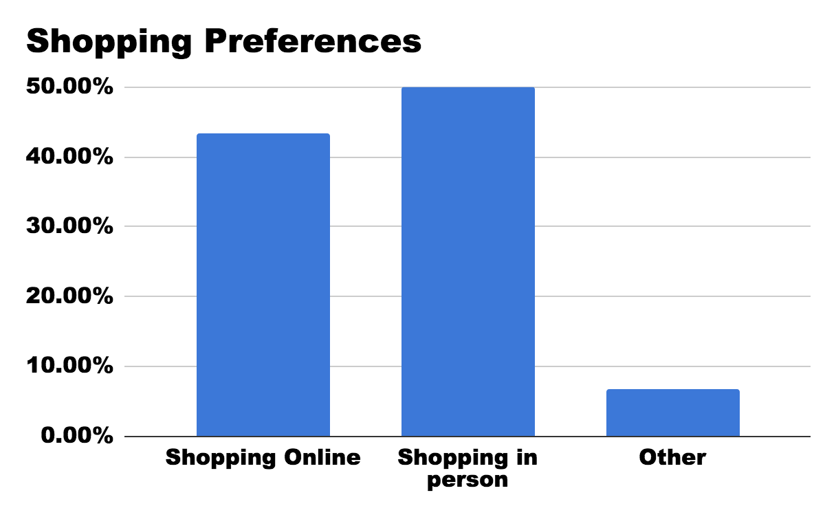

**Figure D: (Survey) Which of these shopping methods do you prefer more?**

One thing noticed during the interview process was the emphasis on the convenience factor of shopping online compared to in-store, which lead to the notion that online shopping was the main bias for the surveyees as well. However, the survey shows that half of the respondents preferred to shop in-person compared to the 43% of people who preferred shopping online (Fig. D). The other 7% had many different answers ranging from not shopping for themselves at all to having some combination of both for different reasons.

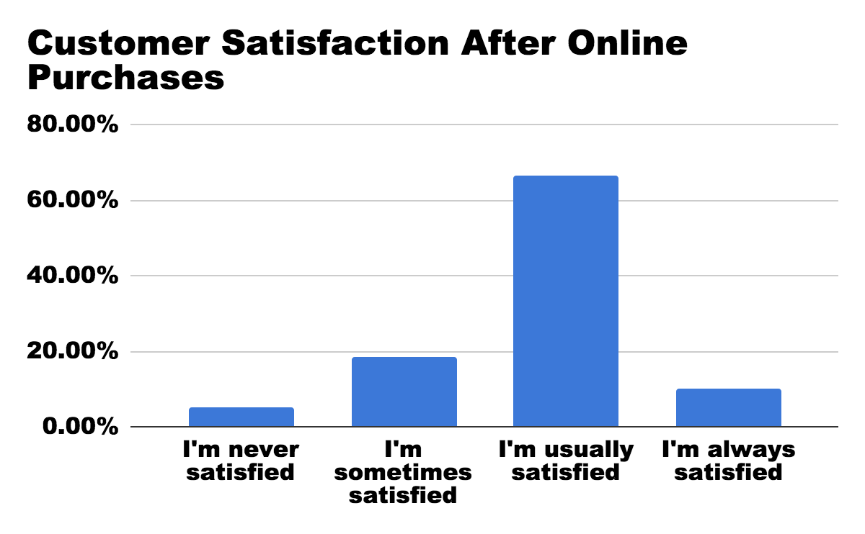

**Figure E: (Survey) How often are you satisfied with your online shopping experience for electronics?**

When looking at the survey data regarding customer satisfaction, around 76% of respondents are usually satisfied with their purchases online (Fig. E). A majority of the respondents shopped at big companies online stores, such as Amazon, Ebay, and Best Buy, which are known to be fast and reliable at providing the products that people would need. On top of all of this, about 70% of people are comfortable with shopping online, meaning most of the respondents find no trouble in purchasing products from online retail sites.

The problem that seems to be deterring some of the respondents from preferring online shopping is the frustration that comes with the process of online shopping. While most aspects are intuitive to some people, there are a lot of minor details that can bother and even deter the online retail sites user bases. About 63% of the respondents seemed to have some sort of difficulty when trying to find the products they needed from an online store; some refer to it as one of the negative sides of online shopping for a casual user (Fig. F).

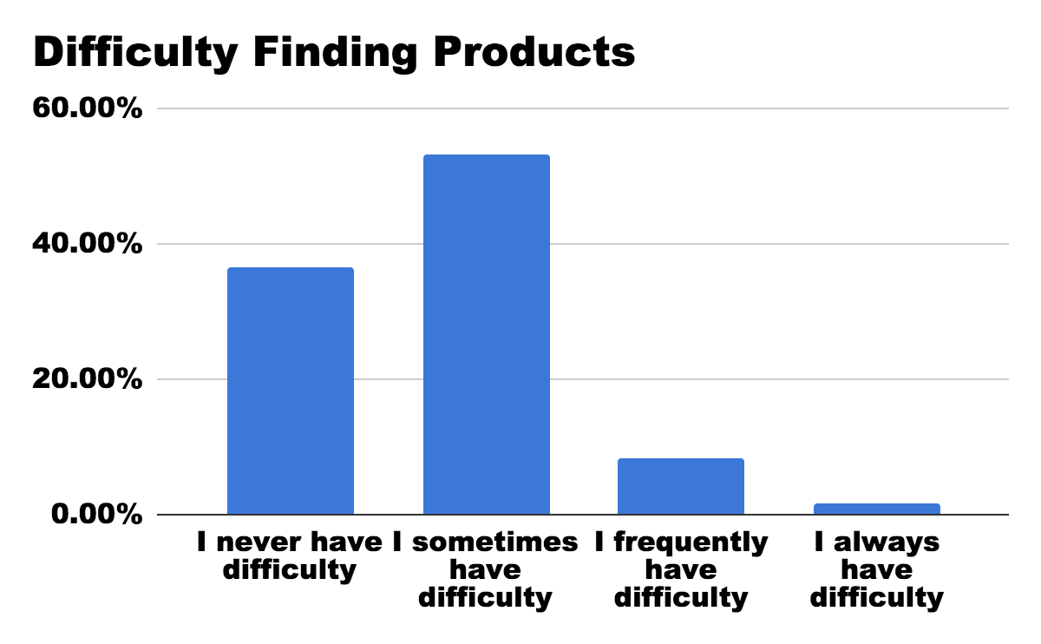

**Figure F: (Survey) Which response most represents you when finding products you want to buy?**

Drawing from the survey and the interviews results, no two people seemed to have the same difficulties when it came to searching for products. After the respondents were finally able to find the product they were looking for, about 70% of them said they spend at least an hour doing research about the product they are interested in. From this, it can be assumed that product research is time consuming for a consumer and, depending on the results, can make or break a consumer purchase. Some of the most popular sources that were used in product research were Google, YouTube, and Reddit (Fig. G). More often than not, participants said they used more than one of these methods to research and compare product information. Some of the respondents even preferred looking for negative reviews in an attempt to weigh pros and cons.

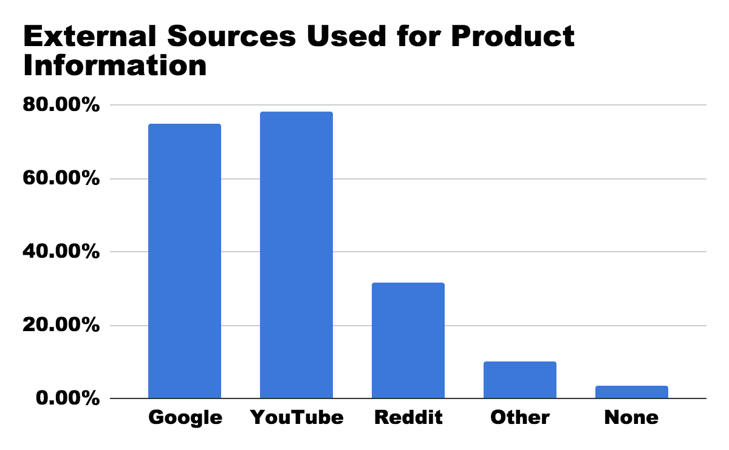

**Figure G: (Survey) What sources do you use for finding information about the products you want to buy?**

Customer reviews were also a big factor when it came to product comparison and the purchasing decision. About 90% of the respondents believed that customer reviews were important and needed to be taken into consideration when purchasing a product. If a product lacked customer reviews, the surveyees found it easy to skip over it for fear of a risky buy.

The last important thing the survey and interviews looked at was the users preferred method of browsing products when already on a specific website. The data for this one sees search bar as the most popular browsing method for the respondents (Fig. H). However, there is only around a 20% difference compared to the other options, meaning that all the users tend to have their own preferences when it comes to browsing.

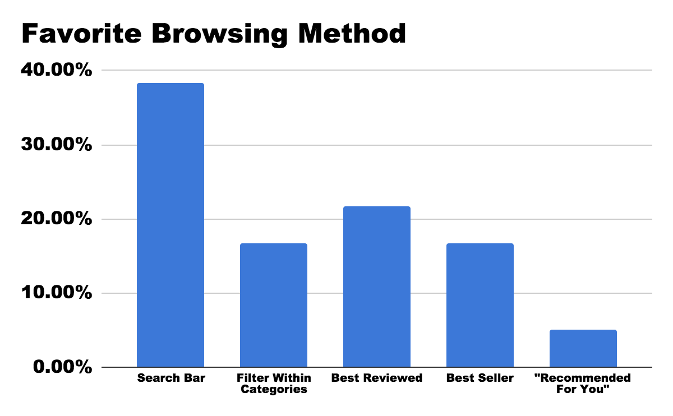

**Figure H: (Survey) When browsing for electronics, which of the following is your favorite method?**

From this data, a conclusion can be made that a good search bar formula would be beneficial towards a more user-friendly consumer products site. Whether it be for convenience or organization, all of the participants had different needs and different preferences. From the survey data, potential users seem to like seeing price first and foremost when they first find a product. Next, they seem to want images, and then customer reviews from their consumer products websites. Implementing better ways of showcasing these attributes on a product discovery page or a splash screen could remarkably improve the user experience of shopblt.com, if implemented correctly.

# Identifying Usability Issues

## Background

Subsequent to our user research we engaged in identifying potential usability issues. Our efforts were lead by the findings of our user research. Below are more details regarding what practices we performed in order to successfully identify and analyze elements that are detrimental to the site’s user experience.

Our team’s initial impression, after initial navigation to the website, is that simple tasks like finding a certain category or product are rather difficult with the tools provided. The site fosters a haven for users with high domain knowledge of computers and electronics, yet it fails to cater to the less informed who could be potential future users of the service. Even though BLT has been in business for almost 30 years, its website (shopBLT.com) has much room for improvement.

The purpose of this section is to analyze user-performed tasks supported by the website to understand what exactly users could struggle with. Our team created several tasks and conducted a usability test and a cognitive walkthrough. Below is a list of areas we wanted to learn more about; the list is derived from the study objectives we used in the previous section when we conducted our user research.

* The terminology of product groupings and categories
* Product visibility
* Product information accessibility
* Navigational tools

By understanding user intentions and website shortcomings, we can offer changes that would improve the website’s usability and hopefully bring it more business.

## Description of User Population

### Target Population & Import Considerations

The primary user base of shopBLT includes a set of individuals, mostly male, ranging from the ages of 22 - 50, who are placed in the socioeconomic class of middle to upper-middle class. The main recurring user base is located in the United States, and thusly most of the traffic, service, and shipping are established domestically. The international population is still an important consideration, as usability between cultures is something we would like to explore to ensure the product-service employs universal usability practices. Data regarding international users however is less than abundant, and therefore, we intend to focus our efforts primarily on the domestic users. Given that a high percentage of our target population possesses high domain knowledge and expertise, we expect and *assume* that the user population frequently shops online. Other characteristics of our user population include valuing: responsiveness (both systematically and from the company), quality customer service, company transparency, secure payment methods, and brand credibility.

## High Level Summary

* Mostly male
* Ages 22 - 50
* Domestically located (high traffic in the United States)
* Users value (Non-technical)
  + Company transparency and responsiveness
  + Quality customer service
  + Secure methods of payment
  + Manufacturer credibility
* Users value (Technical)
  + System responsiveness
  + Technical jargon

## Surveyed Population*1

Of those that we surveyed and interviewed to gain a perspective on our higher level evaluative goals, we discovered that the data reflected some core characteristics of our true target population. For example, the gender distribution was fairly consistent with our target population, with the majority being male at (55%). Furthermore, most of our participants fell within the target population age range, with a few survey participants inconsistent with the range. The lowest recorded age was 18, with the mean being 26, and highest age 42. Based on participant responses, consistently held values between target population and observed population include: quality customer service, secure methods of payment, manufacturer (and retailer) credibility. The majority of our observed population did not reflect the same level of technical experience with our target population. Lastly, while all of the participants were interviewed or surveyed in the United States we have no data of ethnicity or international status, and thus cannot make any claims or connections to the target population in that respect.

**Participant Sample*2**

Our participant sample for the usability tests primarily consisted of male subjects. As a whole the technical expertise of our participant sample is less than that of the target population, however; we tried to recruit participants that shared some core characteristics of our true target population. For example participant three possesses an “Advanced” level of expertise and domain knowledge similar to our target population. Our participant sample also consisted of set of individuals that share similar online shopping habits in terms of frequency. A summary of our participant population is provided in the tables below.

*1Note: We attempted to reduce bias as much as we could when gaining information from our interviewees and survey participants.

*2Note: It should be noted that our participant sample is relatively small with a size of five separate individuals. These participants are not completely representative of our target population, as the technical experience of some of our participants is less than that of the average consumer of shopBLT.

## Methodology and Goals:

To evaluate and analyze usability issues that fall in line with our areas of interest we conducted two separate usability activities: a usability test and a cognitive walkthrough. We began by assessing the data we received and analyzed from our interviews and surveys. Subsequently, we identified common areas pertaining to crucial usability issues. From our **findings** we **identified**: ***product visibility*, *functional tool discovery*, *product information availability*,** and ***characteristics of the navigational tools*** to be **primary areas of interest**. Thusly, we designed usability test tasks around these findings to gain finer-grained specifics about usability issues in these areas.

## Participant Recruitment

Admittedly, our observed population (subjects who participated in usability tests) is not representative of our target population. We gathered our participants primarily through convenient means such as recruitment of friends, peers, etc. However, our goal was to test and analyze those who met a number of qualifying characteristics to get them as close to the target population as we could. We performed usability tests on five separate individuals in teams of two (one scribe, one facilitator).

## 

## Data Analytics

Once we gathered our data from the usability test and cognitive walkthrough, we constructed two separate affinity diagrams. A single diagram was used to interpret data from the usability tests, and the other for the cognitive walkthrough. We then discussed the issues and consolidated the overlapping pain points and while filtering out some of the other smaller more user specific difficulties that were not supported by our previous findings. Given there were numerous issues discovered, we then performed analysis of the data using a prioritization matrix, rating pain points on the dimensions of “user value gained” and “feature complexity”. Our findings and prioritized set of issues to develop solutions for include:

**Product discovery**:

1. Search Bar: Unoptimized boolean search algorithm that reads for keywords and produces false negatives. Presents misleading information to the user.
2. Categories: Caters to users who possess high levels of domain knowledge. Category listings use technical jargon relating to more specific areas of electronic and computer components that confuse more general users.

**Product identification**:

1. Product visibility: There is a feature already in place allowing for product visualization; however the feature is not available for most products and the execution of the current feature is lacking. A large image is produced that populated most of the user’s screen eliminating the ability to view other product details and other product listings.
2. Product Listings: Product listings are displayed as tables with several columns for distinguishing information. Product information reads as technical detailing information which excludes a wide set of individuals from shopBLT’s user base.

**Customer Service**:

1. Customer Service and Contact Information: Customer service is an important aspect of any business and customers who are afraid to ask for help or are turned away by the terminology may end up going to a competitor with better service.

## 

## Usability Test

Tasks:

* Load the product page for any monitor without using the search bar.
* Reach the user information page with all fields complete and a monitor in the shopping cart.
* Get customer service help for information on exchanging a product.
* Find the dimensions of an “GRAPHICS CARD AREZ RADEON PHOENIX SERIES RX550 2GB” (using any method to navigate to the product page).
* Find a black mouse pad, with a gel wrist rest, of any size that is priced between 25$ - 35$ using the advanced search functions.

## Cognitive Walkthrough

Tasks:

* Find a black mouse pad, with a gel wrist rest, of any size that is priced between 25$ - 35$ using the advanced search functions.
* Submit a request to obtain and RMA numberto returna product to BLT.
* Find and place an order for a "Logitech Wireless Headset H800" using the category sequence.

## Findings

After conducting and analyzing the usability tests and cognitive walkthrough, there has been a decision to focus on two main issues that need a redesign to improve the performance of the BottomLineTelecommunications website. One of the main issues we found was that product discovery could be difficult to both novice and expert users of e-commerce websites. Two of the main ways users typically search for products is through a search bar or through categories that the site creates. These two functions do perform their job as intended at the lowest level, however if there is a lack of knowledge in how these functions work then it will be difficult to discover any product, even if it does exist on the website. The second main issue was that product identification could be a challenge again for both novice and expert users of online shopping. Users consider the product price, pictures, customer reviews, shipping time, shipping cost, specification, and name of the product to be essential items for available products to portray; however, on BLT’s website most of this information requires extra steps to find even though it is what customers value the most, according to our findings. Although it’s not as high a priority as the other two issues mentioned, one more section of the website that could also benefit from a redesign would be the checkout process. There’s more detail about it in the appendix, but it’s still worthy to note that the checkout process has a fair amount of redundancy and has some confusing processes that can be improved; the website still does function well and will complete the order once the inconvenient process is made.

As mentioned above, one of the main issues we found with the website was the difficulty people had in finding a desired product. In general, people understand how to use a search bar when they need to find a product on a website; on shopBLT’s website, however, using the search bar was an unanticipated issue that our users ran into. For one, when our test-subjects were searching for a product they had to assure themselves that what they inputted in the search bar was correct; “correct” in this sense meant that they couldn’t accidentally misspell the product name, nor could they make it plural, because the website wouldn’t return any results.

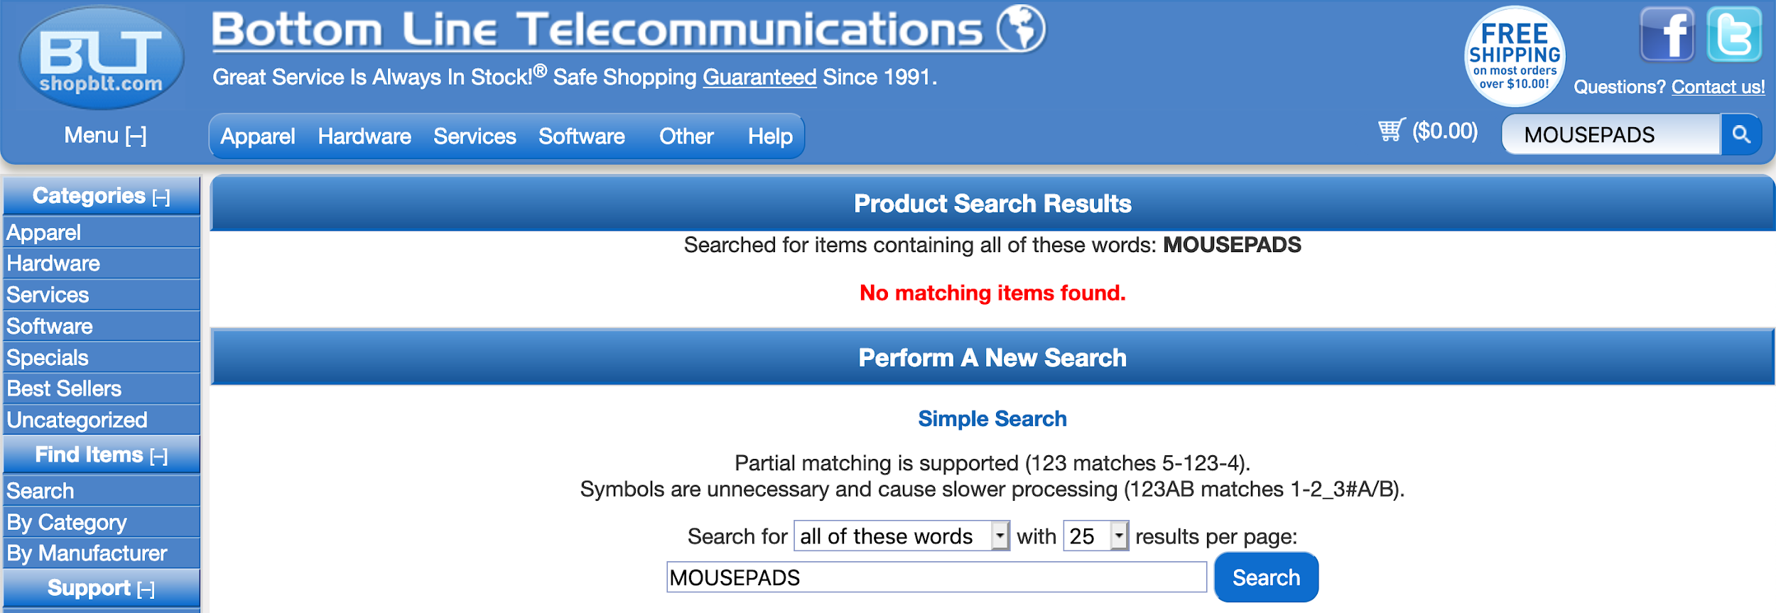

**Figure A: The results from the user typing “mousepads” in the search bar.**

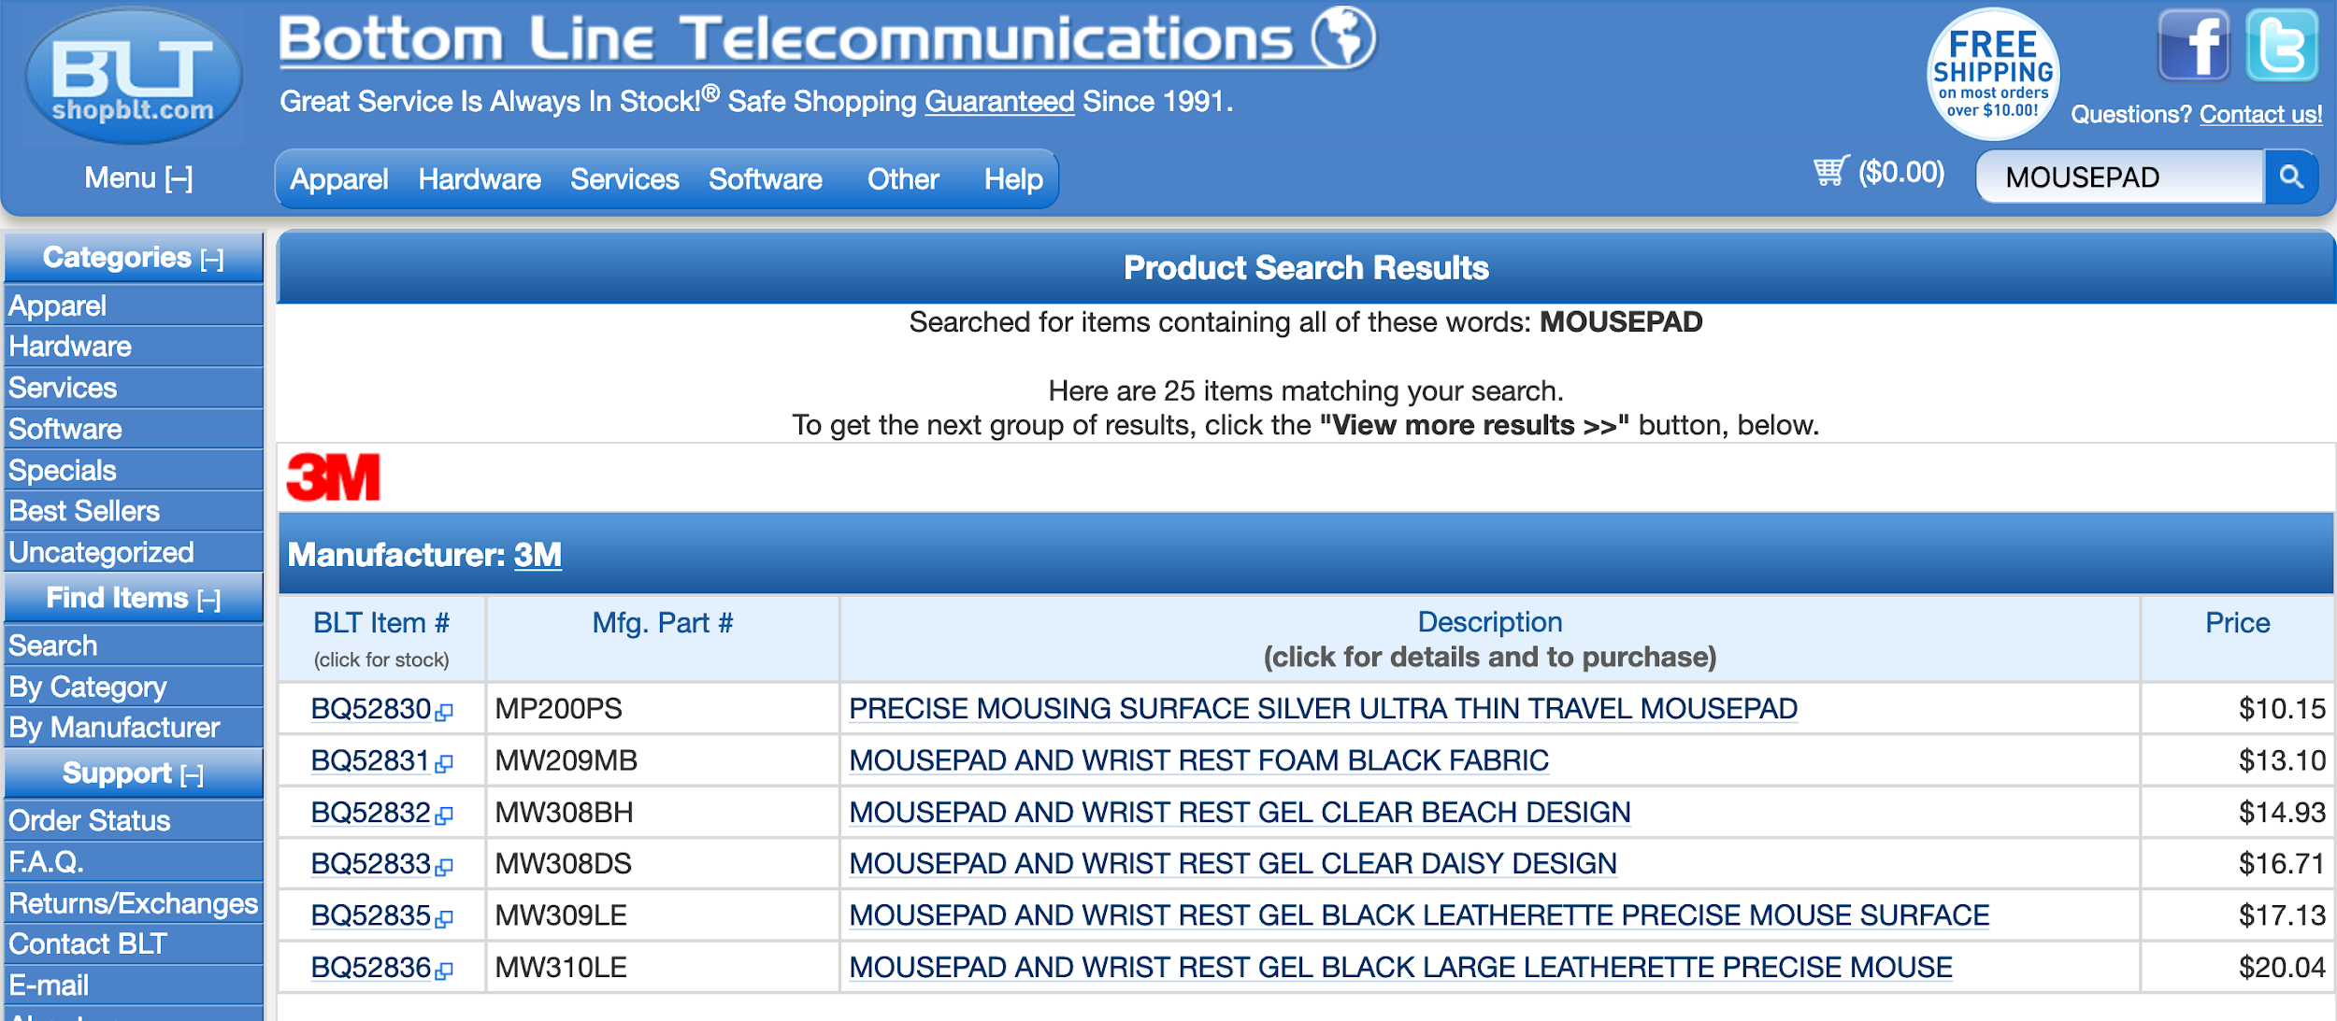

**Figure B: The results from the user typing “mousepad” in the search bar.**

Figures A and B are an example of this discrepancy, where the objective of the user was to search for a “black mousepad with a wrist rest.” Figure A demonstrates what happened when our test-subject inputted “mousepads” in the search bar, thinking that a long list of different mouse-pads would appear. Instead the website responded with zero results and our test-subject had to rethink their method of searching for the product. Figure B is the result of our test-subject changing their input, by simply removing the “s” at the end of the word and getting a full set of results. This flaw that the website has confuses the user and leads them to believe that either the website is mistakened, or it really doesn’t have the product they’re looking for. Either case, the user can’t surely know until they’ve tried every possibility and have used up all their known resources.

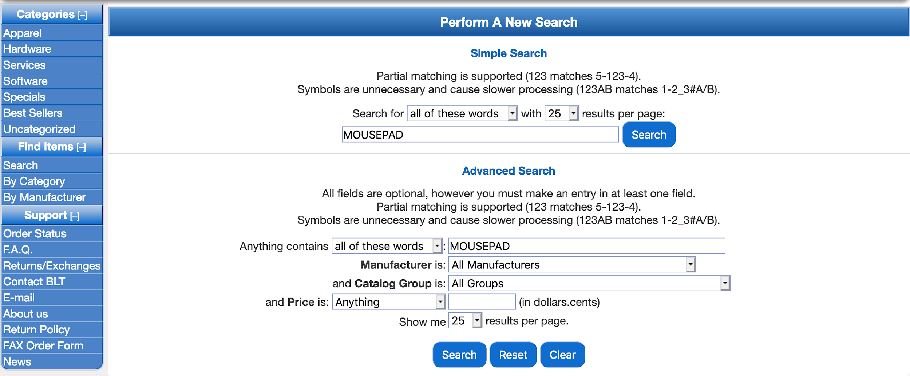

**Figure C: The filtering menu for shopBLT’s website, it’s meant to reduce product search results.**

Aside from the user just inputting text in the search bar, they also have the option of using filters to condense their search results. However, this option is not available for the user until they have already made a search query. On top of that, the filtering menu is not readily available to the user, they have to scroll all the way down past the product listings to get to the filtering menu at the bottom of the page. Figure C is an image of what the user sees when they get to the filtering menu. The features of the menu are not so great either, they provide unorthodox/non-standard metrics for filters; for example, the three grouping options provided for pricing are “Anything”, “Equal or Less Than”, and “Equal or More Than.” In general, these metrics are not what people usually consider when looking for a product; they usually consider things like “Under $10” or “$50 & Above”, or a range like “$20-$30”.

Another way users look for products on a website is through categories. Again, generally people know how to maneuver their way around a website with the categories provided; with shopBLT’s website, however, the categories are confusing and dense if a person doesn’t have prior knowledge about the site. The categories are full of jargon that only a tech savvy person will understand. “Yes they are learnable, but a person doesn’t want to spend the time to learn the categories,” as one of our test subjects said. Figure D shows one of the categories in shopBLT’s website, and how within itself has many other categories as well. The categories have jargon, such as “Graphics & Multimedia” or “Network Protocols, Drivers”, that a user must understand what the terminology means in order to proceed. Most of our test-subjects, at least 3 out of the 5, didn’t know what the terminology meant so they searched through every category of the website until they found what they were looking for. In their case, they had to learn how to maneuver themselves around the website in order to find the product.

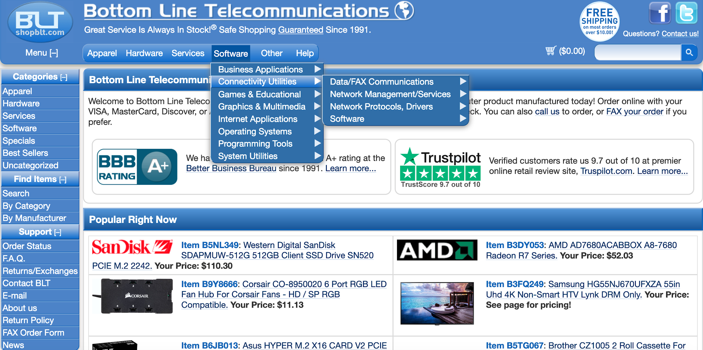

**Figure D: The drop-down menus when a user clicks on “Software,” then “Connectivity Utilities.”**

The second main issue we found on the website has to do with product identification; by this we mean that when users are looking for products, there are certain aspects about that item they want to see in order to verify that that’s what they’re looking for. These aspects include: product name, price, pictures, customer reviews, shipping time, shipping cost, and specifications.

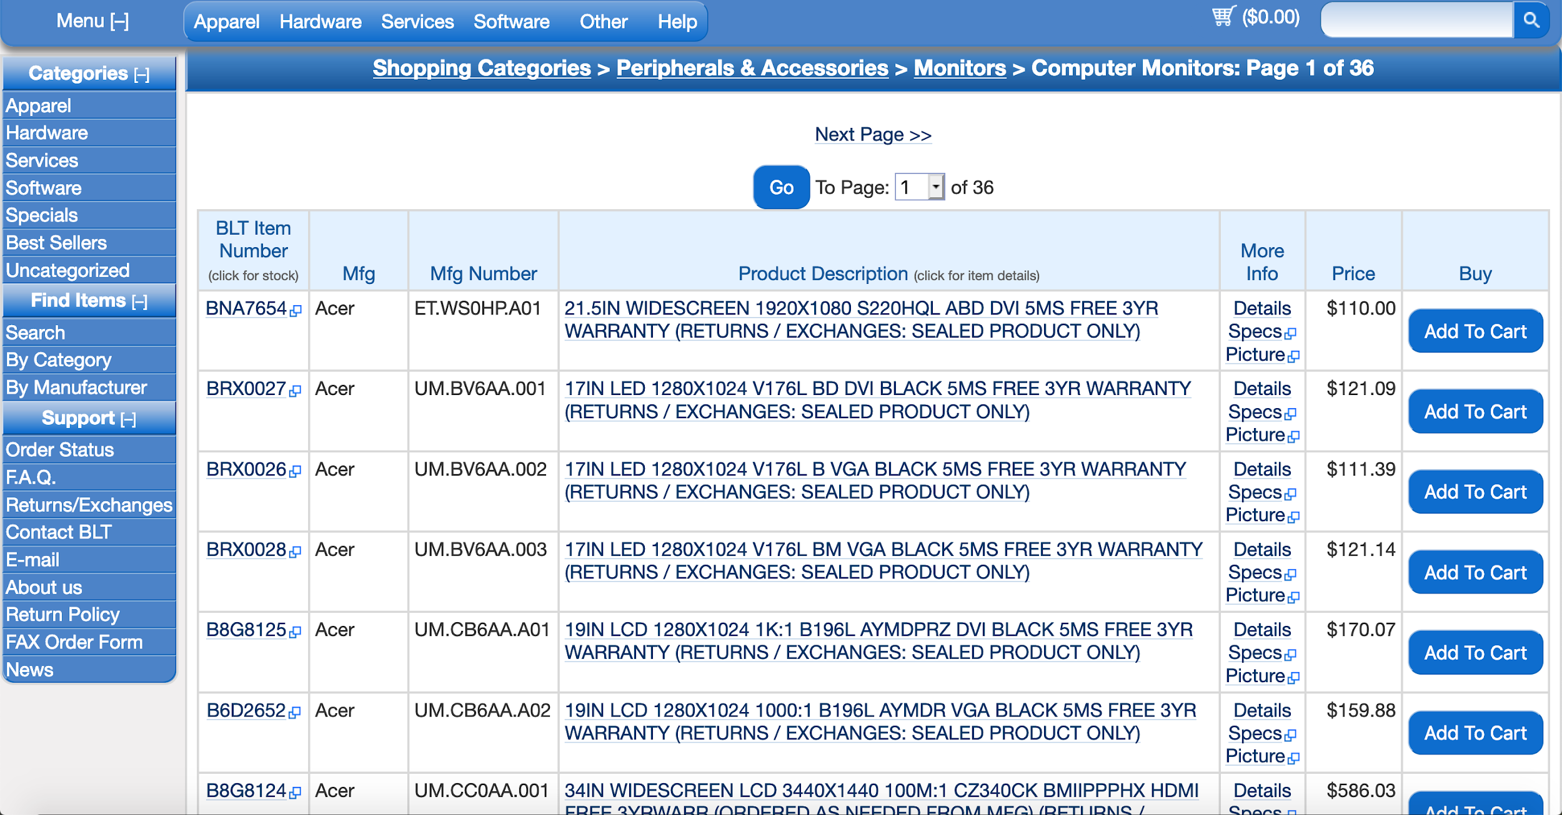

**Figure E: The results when a user clicks “Computer Monitors” in the “Hardware” category.**

Referring to Figure E, it’s clear that it’s difficult to read exactly what each product is. The easiest part to read is the price but there is no immediate image that a user can correlate the price with. The important aspects that a user wants are not readily available, which is a huge issue for shopBLT; if they want to be more appealing to their audience, shopBLT needs to consider redesigning this aspect of their website. Aside from this there also doesn’t seem to be any real order to the items listed, and as one of the test-subjects mentioned, the order seems random and it’s hard to see anything that they would want. During the cognitive walkthroughs it was determined that the site functions as intended, however the main issue lies in the fact that it’s not user friendly at all. Particularly, only users who are experienced with this site will be able to navigate it efficiently while more novice users will be rather frustrated than pleased with what the site has to offer. The intuitive parts of the website, such as adding to the cart, is there but actually locating and identifying products, which is arguably one of the most important features, is not very intuitive and will take a good amount of experience in the site to execute correctly.

In conclusion, if the two main issues we found, product discovery and product identification, are to be considered for a redesign, in return the redesign will help fix the issues on shopBLT’s website and promote higher praise from novice/expert users. As it stands now the website is in ‘good’ standing conditions from having its regularly-visiting customers, but its reputation can be immensely improved if changes are incorporated and newly-visiting customers are pleased with its functionalities.

# Redesign

**Goal**

The goal of this section is to show how we performed a redesign of the website shopBLT based on of the previous sections where we gathered real data and performed usability task tests to create as accurate of a redesign as possible.

## **Methods**

The two main methods used to create these new redesigns was through **sketching** and creating **high fidelity mockups**. The first step was coming together as a group and deciding what the big and small targets of the redesign were. The big targets that were concluded were the search bar and product visibility, listings, and discovery. The small targets that were included were product filtering, checkout, and customer support. After selecting these targets then our group was able to sketch about three sketches for each target then each person was assigned at least one high fidelity mockup to work on.

## **Report**

Below are the final results of all of our group’s discussions and details of everything that had to do with the redesign. Most of the fixes were not too complex within themselves since the biggest problems with most of them was either the placement or the complexity of the way information was portrayed. Aside from the search bar, the four other targets that were decided upon just needed to be simplified and made more user friendly. By using the information from the cognitive walkthrough from the last assignment, it was concluded that the site functions as intended as long as it is executed in a very specific way that is not intuitive to the users. Since this is the case most of the redesigns just required some rearranging and better placement to make it more intuitive for the users. In regards to the search bar the underlying logic was the biggest problem. However, the fix was not extremely difficult since the main thing to do is to change the logic to be a more modern search engine rather than just a binary method where either a keyword exists or doesn’t exist.

## Prioritized Design Targets

## Big Targets:

### Search Bar:

* + **Description of Intended Change**
    - The current state of the system possesses a feature that allows users to query the site for specific products. The search bar component is outdated and uses boolean retrieval practices in its algorithm. The visibility of this tool is sufficient, however the usability is lacking. The algorithm is based on keywords and cross-checks the query with product names in the inventory index. The feature depends on keyword existence in the product title and will sometimes produce false positives if the keyword is not exact. We intend to change the functionality of the search bar to promote friendly searching; improving usability and error prevention by implementing new logic to provide query suggestions and interpret misspelled queries.
  + **Source Justification**
    - *Usability Tests:* Data from our usability tests shows that queries that do not match specific keywords in product names and titles will produce false negatives stating falsely that a product was not found.
    - *User Surveys:* Data regarding the search bar showed that it was the most frequently used feature to discover and navigate for products.

### Product Visibility, Discovery and Listings:

* + **Description of Intended Change**
    - Three main aspects of the website can be consolidated under this category. The aspects we intend to change all relate to the overall display of information. The generated product listing at the moment displays a dense table of information and lacks images - an important aspect of product discovery. Products listed on the front page of the website are independent of the user and are not categorized in any particular way. Given the products listings (whether navigated to via the search bar or categories) is displayed in a text-based table, the user cannot quickly discern valuable product information. The homepage also does not offer any products that are relevant to the user. These two factors cripple the site’s ability to offer the user an opportunity for product discovery. Users that do not have high domain knowledge must spend an unnecessary amount of wading through product listings and backtracking to find the appropriate product. We aim to provide greater product visibility by providing pictures and make product discovery easier for the user by redesigning product listings visualization. These changes should work toward expanding the user base to be more inclusive to parties that have less domain knowledge.
  + **Source Justification**
    - *Usability Tests:* Data from the usability tests asserts that participants had trouble reading the information presented in product listings table. Participants were unable to determine if a product found matched the product outlined in the usability test requirements because there were no pictures, and the tables were reportedly “difficult to read”.
    - *Cognitive Walkthroughs:* After gathering data from the usability tests our team investigated the product discovery and visibility aspects of the product listings visualization. We found that some products do have images both in the product listing and the product page, however, finding the option to display the image is difficult. Furthermore, once the image is displayed in product listings we found it was troublesome to try to get rid of the image. Our team also discovered that parsing the information in the tables is rather difficult.

**Small Targets:**

### Product Filtering:

* + **Description of Intended Change**
    - This feature serves the purpose of reducing and condensing product search results for users. However, where it currently sits on this website is hidden from the user, at the very bottom of the webpage after all the product search results. The user has to scroll all the way down, pass 25 product search results, in order to reach the filter table. Along with that, the options given to reduce the search results are unorthodox and different than what users are accustomed to. For example, the given options for pricing are “Anything”, “Equal or Less Than”, “Exactly”, and “Equal or More Than”, which are all pricing options that modern shopping websites don’t occupy. We’re going to take inspiration from competitive websites and follow the same idea of utilizing the left side of the webpage, to make a customary ‘Advanced Search’ filter table. The user will see what categories the product search results can fall under and will be able to have the option of selecting a specific manufacturer from a list of partnered manufacturing companies and inputting a price range to narrow the results.
  + **Source Justification**
    - *Usability Tests:* Data from our usability tests suggests that feature discovery was difficult for users; they had a hard time finding this tool and didn’t know it existed on the website, until were guided to it.
    - *Cognitive Walkthrough:* Data from our cognitive walkthrough suggests that the functionality of the filtering feature doesn’t actually work; when a user specifies a certain option along with a price range, the product search results remain the same rather than condensing and becoming more accurate.

### Product Check Out:

* + **Description of Intended Change**
    - The product check out is poorly designed. The checkout process asks for the user’s email address in the billing information when it would make more sense to put it in the user information section. The process also includes two separate options to navigate forward in the checkout process, proceed using a secure checkout, or an insecure checkout method. This additional step is superfluous in the process, as each option navigates the user to the same checkout page located within the same server. This shows that the developer of the site changed the checkout process but did not revisit this step to produce a more streamlined and clear procedure. The process asks the user’s daytime and evening phone. The goal of the intended change would to consolidate the two checkout options into one option that would work for all consumers; it would save an extra click for the customers. It would also help to take out unnecessary information such as ‘Organization Name’ and the evening phone. We intend to consolidate the information presented in the prerequisite steps of the checkout process, and offer a new method of payment that would provide more variability in payment procedures in an attempt to reach a wider user base.
  + **Source Justification**
    - *Usability Tasks:* Our users commented that copying/pasting information was annoying and that if the form was submitted with an error, it would have to be re-done and that was very time-consuming.
    - *Cognitive Walkthroughs:* Having to pick between two checkout options is time-consuming when the consumer can be automatically directed to one without having to waste time being confused. The customer also has to fill in the same information multiple times (i.e. phone numbers for both the evening and the daytime)

### Contact Information & Customer Support:

* + **Description of Intended Change**
    - We received feedback from an expert part who mentioned that website’s tools for customers to receive help are interlaced with many clicks and superfluous information that could come off as less than hospitable. This may give off the vibe that the website may not want to help its customers. Customer service is an important aspect of any business and customers who are afraid to ask for help or are turned away by the terminology may end up going to a competitor with better service. With this in mind, the change that would be best for shopBLT would to have a customer service experience that does not make the customer feel bad for trying to ask questions and is not riddled with information and multi-level navigation to get to the contact information. The information, regardless of how trivial the question may be, should be readily available to the user to promote a hospitable and friendly user experience.
  + **Source Justification**
    - *Expert Analysis:* Our expert analysis on this issue comes from inspiration from other competitive websites, such as: Best Buy, Amazon, NewEgg, and eBay. When analyzing all these websites as a whole, we realized they had a set of norms when it came to their customer support reference page. For starters, they all believe it’s important to separate their customer complaints into different categories - this way customers can identify their issues quickly and easily. Some of the websites go more in depth with their categories, but, for the most part, they all have a similar basis as to what they consider to be typical customer concerns. They relate primarily to the most frequent issues presented by customers that they face. Once they’ve chosen a category, the user is presented with the necessary information and steps needed to solve their problem. The steps are easy to follow and the information is easy to comprehend; the page is not an overload of information. More importantly, the language and tone used by the website to communicate this information to the user is friendly and inviting.

## High Fidelity Mockups & Design Documentation

## 

## Customer Support and Contact Information

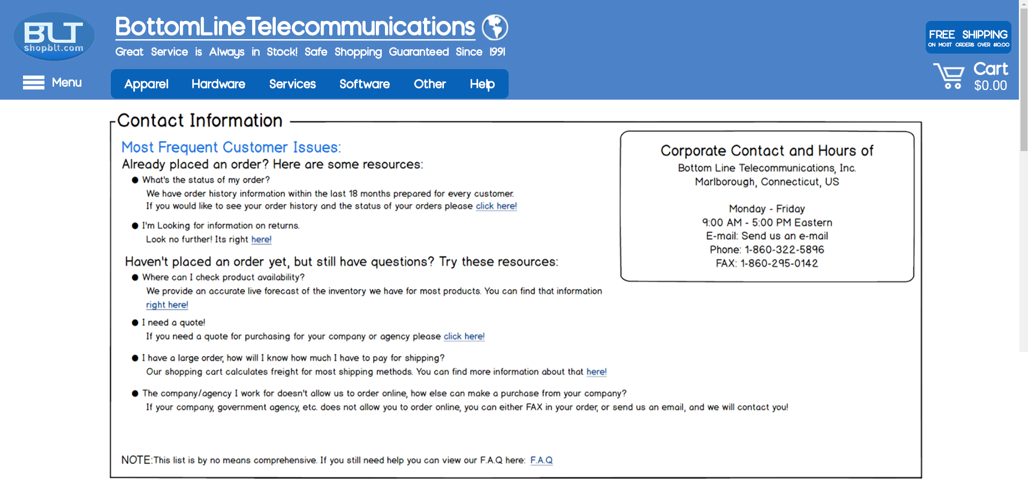

Figure A: High fidelity mockup of the **customer support/customer information** to improve **customer support and contact information**.

## 

## Design Documentation for Customer Support/Contact Information

**Problem:** The customer support and frequently asked questions pages on Bottom Line Telecommunication’s website has poor customer orientation and indirect customer interaction. The information displayed on these pages is both verbose and cumbersome. Customer’s seeking quick access to straightforward information must wade through a plethora of text, minimizing the importance of the customer’s queries and projecting an attitude that is less hospitable. The terminology has been described as “snarky” and “unwelcoming” by parties who have reviewed the site, including our development team and user experience researcher Hillary Abraham. In sum, the site does not offer a more friendly and inviting environment for indirect customer interaction, and openly discourages customers from reaching out via methods that would establish a direct connection between the customer and the company.

**Evidence:** As noted above, the issue was primarily introduced to us by user experience researcher Hillary Abraham. After she had brought this issue to the attention of our team, we revisited qualitative data we received from our user research and interviews. We have data to support that customers and users alike prefer quick and easy access to information regarding products, ordering, and retailer policies. We also researched and compared the structure and language used by competitors in their customer support section, revealing practices that organized the information neatly into small text packages as well as encouragement to reach out to the company with any and all inquiries. The contrast between (customer expectations and competitor practices) and shopBLT’s execution of approaching customer service was staggering.

**Process:** The range of our designs reached from changing only the terminology and wording, to removing it all together. We also considered reorganizing the presentation of information, and where the actual contact information would be placed. Sketches were done to communicate the categorization and groupings of the text presented to customers as well. While these methods produced important design artifacts, our main focus was creating a more welcoming environment to the user, eliminating the discouraging sense presented on the site now. We consolidated our design ideas by iterating through all of the sketches and cherry-picking the best features that fell in-line with our expert opinion and key points found from user research. We chose this final design because it uses collective terminology (words like “we” and “us”) and took an approach to delivering information that streamlines the information to the customer and is oriented around the customer.

**Results:** Our designs aimed for more friendly indirect interaction with the user. We also utilized collective terminology by using words like “we” and “us” and took an approach to delivering information that streamlines the information acquisition process and is customer oriented. We also focused our efforts in establishing good use of design real estate. The goal was to provide friendly user interaction with quick access to information while maximizing potential use of screen space (minimizing white space). We consolidated sketches to produce the ideas for organization of information by categorizing them into relevant sections: “already ordered” and “have yet to order”. We only provided a high fidelity redesign for the “Contact Us” page and decided against redesigning the F.A.Q page as well; given that the F.A.Q. page possessed an inordinate amount of text content. Rather we sought to provide a model for customer support and indirect customer interaction that can be applied to other areas of the site. The redesign presents the information in a more friendly and encouraging way. We changed the terminology and structure of the wording presented on the page to promote a more hospitable and welcoming environment. We also moved the contact information from the bottom of the page where it was (buried underneath text) so that it is readily available to the user, indicating that direct communication is welcome and encouraged. The categorization follows that presented on the website now to retain familiarity with existing users. The disclaimer prompting users to review all text based information before reaching out to the company has been removed as it was seen as “snarky” and “discouraging” by our team (expert opinion).

## 

## Product Discovery, Visibility, and Listings

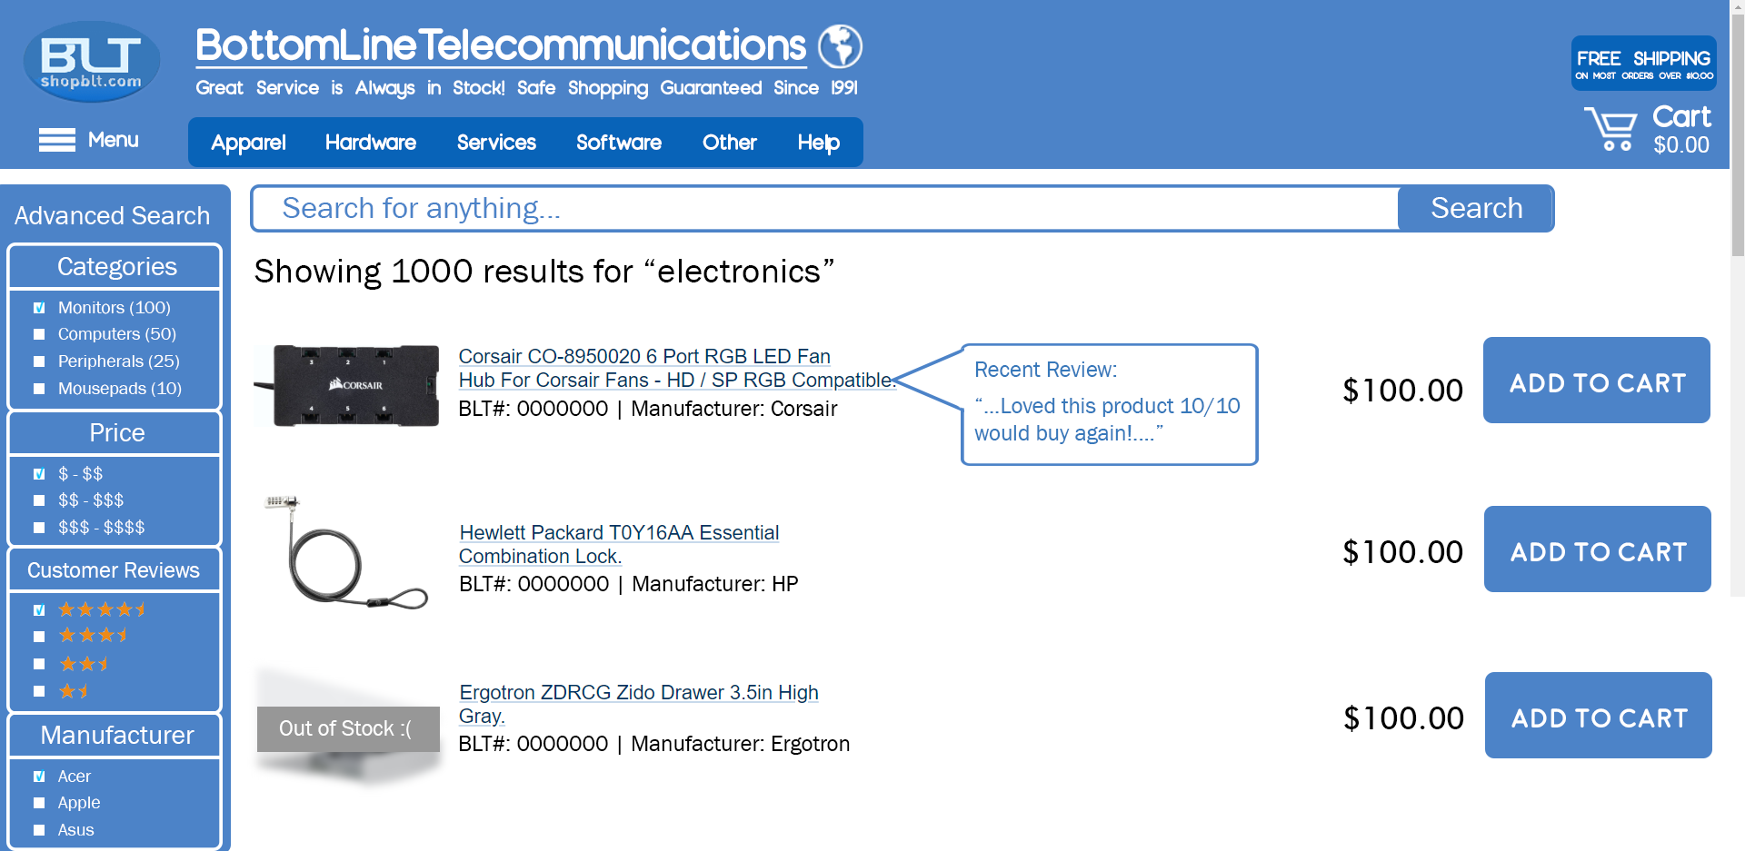

Figure B: High fidelity mockup of the **product listings** and corresponding images to improve **product visibility**.

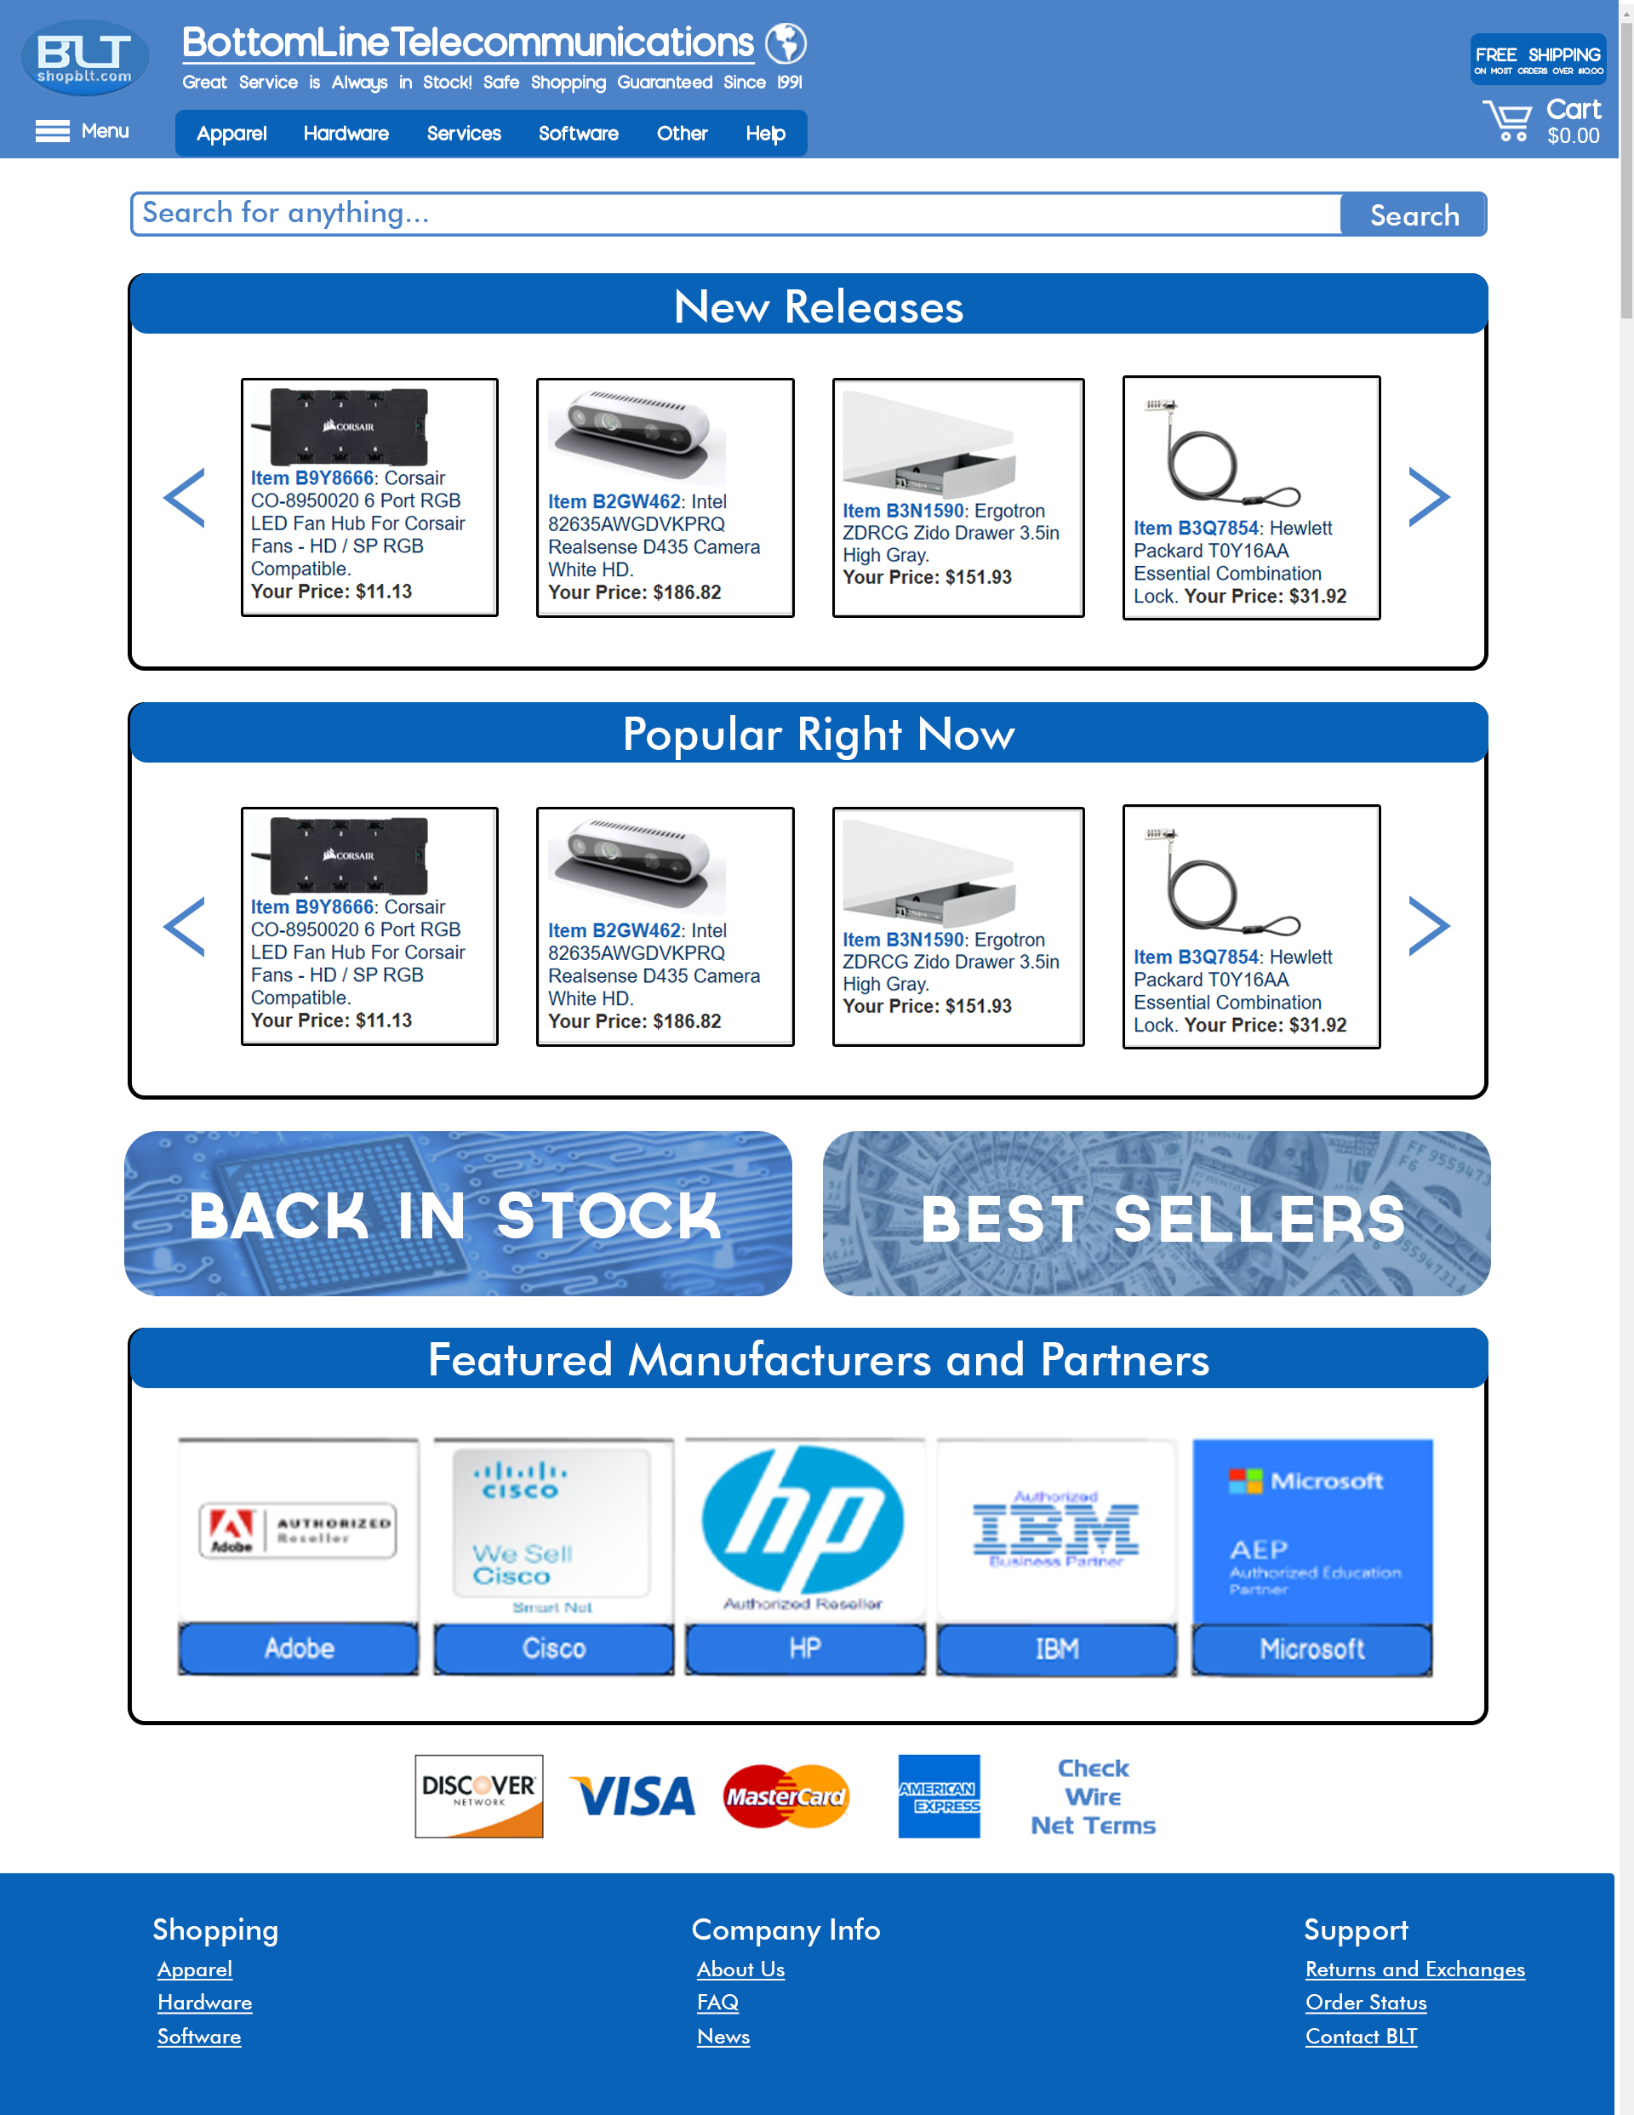

Figure C: High fidelity mockup of the homepage to improve **product discovery** and **product visibility**. (Figure shows entirety of page, actual implementation will involve scrolling).

## Design Documentation for Product Discovery, Visibility, and Listings

**Problem:** The current state of the design for product visibility, discovery, and listings is lacking. User research conducted by our team shows that consumers value and depend on certain kinds of information to make an informed decision before purchasing an electronic item online. Information such as: price, product details, retailer reputation, and product images are important to the user. Among those, our research shows that within our participant population, product visibility (images), price, and reputation are the most important. The current design does not support increased product visibility in a user friendly fashion. Product information prioritization is not optimized with the current state of the product listings page. Some information is irrelevant and can be placed directly on the product page, rather than in product listings. We decided to redo the homepage as well, given it is the primary landing page for the company. The homepage of competitors present a number of interactive listings and options that entice the user or customer to become engaged in the site and allows for greater chances that a customer finds something they may want or need. The site introduces itself to the user by declaring that it is indeed a trusted site and has good standing within an official review. We wanted to present a more engaging atmosphere to the user and also show the site can be trusted, rather than stating it is.

**Evidence:** When conducting our user research, we discovered that many of our research participants value the ability to have a visual representation of the product, as it allows the customer to get a better sense of the product they are going to buy (especially when shopping for electronics). Our user research showed that ~50% of our research participants prefer in-store shopping to shopping online because of the ease of access to product information (customer service) and the customer can see and feel the product before they buy it. Qualitative data from our interviews suggest the same thing, as ~60% of our participants stated they sometimes shop in stores because of greater product visibility and access to information. Additionally, from those participants who did answer that they shop online for electronics, we also see ~75% of individuals using external online resources (such as Google, and YouTube). When asked why we received responses stating that these external resources helped the participant paint a better picture of the product, how it’s used, and whether it will fulfill the needs of the customer. Furthermore, when conducting our usability tests we recorded several comments regarding the availability of product images. A quote from one of our participants from the usability test, commented on the product listings and product visibility “It’s confusing because I don’t even know how its sorted, it looks kind of random, because you have the product information but it’s the fourth column in the table and there are no pictures.”

**Process:** The sketches for this redesign ranged from simple changes like adding product images and condensing information to performing a complete overhaul of the product listings and the organization of the homepage (product discovery). After each team member built their sketches individually, we laid out all sketches and presented them for review. We filtered out the sketches that possessed similar problems to the home and product listings page, but kept good suggestions like image placement and which information to preserve. We then chose from three separate designs, the best features to be consolidated into a final design. A sketch we produced presented the retention of important information, while improving the readability and accessibility of the same information using symbols and condensed text. We aimed to provide new organization and ordering of products, as well as product visibility to consumers and strived to provide faster access and identification of important product information.

**Results:** Our final design made information categorization and accessibility a priority. The product listings page was changed from a table to a linear display (running top to bottom) that possesses tools for filtering, condensing, and specifying the desired listings. We attempted to retain all of the important information already present, and reorganize the way it is displayed. We based our idea of “important information” around data we gathered from our user research and surveys. The information we included are: product name and description, price, image, and manufacturer. The addition of images was one of our higher priorities. The new design reformats an interesting feature already deployed on the website. The site offers live inventory stock checking, but the signifiers for this feature are poor. We decided to redesign this feature by displaying either a green check mark, or a red “x” in the top right hand corner of each product image. This design is meant to improve the readability of the interface signalling that an item is either in stock or not, at a glance. Product name and descriptions have been kept as they link to the specific product page, but we added a tooltip bubble to present a quick summary of other information to the user, such that the use does not have to navigate away from the product listings page to view more information. The homepage was also changed to promote more interactivity and product advertisement to entice the user in delving further into the site to see what it can offer to the user/customer. Side scrolling panels display a revolving set of product listings. The disclaimer at the top of the page promoting the site’s reputation was kept but moved to the bottom of the page, as shown in Figure C. We wanted to mix up the way information was displayed for variability, while maintaining a similar feel of the original website so existing users do not have to relearn the interface.

## 

## Product Filtering

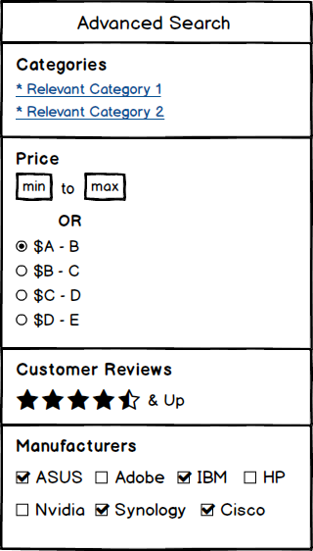

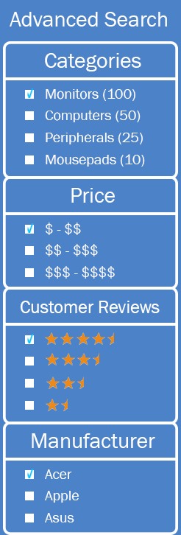

Figure D: High fidelity mockups of the **filtering menu** to improve **product filtering**. (The filtering menu will appear on the left side of the webpage, after a user has inputted a search query)

## Design Documentation for Product Filtering

**Problem:** As it currently stands, the product filtering menu is not clearly visible for the user. Rather than having the menu be instantly accessible to the user, the menu is placed at the bottom of the webpage after all the product search results. The user has to put in the effort of looking for the filtering menu if they want the opportunity to utilize it. Along with this, our user research demonstrated that the filtering options given to users were not so helpful either. The filtering menu currently implemented has four options: manipulation of the search query, “Manufacturer”, “Catalog Group”, and “Price”. Within these four options, the metrics used to filter out the search results are unorthodox/non-standard. For example, in the “Price” option the metrics given to the user are “Anything”, “Equal or Less Than”, and “Equal or More Than.” In general, these metrics are not what people usually consider when looking for a product on a shopping website; they usually consider things like “Under $10” or “$50 & Above”, or a range like “$20-$30”. By addressing these issues we hope to provide the user with a more helpful filtering menu, which is what it originally was meant to be as a website tool.

**Evidence:** When conducting our user research and doing usability tests on the filtering menu, we discovered that users either had a difficult time locating the filtering menu or did not find the filtering menu at all. When asked to find a product on the website that was within a certain monetary price range, users went directly to the search bar and manually looked for the product. One out of the five test-subjects actually used the filtering menu to find the product within a price range. But this test-subject also had trouble with the given options and metrics the menu gave them. Also when conducting our cognitive walkthrough, our team noticed that the actual functionality of the filtering menu didn’t work either. When we inputted a search query and only wanted the results for products that were “Equal or Less Than: $25”, the menu disregarded this input and still gave us all the products that were available; we had product results with prices like $30 or $40.

**Process:** To help decide for the final redesign, we all put our sketches together and started picking different features from different sketches that we liked. In the end, this is how we decided what the redesign should look like and which would help users the most. The sketches for this redesign all had similar ideas in terms of what the filtering menu should look like and where it should be placed. All sketches of the filtering menu were in the shape of a long box and each filtering option had its own section within the box. Many of the sketches had the filtering menu on the left-hand side of the webpage. Common filtering options that were previously on shopBLT’s website were “Price”, “Manufacturers”, and “Categories”. But on the sketches, these options were altered and looked different than what shopBLT had them to be. For the “Price” option many sketches had text fields for the user to manually input a price range, along with a radio button group that had determined price ranges already. For the “Manufacturers” option, sketches had a checkbox group with names of different popular manufacturers that users can select from. For the “Categories” option, sketches had the names of relevant categories the product belonged to; users were able to click the category if they wanted to look for more similar products. A new category that appeared from many sketches, was “Customer Reviews”. Team members showed this part of the filtering menu as filled/non-filled stars, in a range of five.

**Results:** Our final redesign for the filtering menu prioritized accessibility and functionality, as far as what it meant to be beneficial for the user. Our team’s motivation was to improve the website’s filtering menu in order to increase customer usability of the tool. First off we decided to make the menu more visible to the user, that way they wouldn’t miss it or have to spend unnecessary time looking for it. We decided to make it appear on the left-hand side of the webpage, after a user has already inputted a search query. As far as filtering options, we decided to keep some of the current options of the menu and improve their use of metrics to more orthodox/common metrics that users are familiar with. By allowing the user to choose relevant categories for the product or choose a price range for the product or select more than one manufacturer for the product, we’re allowing the user to have freedom and accurate search results. We also decided to include a new option that we think users will find more beneficial when trying to search for desired products. We found in user data that people want to see certain information when looking for a product, in order to help them decide whether or not to buy the product; providing information like customer reviews, allows the user to see which products are worth spending their time investigating. We wanted to make the filtering menu more familiar to users, just as they would see a filtering menu in another shopping website. Figure D is the final product of the newly improved filtering menu.

## Product Check Out

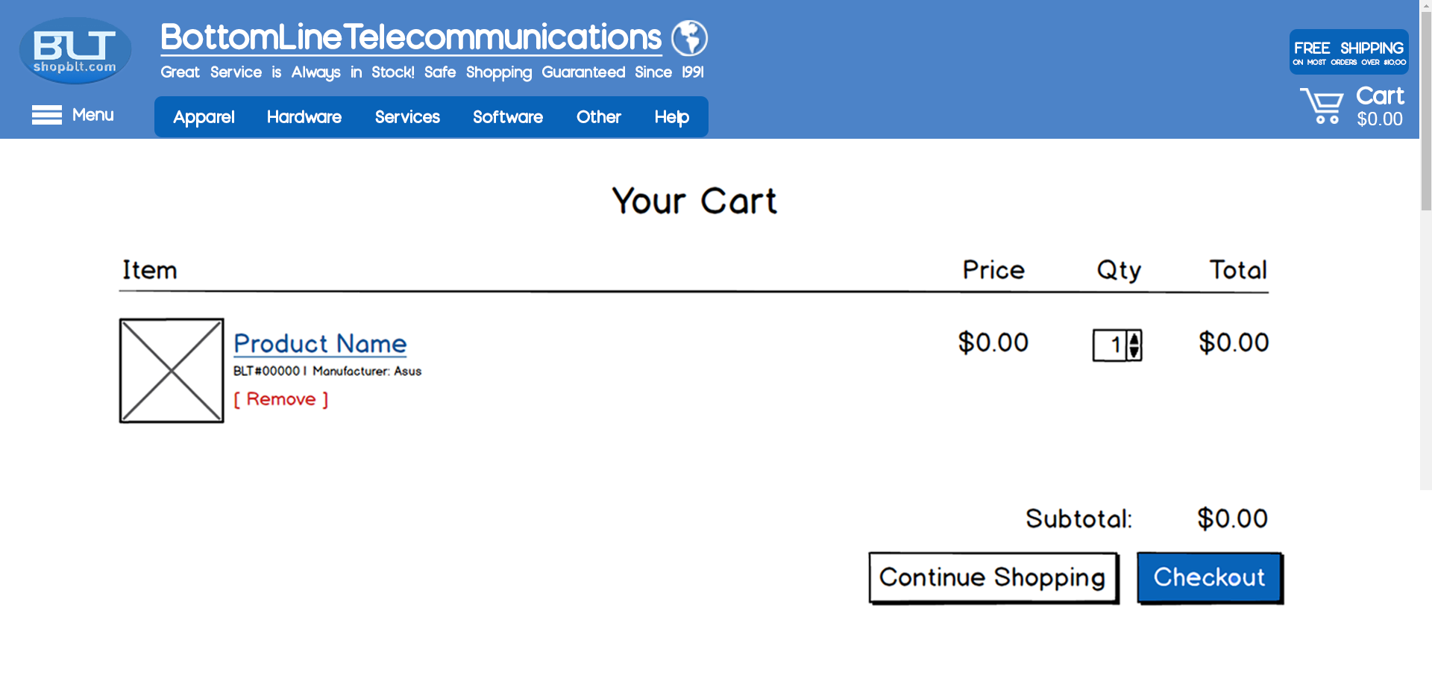

Figure E: High fidelity mockup of the **Cart** to improve **product checkout**.

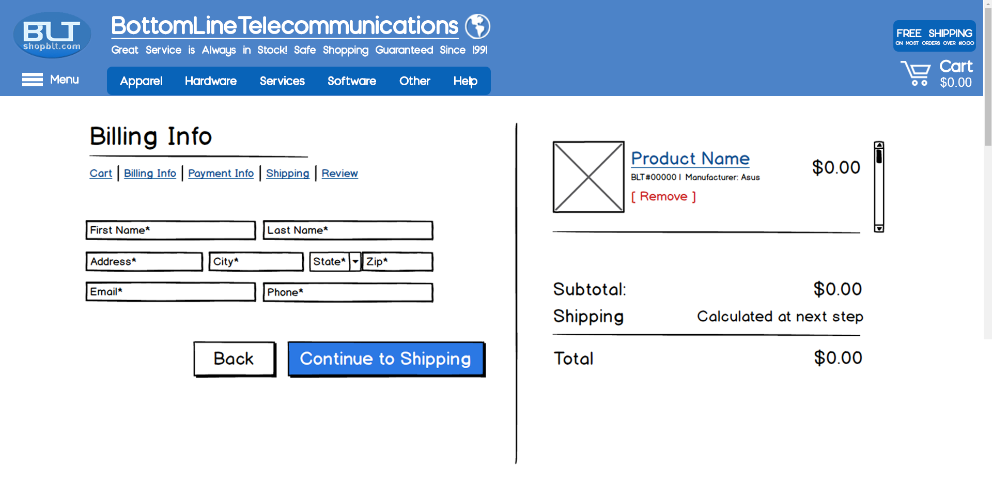

Figure F: High fidelity mockup of the **customer billing page** to improve **product checkout**.

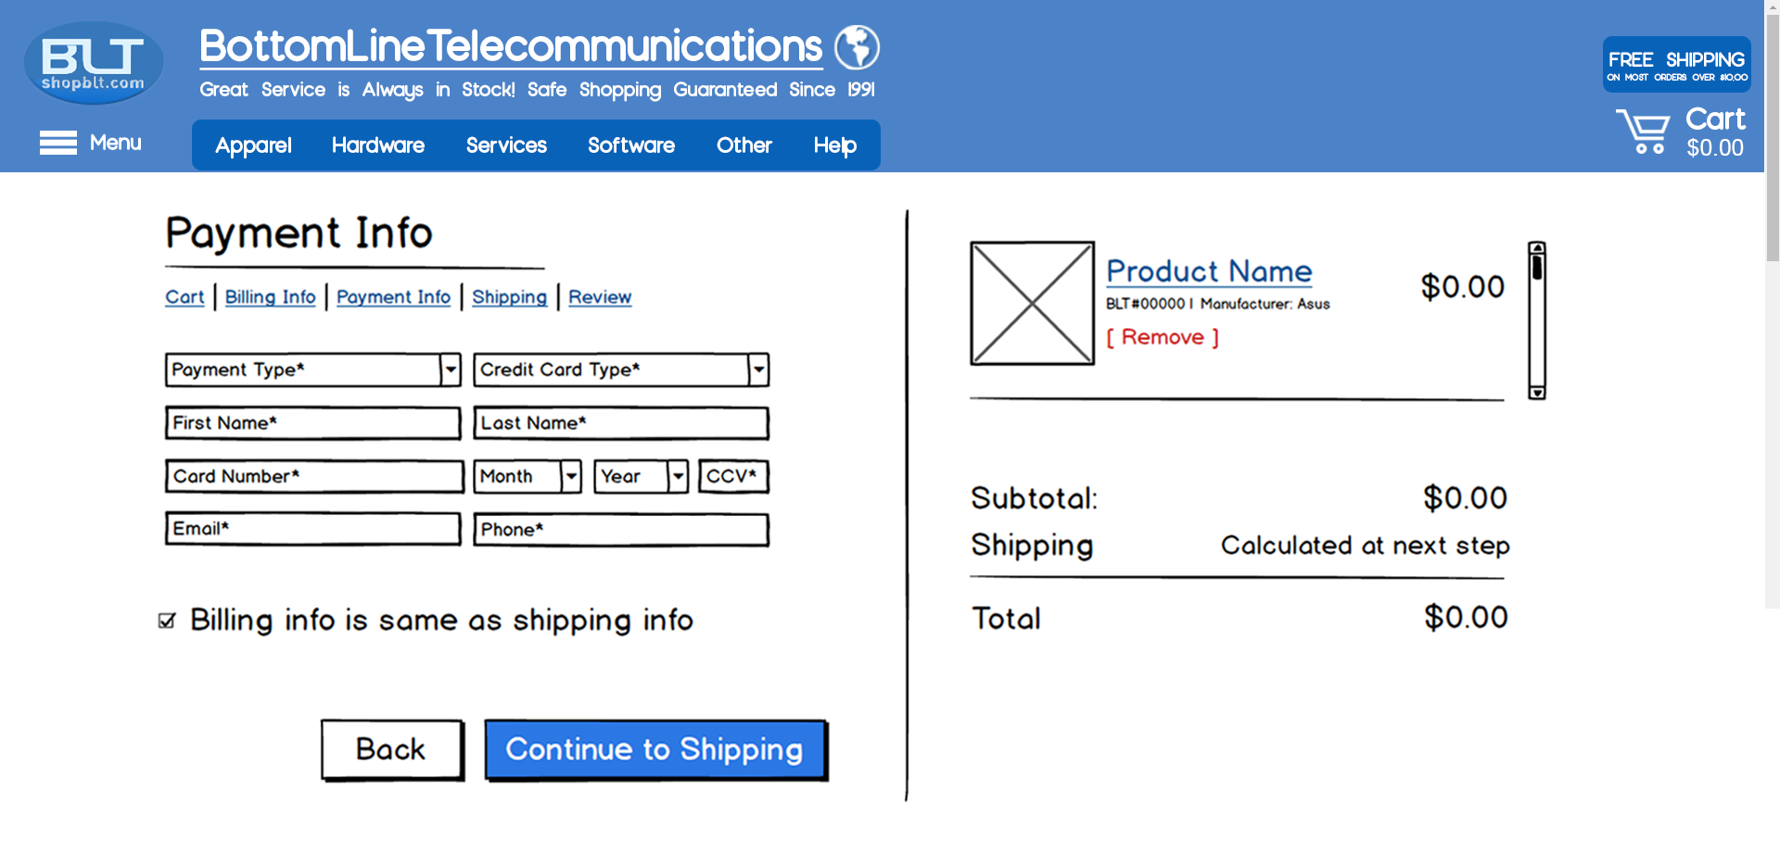

Figure G: High fidelity mockup of the **customer payment information page** to improve **product checkout**.

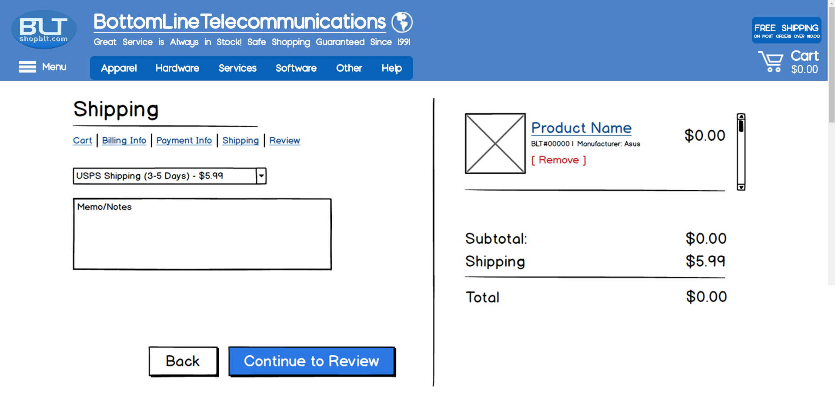

Figure H: High fidelity mockup of the **shipping page** to improve **product checkout**.

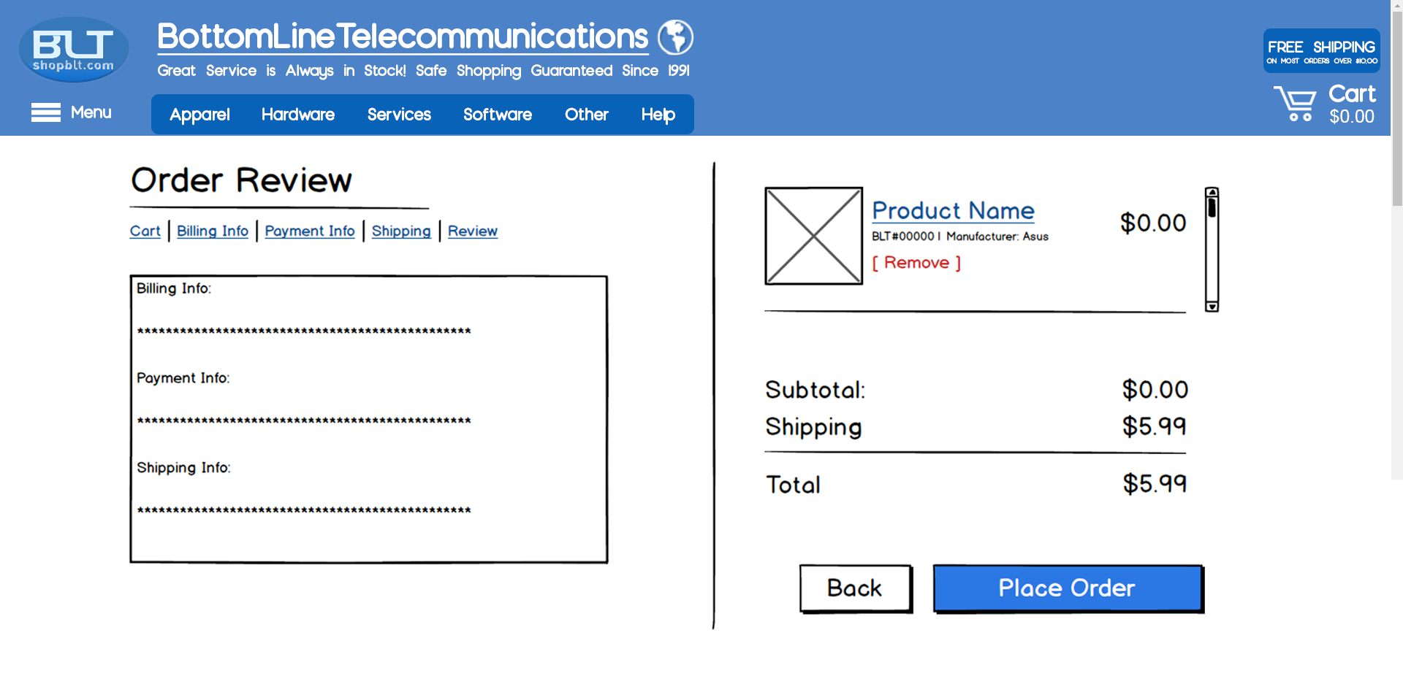

Figure I: High fidelity mockup of the **confirmation page** to improve **product checkout**.

## Design Documentation for Product Check Out

**Problem:** The current checkout process for shopBLT is out of date and takes the user through several pages that can be seen as redundant and unnecessary. When initially going to checkout, the user is overloaded with a plethora of information, some being unimportant or irrelevant to the user (ex. wait or the manufacturer number). Additionally, on the first page of checkout, the user is met with a secure checkout and regular checkout option. The secure checkout seems to be the first pick for most users but the issue is that these two buttons take the user to the same place - it does not make sense as to why both exist in the first place. After selecting one of these options, the user is taken into a page denoted for reading the terms of services. Most users will not care to read the terms of services, creating an extra page the user has to navigate through. Once the user advances forward, they next fill out the basic information such as shipping and billing information. However, in some cases, the user is forced to have an email that is not provided by a free email service such as Gmail or Yahoo. This is an issue since most common online shoppers use free common email websites. If a user is unable to successfully provide an email or does not have access to one, then they will feel obligated to leave the site and purchase the product elsewhere.

**Evidence:** Product checkout is one half of the ecommerce purchasing process. It is the second most important part of a user’s buying process, the first being product discovery. Since checking a product out and purchasing it is so important, we felt it was necessary to ensure the effective usability of this experience. Our new design pulls inspiration from simpler and newer checkout processes. We derived most of what needed to be changed from our Usability Tests, in which users were observed having trouble inserting predetermined data into the website’s current checkout process. We believe from expert analysis that purchasing a product should not take longer than 5 minutes. From our testing however, we saw that users consistently took longer than 5 minutes when attempting to insert information. We also saw from our findings that this problem could be due to a lack of accurate signifiers; users were slowly moving their cursors and found the next info box in a slow and steady manner.

**Process:** Most of our designs were very similar to the designs we have used in our own ecommerce experiences. The designs are reminiscent of Amazon, eBay, and PayPal checkouts. We all made multi-page designs, which required “Next” buttons in order to advance to the next step in the check out process. We eventually decided on this simplistic design, since it would provide a simpler checkout process while still leaving the site looking similar to the original. We also decided on adding different form boxes and less clutter. Instead of endless entry boxes, dropdown boxes and checkboxes are here. Instead of unnecessary text everywhere, we opted for a clean design with minimal typography. We found that dropdown boxes and text boxes were easier for our users to use rather than the radio buttons some of us drew in our original sketches. We also opted to keep our design with a product summary on the side at all times so the user knew what they were purchasing. We put our sketch designs on the left side and the summaries on the right.

**Results:** Our redesign attempts to split up the checkout process from a long scrolling page of information to a paginated design. Figures E-I show the logical process from first step in cart to last step of order review. Figure E shows the cart itself, which is simplified to show a picture of the item, the title, the BLT number, the manufacturer, the price, and the quantity. At the bottom, there is a continue shopping button, followed by the actual checkout button. Clicking the checkout button will take a user to Figure F, the Billing Info page. Here are entry boxes that are relevant to the billing of an item. On the right is the summary of the process, showing the same info as Figure E at all times. After clicking, “Continue to Shipping”, the user will be taken to Figure H, which is the Shipping page. This page contains different shipping options in a dropdown menu, along with a text box for memos or any other information for BLT managers to know about this shipment. This, we believe, helps cut down on superfluous text and options in the checkout process. Included as well are all of our relevant sketches, which display our thought processes during the storyboarding process.

## Search Bar

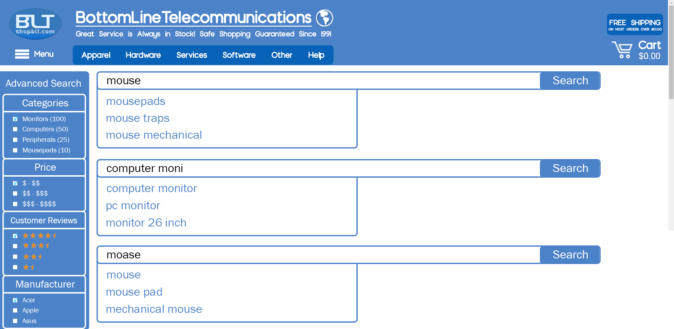

Figure J: High fidelity mockup of the **search logic** to improve the **search bar**. (Mostly relating to the logic of the search bar, we can see search attempt to guess what the customer is trying to put in the search bar for three different instances)

## 

## Design Documentation for Search Bar

**Problem:** The problem we found in the past assignments was the search bar algorithm—or rather lack of one. It was unable to understand anything besides exact keywords (i.e. “mousepads” would not turn up any results, but “mousepad” did). A potential customer could want to see what mousepad shopBLT offers and may put “mousepads” only to be met with no results. For a better user experience, we also wanted the search bar to show suggestions for multiple occasions: one such occasion is one where the user types in a word and the search bar shows related suggestions (i.e. “mouse” would return “mouse pad” and “mouse trap”). It is important to make the process as easy as possible so that the customer can quickly and easily purchase products. The other occasion would be when the user types in a query that has a spelling error. In this scenario, the search bar would show the suggestion “mouse” when the query would be “moose”. It is very helpful to account for misspelled words as even the most skilled spellers and keyboardists make mistakes.

**Evidence:** During our cognitive walkthrough, usability tasks, and general use of the website, we discovered that this issue could potentially turn away customers from buying a product simply because they did not give the exact query. We also wanted to attract more customers by making their user experience easier, therefore, offering them suggestions when they misspell a word and offering them suggestions of the most sought after items to help the user.

**Process:** We came to the conclusion that there was not really anything wrong with the search bar visually - only logic needed a redesign. Since we all agreed on its logic and with the guidance of Hillary and Professor Bietz, we all agreed to sketch out the logic of the search bar. When we all met with our sketches for the search bar logic, we were able to consolidate our ultimate sketch detailing its scenarios and how it catches errors. This ultimately enables customers to have an easier user experience and attract more business.

**Results:** Lastly, the new design accounts for the consolidated logic of the search bar created by the team. On the current website of shopBLT.com, the search bar does not have any form of error checking for the user. It also does not offer any suggestions to ease the user experience. The new search bar will account for simple queries such as recognizing “mousepads” as “mousepad”. It will also account for misspellings of queries as well, realizing “moose” as “mouse”. The logic for the search bar should also be able to do even both of those “moosepads” should return the result of “mousepad”.

# Heuristics Re-Evaluation

**Goal**:

The goal of this section is to provide our final collective re-evaluation of the system (shopBLT). For this section, we have broken down our individual assessments of the system grouped by each team member. We used Jakob Nielsen’s “Ten Usability Heuristics for User Interface Design,” to evaluate our efforts toward the redesign (as seen in the previous section).

The redesigns that our team members were conducting heuristic evaluations on were: 1) Customer Support and Contact Information, 2) Product Discovery, Visibility, and Listings, 3) Product Filtering, 4) Product Check Out, and 5) Search Bar. When conducting the evaluations, each team member scored the redesign on a scale from 1-10. Overall, our team collectively agreed that each redesign was considered either average or above average. Those that were considered above average were because the change from its original version to the redesign, made a huge difference in terms of user experience and interface design.

**Results:**

For the redesign on **Customer Support and Contact Information**, our team agreed that the layout of information from the previous version to the redesign was much better for users. The information was simplified and condensed for better visibility, and the users now had the capability of accessing information much quicker; there was no information overload. On top of that, our redesign changed the language of the webpage that created a more friendly and welcoming environment for users. We believed that since it is a customer support page, the system should wish to seek and help its users as much as possible.

For the redesign on **Product Discovery, Visibility, and Listings**, our team agreed that although we did redesign the web page to help with discovering and visualizing products, we didn’t consider other factors that could affect the system as a whole. We implemented two new features in the system, that are not so popular features as users are accustomed to seeing. The first is hovering over the product description for a more detailed layout of what the item is about, and the second is having a check mark or a cancel out sign to signify whether the product is in stock or not; these features, although seemed like a good idea at first, now seem like they can be a nuisance for users since they might need some training in order to understand what their purpose is. Also, when a user adds something to their cart and wish to remove it, they’re required to go to their actual shopping cart in order to remove it. They can’t remove it from the same page they added it. This might take at least a few pages of dialogue, not taking into account going back to the original page they were browsing through, which in turn frustrate some users. Overall, however, we still believe the redesign is a great improvement from where it used to be.

For the redesign on **Product Filtering**, our team agreed that we updated the filtering menu to fit more modern filtering menus, in order for users to be more familiar with it. With this new filtering menu the user is free to use individual filtering functions, as well as a combination of functions, to display a desired set of product listings. However, we failed to include a “clear all” function that returns the *initial* standard set of product listings from the original search query. The design restricts the user to follow through with the filtered products, and forces the user to perform a new query, or navigate back to a previous page to clear filters.

For the redesign on **Product Check Out**, our team agreed that this checkout process follows how most other websites do their checkout processes, therefore it’s easy for most users to understand what to do in each step. Each page during the checkout process outlines a simplistic process. The user must input information in order for the system to successfully process an order. The user is free to navigate back to any previous page to change: order information, billing information, shipping information, and payment information. Having these pages available for the user to navigate through, gives them control over the type of information they want to provide in the system. On top of that, the order page will keep information filled out in case a user needs to look back for reference.

For the redesign on the **Search Bar**, our team agreed that the concerning issue with the search bar was specifically the logic behind it. The UI aspect of the search bar had no faults since many users are familiar with a search bar, but the UX aspect did have faults since its algorithm was disrupting user experience. The added logic we provided for the search bar was a good addition, as it would help users find products faster. For instance, the search bar will now accommodate for misspellings of search queries by offering a suggestion of “did you mean X?”, and would also autofill with suggestions as users were typing the queries. The search bar would also register similar search queries, like “pc monitor” and “computer monitor” to prevent false negatives (stating that a product is not available when it actually is). One member also mentioned that to further help users it would be ideal to save past search queries, in order to assist users in terms of the heuristic “recognition rather than recall.”

# Conclusion

From the extensive testing and analyses we conducted over the course of the last ten weeks, our team was able to make several conclusions based on our findings. Our team conducted a competitive analysis, interviews, surveys, cognitive walkthroughs, user testing, wireframing, sketching, high-fidelity mockup creation, and heuristic evaluations.

For our first task, we worked on the collaboration plans (assigning particular roles, how often we will meet, communication strategies, etc). Ultimately, we decided on shopBLT.com for our redesign target. We wrote out basic details of the product (i.e. who runs it, what kind of organization it is, the type of customers it attracts, etc.) and conducted a competitive analysis, identifying the site’s direct and indirect competitors. For our next task, our team conducted user research to gain insights on the users of shopBLT.com. We conducted interviews and collected data from surveys to draw conclusions. We concluded that our hypothesis was true: our main users were males between the age of 20-40. We also concluded that shoppers who preferred online electronics shopping held a higher standard on product filtering and search bars.

For our next task, we conducted usability experiments and cognitive walkthroughs to identify key usability issues within shopBLT.com. Our findings highlighted product discovery and product identification as to areas of the website that needed the most work. Our testers noted that product images, usable product listings, and a friendly search bar were important aspects that were absent in the current design. They also identified that the checkout process could use a definite redesign as well. For our next task, we came up with five design targets: Search Bar, Product Discovery, Visibility, and Listings, Product Filtering, Product Checkout, and Contact Information & Customer Support. We then individually created sketches for each of them and then consolidated them into high-fidelity mockups and wrote up design documentation for each of them. For our final task, we used Jakob Nielsen’s “Ten Usability Heuristics for User Interface Design” to re-evaluate our final designs in a heuristic evaluation. We then used the WebAIM (Level A) checklist to conduct an evaluation of the original shopBLT.com.

From our cumulative findings, our team can conclude that our redesigns would improve the usability of shopBLT.com. Our extensive testing and experiments can back up the logic behind each of our redesign targets. The goal of this usability project was to not only redesign shopBLT.com, but have that redesign make sense and be practical in a real world setting. We believe that if BottomLineTelecommunications was to implement these changes into their website, a broader market would be more attracted to using the site, and of course, make purchases using the platform.

# Appendix:

## Accessibility Evaluation Report

The accessibility of shopBLT covers most if not all of the *relevant* success criteria, based on those found in the WebAIM (Level A) collection. Our team performed the accessibility evaluation using several different methods to ensure complete coverage of the success criteria. For simpler dimensions, we performed a face-value evaluation in which we used a two laptop computers for side by side comparisons to see how the system faired on different browsers. The evaluation we performed evaluated dimensions that can be assessed visually with basic input controls and tools. Basic hovering techniques were used to expose alternative text for buttons, images (for those that were present), and frames. The site’s navigational competency was also tested using a keyboard as the navigational tool to assess dimensions such as “Keyboard” and “No Keyboard Trap”. For dimensions that relate to the operational capacity on mobile devices like “Pointer Gestures” and “Meaningful Sequence” we used both the iPhone and Android assistive voice-over technology to assess the usability. Given most of the information on the website is text based, with those images that exists possessing alternative text, the success criteria for “Meaningful Sequence” were satisfied. We tested this in the product listings, contact information, and frequently asked questions pages. Dimensions relating to time based media, audio and visual media, bypass blocks, and physical reactions (flashing and seizures) were not applicable to our evaluation as the site did not possess any elements relevant to these dimensions. Finally, for more complex criteria, we used the browser’s inspect method to compare the implementation of the site’s structure and markup to WebAIM’s recommendations.

For categories that perhaps may need some more attention, we found: “Parsing”, “Name, Role, Value”, and “Error Identification” to be the only dimensions that can be improved upon. While “Parsing’ and “Name, Role, Value” related primarily to the site’s implementation, “Error Identification” is pertinent to the user’s experience. The site successfully implements form validation, but relies on the assumption that the user knows specifically how much information to provide in various text fields. Providing descriptions and further information for users less familiar with standard text forms would improve the accessibility and promote error identification and recovery.

Our team’s consensus is such that the website fares favorably in comparison to other systems, with an overall rating of nine out of ten (9/10). We recommend that you (the developer) research more into compatibility (guideline 4.1) section of WebAIM’s heuristics to avoid parsing errors and to promote the accessibility of your use of Markup.

## Individual Heuristic Evaluations

### 

### Alonso De La Torre Vega

**Customer Support and Contact Information (9/10)**

* Visibility of system status:
  + Our redesign does good in giving the user feedback on the status of the system. When a user clicks on the “Help” link, they get redirected to a new page that’s titled “Contact Information.”
* Match between system and the real world:
  + We made an improvement on the language provided in the customer support page, where the user can feel more welcomed and inviting. The previous language made it seem like providing help to the customer was a tedious task they didn’t want to deal with.
* User control and freedom:
  + The system already did a good job of making sure the user had the option of undoing their actions. The back button is provided on the page, allowing the user to undo their mistake if necessary.
* Consistency and standards:
  + Our redesign does very well in following regular standards, such as headers, bullet points, English language reading from left to right, and clickable links for more information.
* Error prevention:
  + Our redesign did good at not creating errors for the users in the first place. The help tab will take them straight to the “Contact Information” page and the user will be able to get the assistance they need.
* Recognition rather than recall:
  + Our redesign focused on condensing the information the original version provided, and making the context more readable and friendly. Thus our redesign did good at allowing the user to read with ease and not have an overload of information, allowing them to recognize more than to recall.
* Flexibility and efficiency of use:
  + The accelerator for this redesign, in this case, can be the fact that there’s a help tab easily reachable from any page. It’s accessible to both experienced and novice users.
* Help users recognize, diagnose, and recover from errors:
  + Our redesign didn’t really focus on this aspect of the system, but in the case that it did, it would follow the protocol of the other system aspects and display clear error messages when needed.
* Help and documentation:
  + The help documentation is this page, therefore I would say our redesign did a good job of providing the help users need.

**Product Discovery, Visibility, and Listings (7.5/10)**

* Visibility of system status:
  + The system does good in displaying feedback to the user, as far as actions done by the user goes. When a user clicks a tab the system responds with a menu, when a user clicks an item the system loads a new page with the product information; it does good at keeping the user informed about the system status.
* Match between system and the real world:
  + As far as typical terms, like “Add to Cart” and “Check Out” go, the website does a decent job to allow the user to purchase an item. And the website does good by providing the information in English, reading from left to right. The actual content of the website, however, has technical jargon that only some people will understand and know what they’re looking for.
* User control and freedom:
  + As far as undoing a mistake, the website does good by supporting the back button of the webpage and reversing user mistakes. Users are able to go back and forth between different product listings.
* Consistency and standards:
  + Although some terminology about the product categories can be unorthodox, the consistency and standards it follows compared to other e-commerce sites is good. The layout of elements on the website, such as the category tabs, the shopping cart, the search bar, etc., allows for users to be familiar with the site. They know to find the shopping cart at the top right corner of the page, or to find the category tabs along the top/left side of the page.
* Error prevention:
  + Product discovery through the logic of the search bar, has been improved so that a user can’t easily make a mistake and not find what they’re looking for. When it comes to product listings, the system already did a good job of displaying options and having that list error-free.
* Recognition rather than recall:
  + The system already does good at making objects visible for the user, and not having the user remember a lot of information. Recognition has been even further improved by making more information visible to the user.
* Flexibility and efficiency of use:
  + An accelerator from our redesign can be the quick access of product information when a user clicks the product link; this can be catered by both novice and experienced users. There aren’t any accelerators that are explicitly for experienced users only.
* Help users recognize, diagnose, and recover from errors:
  + The system already does well in helping users recognize errors, with good error messages that are in English and to the point. It also lets them know what they need to do in order to continue.
* Help and documentation:
  + Our redesign didn’t really focus on the aspect of providing help documentation to users, but in general the website has its own help documentation that is extensively informative.

**Product Filtering (9/10)**

* Visibility of system status:
  + Our redesign of the product filtering menu does a good job of providing feedback to the user when they click on an option. Everything from checkboxes to radio buttons, the user will know an action has occurred because the system will send feedback by showing a check mark in the selection they made.
* Match between system and the real world:
  + The language we use on our redesign is a huge improvement from the previous one. Users are now more familiar with the filtering options and the phrases used are more common.
* User control and freedom:
  + The redesign does good with allowing the user to pick and choose any options they desire to have. With this any option a user didn’t wish to select, a mistake, can easily be undone by simply checking the option. Users have the freedom to choose as they please.
* Consistency and standards:
  + Our redesign does well in staying with the standards that other e-commerce websites have. Users are familiar with the rectangular box, split up into different sections, for the users to select options from.
* Error prevention:
  + Our redesign focused on the layout and wording of the menu, in order to move away from the original design that caused errors. The logic and confusion behind the original has now been improved to reduce the amount of errors it had in the first place.
* Recognition rather than recall:
  + Our redesign does well in providing information that’s recognizable for the user, such as categories and manufacturer names. The user simply has to know what they’re looking for, and the menu will provide it for them; they don’t have to recall specific information.
* Flexibility and efficiency of use:
  + The filtering menu itself is an accelerator for both novice and experienced users, that allows for quicker searching within the site. Instead of having to do extensive searching within the site, the filtering menu can condense information for the user to select from.
* Help users recognize, diagnose, and recover from errors:
  + Although our redesign didn’t really focus on this aspect of the system, in the case an error did happen in the filtering menu, the menu would prompt the user with a message on what they should do to fix the issue.
* Help and documentation:
  + Our redesign didn’t focus on this aspect of the system that much, but its implementation is pretty straightforward. In the case the user can’t figure something out, they can go to the help document provided by the system already.

**Product Check Out: (9/10)**

* Visibility of system status:
  + The system already did a good job of providing feedback to the user, but our redesign made sure the feedback was much more visible; from clicking text fields to clicking buttons, every action was certified with some sort of feedback for the user to be sure their actions did something.
* Match between system and the real world:
  + Our redesign did good on making sure the information provided to the user is readable and understandable. It uses language that users are familiar with, such as big headers and phrases that are commonly used in other e-commerce sites.
* User control and freedom:
  + Our redesign, like the original, supports the back button on the page just in case a user makes a mistake. They can go back a page if they change their mind about a product or choose to leave the page entirely and go to the main menu.
* Consistency and standards:
  + We improved the system by making the placement of information follow standards more closely. Users are accustomed to having clear signifers on the price of a product, as well as the subtotal of the product. The placement of shipping and payment info also follows standard placement, as if users were handwriting the information.
* Error prevention:
  + When a user mistakenly adds a product to their cart, the system clearly shows a “Remove” button that will allow the user to delete the product from their shopping cart. They can also use the back button if they wish to fix information previously inputted on the other pages.
* Recognition rather than recall:
  + Our redesign focused on making sure the user never had to doubt how much the subtotal of a product would be. On every page, the product information follows the user, until they’re ready to pay. Hints in the text fields also allow the user to know what information is required in the box.
* Flexibility and efficiency of use:
  + Our redesign didn’t really provide accelerators in the sense that it will make processes go faster. It was meant to help users fill out everything necessary as efficient as possible, by providing text fields that are easy to follow. I believe it did good on catering for both novice and experienced users.
* Help users recognize, diagnose, and recover from errors:
  + Our redesign has required text fields, so if the user makes a mistake there will be pop up messages notifying the user of what missing information they need to input in order continue. Our redesign did good in this aspect.
* Help and documentation:
  + Our redesign didn’t really focus on this aspect of the system. Much of the redesign is meant to be straightforward for the user to know what they need to do. But just in case a user needs help they can seek the original website’s help documentation.

**Search Bar (9/10)**

* Visibility of system status:
  + Our redesign did a huge improvement on providing the user feedback by allowing the user to see recommendations made by the search bar. When a user is giving input in the text field of the search bar, the search bar responds with a drop down menu of plausible items the user might be looking for. This allows the user to verify their actions on the system.
* Match between system and the real world:
  + Our redesign does well in providing language that users can understand. This is part of the design aspect we were aiming for, where we help users figure out what they are looking for with suggestions and corrected phrases on the inputted search queries.
* User control and freedom:
  + Our redesign, like the original version provides the back button for the user to press when they have made a mistake. They can also choose to delete the original search query and input a different one if they wish to.
* Consistency and standards:
  + Our improved logic of the search bar now follows closer standards to that of other e-commerce websites. Users recognize the long text field at the top of the webpage, and the search bar icon (magnifying glass) next to the text field. Users also recognize the suggestions/auto-correct phrases from the drop down menu.
* Error prevention:
  + The logic of the search bar has been improved so that a user can’t easily make a mistake and not find what they’re looking for. Before, a user can make an incorrect search query and have to believe that the website didn’t carry that product, now the website provides word-corrections and asks the user to verify if that’s what they were looking for.
* Recognition rather than recall:
  + Once again, our redesign improved on the logic of the search bar by providing users suggestion and auto-corrections on search queries, therefore improving the recognition of product results. Users don’t have to spend too much time recalling information they can’t remember.
* Flexibility and efficiency of use:
  + Our redesign of the search bar does good in efficiency by providing the user the suggestions and auto-corrections. This makes it the accelerator of the system, since it’s meant to help both novice and experienced users of the website.
* Help users recognize, diagnose, and recover from errors:
  + In the case that the user does not input a search query, the system will provide an error message letting the user know that they need to input a search query in order to get results. Our redesign does well at handling this situation.
* Help and documentation:
  + Our redesign didn’t really focus on the help documentation of this aspect of the system, but rather improve the logic through presentation. The user can look for guidance through the help tab on the original website.

### Matthew Morales

**Customer Support and Contact Information (8/10)**

* Visibility of system status:
  + The site provides static pages with text-based content providing instructions for finding information regarding the service and product orders. When a resource is found and used to navigate to information, it is clear to the user that new content is presented. There is a visible transition that re-orients the user’s position within the sitemap of customer support information.
* Match between system and the real world:
  + The labels for information were not changed from their initial state. The terminology used within the current system is accessible to users from a non-technical background, as the purpose of the customer information page is to provide clear and direct access to relevant content to the customer (order based information).
* User control and freedom:
  + The redesign restructures the navigation tools provided to the user in the form of hyperlinks. Clear signals are provided in a consistent format to indicate action can be taken that will direct the user to another page. All of the links are clearly labelled and the context surrounding each link gives the users clues as to where the link will take them.
* Consistency and standards:
  + For the page that we redesigned, and consequently all related pages, we used the same hyperlink framing for text as most other systems. All links are labelled with terms such as “here” (as in “click here”) and are outlined in blue text with an underline. This follows the same textual formatting to indicate to the user that a link is available to use to navigate to more information.
* Error prevention:
  + We did not decide on implementation for error prevention. The initial design of the site does not establish a dialogue with the user nor does the redesign. Error prevention could be implemented in the form of a “sanity-check” when a user clicks on a link (in the form of a confirmation box). This would give the user a chance to stop and confirm whether the user would like to navigate away from the current page or stay where they are.
* Recognition rather than recall:
  + There are several kinds of information in the customer service section of the site, the redesign organizes the information present into relevant categories pertaining to orders that have already been made, and orders that have yet to be made (or information for before you order).
* Flexibility and efficiency of use:
  + Hyperlinks are provided to help streamline the navigation process, clearly indicating the intended destination for each link. The context of each link gives the user some clue as to what to expect should a user follow through. Shortcuts and macros are not available, nor does the site provide tools to expert users to allow for greater scale and efficiency of use.
* Help users recognize, diagnose, and recover from errors:
  + The design is already responsive in terms of displaying information to communicate the current state of the system. Although there is no error prevention, there is not many opportunities for the user to encounter an error, other navigating away from their current page by mistake. In such a case, the user’s browser possesses tools that allow recovery from such mistakes.
* Help and documentation:
  + The site provides comprehensive documentation regarding resources for information pertaining to the company’s service. Although the system is not complex, there is very little in the way of documentation or help for technical issues or tips for the tools provided.

**Product Discovery, Visibility, and Listings (7/10)**

* Visibility of system status:
  + When a search is made, a clear transition via page refresh is made and product listings are displayed in the form of a linear set of products that run down the page. The images provided for all products can be interacted with. When an image is clicked on, it is expanded, and the user can observe the shift in size relative to the rest of the page. Tools used in product discovery such as side scrolling discovery feeds update the list of products displayed each time a user cycles through the list.
* Match between system and the real world:
  + The product listings use familiar wording to refer to objects relevant to the user’s experience. Actions like “add to cart” and “view cart” are familiar to users who have used other systems developed by shopBLT’s competitors. The product discovery feed runs from left to right which follows the same reading pattern for those who live in the United States (where most of shopBLT’s user traffic originates).
* User control and freedom:
  + The user is free to sort and organize product listings, expand and minimize images, and scan through and view information on products in the product discovery feed. Elements contained in these sections of the design target do not provide much in the way of interactivity.
* Consistency and standards:
  + Standard terms are used to describe different types of objects the system uses to convey information to the user/customer. Words like “shopping cart” and “price” are consistent with the user’s mental model of a marketplace, indicating the purpose of certain tools and icons. A shopping cart is used to represent the customer’s purchasing inventory, and product information reads left to right beginning with the image, followed by the description, and ended with the price which is consistent with most system models in the competitive domain.
* Error prevention:
  + Confirmation messages were not implemented in the redesign nor were they present in the initial design. There is no error prevention for the current state of this design target.
* Recognition rather than recall:
  + Users recognize products and product related information. Additionally, information pertaining to the tools used to manipulate product listings and visibility are provided in a standard interactive manner (clicking to enlarge and sorting results).
* Flexibility and efficiency of use:
  + Additional tools and functionality were not implemented to allow the customer streamlined use. We could have implemented a “popular for you section” that would cater to the user’s activity. A “single click checkout” option for faster check out processing.
* Help users recognize, diagnose, and recover from errors:
  + Signals are not provided for recognizing when errors occur. The opportunity to perform an action that results in an error is minimal. Most of the information pertaining to this design target was purely aesthetic, and does not pertain to an real functionality.
* Help and documentation:
  + There is no documentation for the redesign in terms of product discovery or product visibility. What we could have done was provided alternative text for images provided after a search, in the product listings.

**Product Filtering (8/10)**

* Visibility of system status:
  + Similar to most other pages on shopBLT’s website, product listings, before filtering functions have been initiated, are static. Once the user has applied the desired filters, the page refreshes and new, more narrow listings are presented. The system makes visible the system state before and after and a clear distinction is made during the transition from one set of listings to another.
* Match between system and the real world:
  + The system uses standard terms and labels that most users of e-commerce websites, or web-based ordering services would be familiar with.
* User control and freedom:
  + The user is free to use individual filtering functions as well as a combination of functions to display a desired set of product listings. What we failed to include was a “clear all” function that returns the (initial) standard set of product listings that appear as a result of a search query. The design restricts the user to following through with the filtered products, and forces the user to perform a new query, or navigate back to a previous page to clear filters.
* Consistency and standards:
  + The filtering functions have clear affordances, signaling what a particular filter will do. These functions are labelled with standard names. Users of competitor websites will be able to predict the behavior of the system if price-based filtering were to occur (or manufacturer based, customer review based, etc.). Furthermore, other signals are provided. The icons used to demonstrate the range of customer reviews for a particular product are consistent with competitors (the use of stars is used in other industries aside from e-commerce, such as hotel or boarding services).
* Error prevention:
  + The redesign of the filtering mechanisms does not provide preventative measures to reduce errors. Should the user use an invalid input for the price-based filtering function the system will redirect the user to an empty page with no search results.
* Recognition rather than recall:
  + Keywords regarding the purpose of each button (or filter) are easily recognized given the consistency with standard presentation. Signals like text-entry boxes are used to provide hints as to what action needs to be performed in order to complete the requirements for specific filters such as filtering by price. Users may recognize the consistency with a competitor’s interface (such as Amazon), as our redesign is heavily influenced on other kinds of systems.
* Flexibility and efficiency of use:
  + Multiple filters can be applied to further reduce and narrow the search results per the user’s specifications. Filter functions follow the free-flowing page as the user scrolls through product listings to improve efficiency of use.
* Help users recognize, diagnose, and recover from errors:
  + The redesign does not account for invalid input for the price-based filtering function. What we could have done is provide feedback to the user before the filter is applied so they recognize that letters are not accepted as valid input. This would help the user recover from receiving an empty page with no search results. Alternatively, a page that is presented as a result of invalid input could be displayed communicating that the input was invalid, explaining the empty search results.
* Help and documentation:
  + The assumption our team worked under while redesigning the filtering functions was such that the consistency of standard organization and structure of the filtering functions would be familiar to most users who shop online. This falls in-line with the user research we conducted and thusly our redesign catered to this population. Documentation was not found to be necessary for these tools as we assumed they would be straight forward.

**Product Check Out: (9/10)**

* Visibility of system status:
  + The checkout process consists of three pages. Each page consists of fields that must be completed in order to progress through the checkout process. If inadequate information is provided the system will not transition into the next state, rather it will indicate that the user has not progressed and there are steps that need to be taken in order for the user to move on.
* Match between system and the real world:
  + Each page during the checkout process outlines a simplistic process for information to be provided by the user in order for the system to successfully process an order. Terms like, “billing” and “shipping” are user-oriented and are accessible to those who are familiar to the e-commerce layout.
* User control and freedom:
  + While the system navigates the user to the next step in the sequence of pages throughout the checkout process, the user is free to navigate back to any previous page to change, order information, billing information, shipping, information, and payment information. Having these pages available for the user to navigate to gives the user control over the type of information they want to provide to the system.
* Consistency and standards:
  + The pages that make up the checkout process use standard text entry fields that receive relevant customer information and consolidate them to successfully process the user’s request for a purchase order. These text fields are used by many other competitors in the e-commerce marketplace (such as: Amazon, eBay, and NewEgg).
* Error prevention:
  + Signals are used during the checkout process to indicate whether a user has entered adequate or complete valid information. If the requirements are not met, the entry boxes are highlighted in red and the user is prompted with a note explaining what is considered valid input.
* Recognition rather than recall:
  + The similar and consistent layout of the text entry fields on each page resemble that of similar others in the e-commerce domain. Users will recognize these pages as having a specific purpose (to acquire customer information to place an order). Instructions for this process are not needed but are provided. User’s can clearly identify what the appropriate actions are to complete the checkout process.
* Flexibility and efficiency of use:
  + A check box is provided to streamline this checkout process. The check box’s purpose is to use the same billing address information for the shipping, eliminating the need for the user to enter that information in twice. Additionally, what we could have done was adopted Amazon’s “one click checkout” which uses information saved from previous purchases to improve the efficiency of this system.
* Help users recognize, diagnose, and recover from errors:
  + Signals are used during the checkout process to indicate whether a user has entered adequate or complete valid information. If the requirements are not met, the entry boxes are highlighted in red and the user is prompted with a note explaining what is considered valid input.
* Help and documentation:
  + Information pertaining to question about the checkout process, or post-checkout process is located in the customer service section of the website, and the F.A.Q. section as well. Using both pages will provide a comprehensive set of information to answer any relevant customer inquiries. Additionally, the customers can always contact the business directly.

**Search Bar (10/10)**

* Visibility of system status:
  + The redesign improves the visibility of system status while the search bar is in use. While the initial system design and our team’s redesign both incorporate an indication of transitioning from a complete query to a set of product listings, the redesign also informs the user of live text processing to show the system’s interpretation of the query.
* Match between system and the real world:
  + The magnifying glass give the user an idea of the purpose of the search bar, as magnifying glasses are used to look through finer grained details, the search bar narrows down the site’s inventory to display a small subset of the products for a user to focus on.
* User control and freedom:
  + Although typeahead and reinterpretation of misspelled queries provides the user with additional error prevention the user is free to ignore these tools and enter a query that they have come up with. Perhaps the system has not been programmed to interpret a particular kind of query, yet the user would still like to perform it, they have that opportunity.
* Consistency and standards:
  + The search bar’s positioning and icon are consistent with the standards of other e-commerce services (see Amazon, eBay, NewEgg, etc.).
* Error prevention:
  + Misspelled and broad ambiguous queries are now parsed correctly by the system. This feature in the redesign prevents false negatives (stating that a product is not available when it actually is) from occurring. The system can now interpret a broader range of queries which improves the user experience because it is now more inclusive of individuals shopping for electronics who do not enough domain knowledge to form a coherent/specific query.
* Recognition rather than recall:
  + The search bar’s positioning at the top of the page is familiar to users from an online shopping background. The magnifying glass icon in the search bar indicates the text field is special and accepts search queries to fetch product listings.
* Flexibility and efficiency of use:
  + When a user performs a search query, the system shows the user a drop-down menu with typeahead predictions of the complete query based on its interpretation of the user’s partial query.
* Help users recognize, diagnose, and recover from errors:
  + The redesign of the search bar includes improved text processing and query interpretation that accounts for misspelled and ambiguous queries. An approach to misspelled queries that we took was using the “did you mean X?” prompt subsequent to a misspelled query. This accounts for user error and helps the user recover by providing an accurate interpretation of the query, reducing the need for users to perform spell checks, backtracking, and searching for domain terminology for product descriptions.
* Help and documentation:
  + While tools for improving the usability of the search a have now been implemented in the redesign, no documentation was provided for the redesign, nor is there documentation to help the user through the searching process.

### Phillip Nguyen

**Customer Support and Contact Information (10/10)**

* Visibility of system status:
  + The most frequently asked questions are in here. Aside from answering basic questions, the page has multiple hyperlinks: one hyperlink is too see the status of orders/order history, one for information regarding returns, one for product availability, one for a pricing quote, and one for shipping questions. If the user is not satisfied, they could search in the FAQ.
* Match between system and the real world:
  + This does not use any difficult language or technical jargon. This is as standard as any other FAQ page one would find on an e-commerce website. The outline of the text is organized in a way to make it easier for the user to read; (i.e. bigger text and then underneath that, bullet points for questions).
* User control and freedom:
  + The user has full control to go to any other page just like the home page. The user could use the back buttons to do so. The user also has access to multiple hyperlinks for specific inquiries and the option to look at the FAQ if the user is not satisfied. Upon using the hyperlinks, the user could also back out of those if they wish.
* Consistency and standards:
  + Overall the language used in this consistent and easy to understand. There is no technical jargon and the multiple hyperlinks correspond to different things and that is clearly highlighted.
* Error prevention:
  + If the user got to this page by accident, the user has the option to use the browser back button to back out of the page and go to the page before. The hyperlinks to the other information pages are not close to each other, so it is highly unlikely that the user would click one hyperlink thinking it was the other and if that was the case, the user could also use the back browser button.
* Recognition rather than recall:
  + The information is laid out so that it is easy for the user to take in. The website specifies the page is the most frequent questions on the page and uses large and smaller text as well. The bullet points (smaller text) highlight the questions and the larger text denotes what area of question it is trying to answer.
* Flexibility and efficiency of use:
  + The page is good in that it does not try to answer too many questions at once and is flexible in that it has links leading to other pages that can answer more specific questions. More experienced users can also call in or e-mail if they have a very specific question or prefer interacting with a customer service representative. Methods of communication include e-mail, phone, direct mail and FAX.
* Help users recognize, diagnose, and recover from errors:
  + Whatever the user is seeing this page from, the native browser/client has a back button that can help the user recover if they click on a wrong page. This page is also outlined and clear to see the text to denote what type of information the user is currently seeing.
* Help and documentation:
  + This page is the very essence of help and documentation. Included are multiple mediums to get information: from sending in an e-mail to calling to self-diagnosing for help. This page also leads to other pages that also answer more specific questions as well.

**Product Discovery, Visibility, and Listings (8/10)**

* Visibility of system status:
  + The cart shows the value of all the items at the present moment. The page clearly states 1) the number of results and 2) specifically what the user typed in to amass the results. The product is aside important information such as price, product details such as manufacturer and others. It also shows whether or not the item is in stock. The page also shows a scroller for new releases and what is popular right now.
* Match between system and the real world:
  + The page has a lot of the similar phrasing as any other e-commerce website. A virtual shopping cart, “new releases” and “popular right now” are all terms that first-hand shoppers would even recognize. “Back in stock” and “best sellers” are also phrases that consumers are aware of. Overall, none of the page has any difficult jargon that consumers would struggle with.
* User control and freedom:
  + The user has the option to scroll up and down the listings on the page. If for some reason the user is looking at a particular product on new releases and loses track because the user clicked on the left/right arrow, the user has the option to click the opposite arrow and get back to the product the user was looking at. If the user accidentally clicks on a product and wishes to go back, the user can use the browser back button.
* Consistency and standards:
  + This is indeed consistent. There are no words that mean something else in a different area of the page. The BLT item numbers would have different numbers as well. The formatting is easy to understand is consistent but none of the words would throw the user off at all.
* Error prevention:
  + Users will have no trouble accidentally adding anything and if they do, they can take it out later. When looking at the slider for some of the products, if a user accidentally clicks right or left, they could do the opposite and get back to the panel they were looking at before. The back button is important if the user clicks on something they did not want to do. Users cannot also add out of stock items and that is clearly displayed.
* Recognition rather than recall: *****
  + The items presented are mainly pictures and some text, users do not have to remember anything or have any sort of memory load on them. Everything on the page is clearly outlined. *Perhaps we should add a page number as well so that the user could know.* Aside from the page number, everything else is mostly present.
* Flexibility and efficiency of use:
  + There is good flexibility and users also have the option to further sort their items out if they want to see certain brands and the manufacturer. If the user wishes to see other products that they did not specifically seek out, the could check in multiple areas such as “back in stock”, “best sellers”, “new releases”, and “popular right now”.
* Help users recognize, diagnose, and recover from errors: *****
  + Users have the back bottom and nothing they do here is permanent. It is best to have a page number just in case users divert from the page they were looking at. Aside from that, the page clearly shows if an item is out of stock and will not allow users to add such items.
* Help and documentation:
  + There is a help button right there at the top in the middle but mostly everything is self-explanatory. If the user is having trouble navigating such page even though the page is clearly laid out. The user could click the help button and talk to a representative who would help the user expedite the process and help them find whatever it is they were looking for.

**Product Filtering (9/10)**

* Visibility of system status:
  + Yes, the radio buttons show what is selected. The checkboxes show what is checked or not checked. The prices, “min” and “max” would have numbers if the user had typed them in. Also to add to all of this, the page would update as soon as the user made any changes to this.
* Match between system and the real world:
  + Aside from using very simple abbreviations that most people understand (i.e. “min” for “minimum” & “max” for “maximum”), the language is very easy to understand. This section would require the user to understand exactly what a “peripheral” or “mousepad” is, aside from that, this language is as easy as it can get.
* User control and freedom:
  + Users can select and unselect options. The user has the ability to put in a minimum and maximum price, the option to sort it by reviews, the option to see categories, sort it by ascending or descending price, the option to select by manufacturer, and the option to see relevant categories based on what the user has been looking at.
* Consistency and standards: *****
  + Apart from everything on the page being unique (i.e. the ability to sort by prices, customer reviews, categories, relevant categories, and manufacturers). The outline is consistent except the radio button to select ascending from descending and using checkboxes. Selection by price should be a radio button rather than a checkbox because it wouldn’t make sense to have a listing that is both ascending and descending at the same time.
* Error prevention:
  + The page would load as soon as an option is selected so the user gets instant feedback and if the user does not like it, the user can select something else or revert back to what the previous options were. The errors that would come up with this page could be easily fixed by doing the opposite. The sections of how the user could sort it by are distanced far enough so that the user would most likely not make an error that way.
* Recognition rather than recall:
  + Everything here is laid out for the user and does not have to spend time remembering anything. The user can see what is selected and what is not selected. Quite practically, the user does not have to remember much on this page.
* Flexibility and efficiency of use:
  + The user does not have to further break down the search, the user can just see all of the items without any preferences. The checkboxes at a first instance are all unchecked and the user may have the option to select some of the checkboxes. The radio buttons are always going to have a default option. The users have the option to play around with all these settings until they have the options that they want.
* Help users recognize, diagnose, and recover from errors:
  + There is very little to worry about when it comes to errors. If the user selects something that they did not want in the first place, they may be able to simply just unselect it. The settings clearly display what is currently selected and the user is notified since the page changes based on the selection.
* Help and documentation:
  + The filters for the page searches are self-explanatory. None of the filters would be confusing for most consumers. Since the product filters would be on the search pages, the user has access to the help button at the top middle of the page.

**Product Check Out: (7/10)**

* Visibility of system status: *******
  + The user is shown the item (including the name, the manufacturer, the BLT item number, the quantity, the image, the price, and the subtotal). All these details help the user know what is in their cart at the moment. The billing and shipping info is also detailed and laid out so that the user can type in the respective details. As the user progresses into the checkout, the user is shown which stage of the checkout process he is in EXCEPT for the cart page. While all of these are present throughout, the right side of the page, the user is shown all the product information. Lastly, the page with the ability to place order houses all the details, from billing info, payment info, shipping info so the user can see all of it in a glance before commiting to the order.
* Match between system and the real world:
  + This matches the real world in the sense that everything displayed is like any other checkout process. Most users would understand the virtual shopping cart, the billing info, the payment info, shipping and order review. It displays subtotal, shipping and total which are all things users are familiar with when shopping.
* User control and freedom:
  + This is done well. At any point of the checkout process, the user can opt out of the checkout process by going to any other page by clicking on the tab or the hamburger menu. The user can also click on on any step of the checkout process to return to that step.
* Consistency and standards: ****
  + Most of the checkout process is as standard as one would find on any other e-commerce website. The one thing that could be better is that the billing info and the payment info can be consolidated into one.
* Error prevention:
  + During the checkout process, the user has to go through several pages to place the order. The user has multiple chances to back out and correct their information before finally placing their order. The order review page is the final page which encompasses all the information the user has put in and the user can glance before placing an order.
* Recognition rather than recall:
  + The order review page (the final page) serves for the user in that the user can glance at all the information the user put before and can finally decide if all of that is correct before finalizing the order.
* Flexibility and efficiency of use:
  + The “back” button that is built-in in the checkout process can be used to access previous sections of the checkout process that the user’s info that they can edit. The easier and more intuitive option that users can also do is to select the specific process of the checkout process and edit.
* Help users recognize, diagnose, and recover from errors: ****
  + Users at the end of the checkout process are presented with the order review. The information that the user has inputted up to that point the user can see, and if need be, they can edit by selecting the pages. One thing that should be added is the check for non-existing addresses and wrong credit card information.
* Help and documentation:
  + The text boxes that the user utilizes to fill in information are all labeled. It is all intuitive.

**Search Bar (9/10)**

* Visibility of system status:
  + The search bar would also try to guess the most common items based off of what is typed into the search bar. This popups instantly and if the user types in something that is not common or has no relevance, that would show up as non-existent as well.
* Match between system and the real world:
  + The search bar algorithm is based off of what the user inputs. If the user knows what to put into the search bar, the system would respond accordingly by showing the suggestions.
* User control and freedom:
  + The user can type and delete as the user wishes. If the user submits a search that does not turn out the desired result. The user has the option to type in another one. If the user would like to go back to previous searches, he can use the back button (given browser history is available).
* Consistency and standards:
  + This search bar works like any other search bar, meaning that users can type in anything and the search bar algorithm will correspond accordingly.
* Error prevention:
  + If the user misspells a word, then the user will be presented with a suggestion that has the correct query (given that the misspelling is not too far off from the desired query). If the user types a query that is not necessarily misspelled but does not correspond to BLT’s queries. Then it will also be corrected, for instance, “computer monitor” would trigger “pc monitor”.
* Recognition rather than recall: ****
  + The search bar will keep all the text that the user has currently inputted. One thing that could be added is that previous queries that the user put, the system could save.
* Flexibility and efficiency of use:
  + The user could type in the entire query or have the option to select the suggestions that pop up. The user could also just type in the full query and click search.
* Help users recognize, diagnose, and recover from errors:
  + Upon clicking search, the user can see how many results come up with the query. It will display how many results or none at all.
* Help and documentation:
  + The help button is at the top of the page but the search bar is intuitive because it is like most other search bars.

### Jason Hing Lun Tam

**Customer Support and Contact Information (8/10)**

* Visibility of system status:
  + The redesign is significantly easier to view in terms of visibility. The information is well laid out with use of color, sizing, and boxes to denote different hierarchies of information. It is much easier to see the important necessary information.
* Match between system and the real world:
  + The system is very reminiscent of FAQs and other contact information pages found on other websites. The layout is simple and orthodox.
* User control and freedom:
  + The page gives users the freedom to access different points of information by hyperlinking access points for the user. It also displays alternative ways of contacting BLT if needed.
* Consistency and standards:
  + The design is straightforward and no-nonsense. Compared to what it was before, the amount of typed copy has been significantly lowered, as well as condensed into one single page.
* Error prevention:
  + The usage of large text, colors, and segments allows for a user to understand the information more easily. A user would be less likely to make a mistake with all these larger and organized components in play.
* Recognition rather than recall:
  + This is definitely recognition over recall since all the information is displayed in one block. Rather than having to remember where everything is, users will be able to recognize the difference between the left FAQ section and the right contact section.
* Flexibility and efficiency of use:
  + It is very efficient as all the information is displayed here. If you need to find more info, you click the selected hyperlink; nothing is necessarily hidden, yet it is more organized than before.
* Help users recognize, diagnose, and recover from errors:
  + The page is easy to find so if a user accidentally clicks the wrong link, they can always backtrack or click the help button to get back.
* Help and documentation:
  + The page is all documentation and help - this is redundant.

**Product Discovery, Visibility, and Listings (10/10)**

* Visibility of system status:
  + Visibility is much improved. After a search, the page would update showing a change in progress of search. The visibility also improves in terms of image visibility (when dealing with products).
* Match between system and the real world:
  + The system is familiar and reminiscent of other ecommerce websites.
* User control and freedom:
  + The user is given many different ways to interact with the results. They can Add to Cart, view more info via the hover option, or click and go into the product result.
* Consistency and standards:
  + The new search postings have a clean layout, consisting of a picture, text, BLT #, and manufacturer. They are laid out symmetrically and are easy to read and interact with. They also match what the site has already been used to.
* Error prevention:
  + The new posting list has more readable text, spaced out products, and clear signifiers of price and actions to take on each listing. These elements help prevent errors.
* Recognition rather than recall:
  + Each product listing is now more recognizable than before. In the last design, you would need to remember the exact name of the product in order to find it. Now, an image and clear “Manufacturer” tags help with this recognition process.
* Flexibility and efficiency of use:
  + The scrollable listing now is able to show less results with more detail. This allows for paginated listings so users can be more efficient with their choice of product.
* Help users recognize, diagnose, and recover from errors:
  + The page includes “out of stock” listings so users can see what BLT is selling, but not selling right now. The listings also will indicate when a user has added something to their cart by signaling with color and the “Added” mark after a click.
* Help and documentation:
  + Help and documentation comes from the hover feature, which at this point, helps display a recent review from a user to help gain an understanding of who just bought the item.

**Product Filtering (8/10)**

* Visibility of system status:
  + Visibility is improved here, as the filter is now on the side and VISIBLE.
* Match between system and the real world:
  + The filter is very reminiscent of what you would find on Amazon and Newegg. The levels of change make sense and users would be able to use it more easily than before.
* User control and freedom:
  + These filters are all about control and freedom. The users can now adjust their product listings and have the listings update instantly.
* Consistency and standards:
  + The filters are easy to find, legible, and ordered in a hierarchical fashion. They are consistent in design as well.
* Error prevention:
  + The filters are semi filled out already, showing the user an example of interaction before actual user interaction. This is an example of error prevention.
* Recognition rather than recall:
  + The filters update after each selection to show progress. This is recognition rather than recall, as the user can look back and see which filters they have just toggled.
* Flexibility and efficiency of use:
  + The user is given several options for filtering. Not very many other options are necessarily needed
* Help users recognize, diagnose, and recover from errors:
  + Each filter is uncheckable and refreshing the page would result in the filters being reset to normal. A reset button could have been implemented, however.
* Help and documentation:
  + No help or documentation of this feature is found.

**Product Check Out: (9/10)**

* Visibility of system status:
  + Each step of the process is neatly displayed at the top or top left of the page. The search bar is removed in order to show a change in system status.
* Match between system and the real world:
  + Our cart system is actually cleaner than other ecommerce websites. Our process is similar, but without a poor use of space.
* User control and freedom:
  + Users are able to use a series of text boxes and sliders to fill out their own information as well as a choice of shipping and a memo box for additional information.
* Consistency and standards:
  + Pagination and clear buttons for progress advancement are found throughout. The pages are ordered logically and are easy to find and large.
* Error prevention:
  + There is a consistent summary of the order that updates in real time that would allow users to know what they are buying and exactly how much they are buying. There is also a final review page in order to make the user know what they just did, without error.
* Recognition rather than recall:
  + The order page will keep info filled if a user needs to look back at each piece of information. The user will also be able to locate whatever they need by clicking the hyperlinked menu options under the title to revert back to wherever they need to go.
* Flexibility and efficiency of use:
  + The check out should be easier to use than the last iteration. Pagination and error checking will help with the progression of the checkout.
* Help users recognize, diagnose, and recover from errors:
  + Error checking (as in field checking) will help with identifying issues with form fill out. If a user tries to advance to the next page, the page will not refresh, but show which forms need attention and a reason why the form needs attention.
* Help and documentation:
  + Each text box is labelled and will move to the top of each box after filling the box out.

**Search Bar (8/10)**

* Visibility of system status:
  + The search bar is now larger and centered for user convenience. It also is colored with text inside to denote use.
* Match between system and the real world:
  + The new design now meets with real world expectations for a search bar. Features like autocorrect and suggestions are ubiquitous throughout real world examples.
* User control and freedom:
  + The user directly types into the box. It gives them the option to delete their query and click out as well for backtracking. The user can search or click whatever they need.
* Consistency and standards:
  + The search bar has a signifier (search for anything text) and a colored search bar to denote an interactive nature. It fits standards of modern design.
* Error prevention:
  + The search bar autocorrects the user’s query with a suggestion.
* Recognition rather than recall:
  + Each search displays the same results when given the same query. For example, the query “mouse” would always display the same suggestions for recognition over recall.
* Flexibility and efficiency of use:
  + The search bar displays different results based on query. It is flexible per user query and is efficient based on the user using it.
* Help users recognize, diagnose, and recover from errors:
  + Users will be met with an autocorrected suggestion under their original query if the search bar has identified the query as a typo.
* Help and documentation:
  + There is not documentation or help for this feature.

### Juwan Michael De Jesus

**Customer Support and Contact Information (9/10)**

* Visibility of system status:
  + With this new redesign users should be able to quickly and easily find out the information they need from customer support and will have quick access to contact information in case they have to ask a more specific question about their order.
* Match between system and the real world:
  + The redesign does a good job of this since the main part of information in this page is the FAQ which shows the most asked questions immediately. This is good since it can solve a majority of the users problems. At the same time if it does not appear there are links to the comprehensive FAQ page and the contact information just in case their question does not exist already.
* User control and freedom:
  + The user should never get trapped at a single page since this section is just an information giving section. If a link is accidently pressed or they are redirected by any other means they will easily be able to use the back button on the browser to go back to where they were.
* Consistency and standards:
  + The redesigned page stays consistent with all other parts of the website. The main layout of everything is the same and easy to navigate so if the user is able to navigate through one part of the site then this section should be no trouble to them at all.
* Error prevention:
  + There should be no room for error here since this part of the site is just for information display of the contact information and customer support
* Recognition rather than recall:
  + Any information that may be relevant to the user is easily available and there should be no page scrolling necessary when looking for information. If a reader is going through the FAQ or contact information then it will be easy for them to find the information and will not have to recall anything.
* Flexibility and efficiency of use:
  + Novice users will be able to find out the most important questions that get asked while the more advanced users will be able to go to the more comprehensive FAQ or just directly contact the sellers through a phone call or email. This means that whether the user is new or old they will be able to use what they need without issue
* Help users recognize, diagnose, and recover from errors:
  + This part of the website is just for information display for the users so it should not be possible for them to make any mistakes regarding the website.
* Help and documentation:
  + The page is intuitive to use and most users should not need much help or documentation to navigate through it. Although if they do want to go through a specific page then it is clear and obvious where they need to go.

**Product Discovery, Visibility, and Listings (8/10)**

* Visibility of system status:
  + Based off the new redesign whenever the user tries to navigate to a new page then the browser will have a short loading screen and the objects on the screen will change. On top of this the user should have an indication about what page their on and what you can do on the page based off the title at the top.
* Match between system and the real world:
  + The system for the most part uses familiar layouts based off of the other popular ecommerce sites. This is done in the forms of side scrolling menus, categories, and search bars. Product visibility and identification was also made easier but there are a couple new features that may not be as popular to most users. The first one is hovering over the product description for a more detailed layout of what the item is about. The second is having a check mark or a cancel out sign to signify whether the product is in stock or not. Aside from this the new format is easy to ready and should be intuitive for users to use.
* User control and freedom:
  + Even if the user goes through a state in the product browsing page they will easily be able to exit out of it simply by moving their mouse away from the dialogue. However, when it comes to adding to the shopping cart they will have to go to their actual shopping cart and remove the item themselves which will take at least a few pages of dialogue not taking into account going back to the original page they were browsing through. In the landing page this should not be a problem though since the home page is meant for just browsing and there is no way for them to accidently place something into their carts.
* Consistency and standards:
  + Everything that is listed will be in a consistent and similar format to all of the other ones. This way the user can easily recognize what the items for sale are and what is just an advertisement or link to a completely different page. Aside from this navigation should be relatively easy.
* Error prevention:
  + When it comes to browsing items there should be no problem discovering items however there is a problem that arises when it comes to adding a product into your cart. There is no dialogue to confirm with a user if they want to add it into their cart so they may run into the issue of clicking into the add a cart button but not being certain they wanted the item so they may have to remove it when it comes to the checkout process.
* Recognition rather than recall:
  + Users will have to remember where they found each item and do not really have a wish list where they can keep track of items they are interested in but do not want to buy yet. However with the added addition of pictures there will be more recognition than recall since they just have to recognize what the item looks like and look at the brand without having to remember exactly what the brand and item looked like.
* Flexibility and efficiency of use:
  + The system should be relatively simple for both older and newer users however newer users may have trouble navigating through the product browsing section at first. Once a user becomes more in tune with a website then there should be easy and quick navigation so they can easily find what they are looking for without having to put much thought into the design of the site.
* Help users recognize, diagnose, and recover from errors:
  + When it comes to product discovery there should not be too many issues that should arise since it is just an information giving page. However, when it comes to product listings the main problem that can be seen is accidentally adding something into a cart. The user will be notified when an item is added in though so at the very least they will be able to remove the item as soon as they see it drop into their shopping cart.
* Help and documentation:
  + There is not much help provided on this section since the design follows a sort of universal standard that most ecommerce sites use. However, the only big issue may be the product in stock or out of stock symbols. Aside from this users should not have much trouble figuring out what to do on the site and how to find their desired items.

**Product Filtering (9/10)**

* Visibility of system status:
  + The product filtering or in other words advanced search function should be relatively easy to see what is going on. Everything involves either a checkbox, radio button, or fill in option so the users can easily see what is being used or not. On top of this once the product filtering section is filled out they can apply the changes and see it happen right in front of their eyes. The page they are browsing should now meet their criteria and many items that were originally there will most likely be taken out so they will only see the ones they are interested in.
* Match between system and the real world:
  + The product filtering bar gives the users options to filter for what seems to be the most important parts to the users based off of the research that was done. In this case two of the biggest things emphasized was price and customer reviews which is made sure to be included in the product filtering section.
* User control and freedom:
  + Since this section is made up of boxes that can be checked or filled out it will be relatively easy for a user to change the options. This means that users have full control and freedom to change what types of items appear in their listing and should not have any frustrations changing the settings.
* Consistency and standards:
  + The design of this is a bit different than many other traditional sites however it is relatively short and the items that it does include are easy to understand and will not leave a user guessing. Once the user reads the options that are available they should easily be able to figure out which ones they want and fill out the information that they desire.
* Error prevention:
  + There is not a lot of room for error here but when the user does make an error they will be able to revert it relatively easily. Aside from this there should be no way to break this function as everything is a checkbox or radio box and makes it easy for users to use.
* Recognition rather than recall:
  + Users should recognize many of the terms that are included so it should not take them much time to remember what all of them means. Many of the terms and options are used on many other sites so there is mostly recognition rather than recall.
* Flexibility and efficiency of use:
  + Both novice and expert users of this function should have a relatively easy and quick time using this. The exact numbers that are used may differ and the ranges may be different than what new users are used to but aside from this this function is relatively simple and should improve the users shopping experience since they can find exactly what they want.
* Help users recognize, diagnose, and recover from errors:
  + This function is option based so it is really up to the user to filter for what they want. However, if they inputted a wrong price range that they wanted then they would have to realize through the listings that the price they inputted was wrong which means they would have to go back to the function to fix it. Once they do figure out what was wrong then they should have an easy time recovering from this issue and fixing the info to what they desire.
* Help and documentation:
  + There is not much help or documentation included for this function but many users should recognize this filtering system based off of other sites that they have used. If they do not the wording of the function is simple and should be intuitive for most users so even if they have not used an advanced search function before they should still be able to easily figure it out and use it to improve their experience.

**Product Check Out: (10/10)**

* Visibility of system status:
  + The checkout process provides clear visibility of what step they are on. Once they complete each step then a new page with a new layout and different information is provided to them. Additionally they will have access to a summary of their order on a majority of their pages to ensure they know what they are buying. This shows the user that nothing additional is being added on to their price tag while at the same time they will have a sense of progression throughout their process.
* Match between system and the real world:
  + Many other ecommerce sites use this checkout system where every step is on a new page so that they are not overloaded with information. On top of this there is an option to put billing the same as shipping to further expedite the process making it easier for the users so that they do not have to fill out the same information twice. On top of this they are given a summary at the end of their purchase so they know that they made the exact right order just like most other ecommerce sites.
* User control and freedom:
  + Users will be able to go freely forward and back through pages as long as it is to their most current step. This way they can not progress to a page that may break the checkout process but if they figured out that they accidently filled something out wrong then they can go back and fix the information. The users are also not forced into doing anything unnecessary so the entire control of the process is in their hands whether they want to add more stuff, remove some items, or just change some of the filled out information.
* Consistency and standards:
  + This checkout process again follows how most other websites do their checkout processes so that it is easy for most users to understand what to do throughout each step. Even if they are not familiar with the standard checkout process the steps are relatively simple and each text box that needs to be filled out is appropriately labeled. This gives the user the easiest and smoothest process that can be provided.
* Error prevention:
  + In order to prevent users from breaking the checkout process they are not allowed to progress to any further steps until they have filled out the previous step first. This is the first line of defense when preventing errors. The next way to prevent them from creating errors is to making sure all of the text boxes are filled with the correct information. This means that if an email address or credit card number was wrong the page would be reloaded and keep only the non sensitive information but the user would need to fill out the sensitive information again and any other checkboxes that were incorrectly filled out.
* Recognition rather than recall:
  + Most of the information is listed out for the user so that they never have to remember everything. When they fill out their basic information then each one is labeled so that they do not need to remember what needs to go where and just have to fill out information that they most likely know by heart already. On top of this the summary section of their items will allow them to see what they are buying at all times which will make sure they do not buy something they do not want or if they forgot something they will be able to see it from there too.
* Flexibility and efficiency of use:
  + Both novice and expert users of this system should not have too much trouble navigating through this part of the website. Everything is relatively straight forward and options such as billing being the same as shipping help to expedite the process so that the user does not have to fill out any redundant information.
* Help users recognize, diagnose, and recover from errors:
  + The system will try its best to prevent any errors from happening in the first place but in the case of an error then the user will just have to fill out information again. The sensitive boxes that are refreshed will clearly be blank to the user and using the standard of red text the user will be told which parts of the forms that were filled out were incorrect. This way the user knows obviously what is wrong and can easily identify what they need to fill out again.
* Help and documentation:
  + The help that is provided in this function is the labels that come with the checkboxes. This way the order doesn't really matter as long as the user can identify which labels go to which checkboxes. Also the order summary and final confirmation page lets the user know exactly what they have filled out and can double check if anything was correct or incorrect before they actually proceed and pay for their items. This gives the user confidence in what they are doing and allows them to accurately purchase and confirm what they want.

**Search Bar** **(10/10)**

* Visibility of system status:
  + There is a clear indication for the user if the search bar is being used since with the new redesign it will feature an autofill function to try and figure out what the user is trying to search for. On top of this once a search is performed a new listing page will be shown along with some suggestions that may come up just in case the key words were off.
* Match between system and the real world:
  + Many modern day search engines provide exactly what the new search engine provides. In search engines such as google it is common for the users entry to be auto filled or autocorrected which is what this new search engine is trying to achieve. This gives the users the most ease of use so that they do not have to worry exactly how to spell a word or group of items.
* User control and freedom:
  + Although the search bar includes an autofill and autocorrect function the user is still in full control of the search engine. This means that if the user wanted to spell a word a certain way they will not be forced into fixing it and will still be able to type their intended word. Even if the word is spelled wrong or incorrect results should still show up so regardless of how a user wants to spell something the results should be accurate and the user should still feel in control.
* Consistency and standards:
  + The way the search engine works is in line with many other popular search engines such as google. Most users of an ecommerce site has mostly likely used big search engines such as google so it will be easy for them to transfer this knowledge to this website.
* Error prevention:
  + With the autofill and autocorrect feature the users should still be able to find accurate results even without knowing how to exactly spell or word or even knowing exactly what something is called. This way users can rely on having a vague memory instead of having to remember exactly what they are looking for.
* Recognition rather than recall:
  + The users should easily be able to recognize the different categories or types of items they are trying to find with the autofill feature. This takes the burden off of the user since often times it can be difficult to remember the complicated names of electronics. With these new added features users just need a general idea of what an item is called and will be easily able to find what they need with minimal effort.
* Flexibility and efficiency of use:
  + Both novice and expert users of the website should have an easy time using the new search bar. There are not really any nuances that exist in this feature so as long as they have experience with at least one other search bar the redesigned sites search bar will be easy to use.
* Help users recognize, diagnose, and recover from errors:
  + If a user makes an error in the search bar it will be easy to fix since they can see it through the autofill feature or if they have already searched for an undesired item then they can just use the search bar again on the top of the screen to fix their issues. Aside from this there should not be any permanent errors that can be made which is a positive thing in both the user and designers perspective.
* Help and documentation:
  + There is not much help provided on how to use the search bar. There is a magnifying glass icon to signify that it is a search bar but aside from this it is assumed that all the users of the site have an idea of how to use a search bar. It is not expected for anyone to need much help or documentation on how to use a search bar that is able to autofill, autocorrect, and use advanced search functions to find related items that they need.

## User Research and Usability Report Supplemental Information

Interview Protocol

Ice Breaker/Intro to interview:

*We wanted to be friendly with our interviewees and sort of ease them into our interview rather than just start it abruptly. Below is our script that we loosely used to start things off.*

Hello, what’s your name? __________. Nice to meet you, my name is _________. How are you doing today? __________, that’s good to hear. So today I’ve brought you in to talk about shopping for electronics. I know many people tend to have different habits when it comes to that. So to start off, how about you tell me about the last time you went shopping…….*then go to first question.*

---------------------------------------------------------------------------------------------------------------------

* How often have you gone shopping in the last month?
* Where is your favorite place to shop for electronics?
* When you shop for electronics do you have a solid idea or understanding of what you want?
* How often have you gone shopping for electronics in the last month?
* When was the last time you bought something electronic?
  + Is there anything particularly difficult about shopping for electronics?
  + Did you buy that online or in a store?
    - Why that choice? (*What is it about shopping online or in person that makes you prefer that method?)*
* When shopping online:
  + What is your preferred method of searching for a product?
  + How do you decide whether or not to purchase a product?

Understand how customers select and order electronics

* What do you enjoy about shopping online?
* What do you dislike about shopping online?
* What helps you make a choice?

Discover what customers do to seek help, in terms of understanding the electronics on the website

* If you are unable to find a product, what do you do?
* (Propose a scenario with a familiar method of online shopping, Amazon). If you are trying to find additional details regarding product information where do you look first?

Discover pain points (and things they like) within search patterns for electronic products

* Do you have difficulties when shopping online?
  + What is the particularly difficult when looking for electronic products?
* Is there anything that makes shopping online easier for you?
  + (If “Yes”) What things make shopping online easier?
  + (If “No”) What would you like to see to make your online shopping experience better?

Discover preferences for browsing within particular categories (electronics)

* What is your go-to method of product discovery when you search for products. (Ex: search bar, categories, front page browse)

Understand what product information customers value when searching for electronics

* When choosing a product, what information is valuable to you?
* What information do you look for when comparing products?

## 

## Survey Questions

**Disclaimer:**

We are conducting a study of customer behavior habits and preferences with regards to shopping for electronic items online. The purpose of this study is to gather relevant participant data, which will be applied to the redesign of the online web service BottomLineTelecommunications (BLT, shopblt.com). This study is not a measurement or performance nor will your answered provided by compared to an objective standard. This study is being conducted as part of a course at the University of California, Irvine, entitled, “Informatics 132: Project in Human Computer Interaction.” As such, this is also a training opportunity for our group as students of information science. By participating in this survey you agree to allow us to use the data you give us, along with the information we collect from other participants, to better design BLT. To ensure confidentiality, we will not associate your name with your data.

**Participant Demographics:**

* What is your gender? _______
* What year were you born?: __________
* What’s your highest education level?
  + Elementary School
  + Middle School
  + High School
  + 1-2 years of college
  + 3+ years of college

**Understand how customers select and order electronics**

* How often, in the last six months, have you shopped for electronics online?
  + Daily
  + At least once a week
  + At least once a month
  + I never shop for electronics online
* Which of these shopping methods do you prefer more?
  + Shopping online
  + Shopping in person
  + Other: __________
* What are your preferred online vendors when shopping for electronics? (Select all that apply).
  + Amazon
  + Best Buy
  + Fry’s
  + Ebay
  + Other: _______________

**Discover pain points within search patterns for electronic products**

* How comfortable are you with your knowledge and skill-set regarding electronics when you shop for them online?
  + Very uncomfortable
  + Somewhat uncomfortable
  + Somewhat comfortable
  + Very comfortable
* Which response is most representative of you when trying to find the products you want to buy?
  + I never have difficulty
  + I sometimes have difficulty
  + I frequently have difficulty
  + I always have difficulty
* What are some difficulties for you when shopping for electronics online?
  + ________________________________________
  + N/A
* How often do you get frustrated when shopping online for electronics?
  + I never get frustrated
  + I sometimes get frustrated
  + I frequently get frustrated
  + I always get frustrated
* How often are you satisfied with your online shopping experience for electronics?
  + I am never satisfied
  + I am sometimes satisfied
  + I am usually satisfied
  + I am always satisfied
* What can make you feel satisfied when shopping for electronics online?
  + ________________________________________

**Discover what customers do to seek help, in terms of understanding the electronics on the website**

* How much time do you research/learn about a product before you're about to purchase it?
  + 0-30 min
  + 31-60 min
  + 60-120 min
  + > 2 hours
  + Other: ________________________________________
* How often do you find product descriptions useful when trying to figure out if the product is the right one for you?
  + I never find them useful
  + I hardly ever find them useful
  + I sometimes find them useful
  + I always find them useful
* What external sources (ex: google, reddit, etc) do you use for finding information about the products you want to buy?
  + Google
  + Reddit
  + YouTube
  + Other: _________________________
  + I don’t use external sources
* When do you find it necessary to seek out information from external sources? (Check all that apply).
  + The product has no image
  + The product has no customer reviews
  + Need additional information about the product
  + Want to compare price of product on another site
  + Other: ____________________________

**Discover preferences for browsing within particular categories (electronics)**

* When browsing for electronics, which of the following is your favorite method to use?
  + Search Bar
  + Filter Within Categories
  + Best Reviewed
  + Best Seller
  + “Recommended For You”
  + Other: ________________________
* Why do you prefer to use the aforementioned method?
  + __________________________________________________________

__________________________________________________________

* How likely are you to look at the related electronics after you have bought something?
  + Not very likely
  + Somewhat likely
  + Very likely
  + Extremely likely

**Understand what product information customers value when searching for electronics.**

* Which product information aspects do you think are necessary when shopping for electronics? (Check all that apply).
  + Shipping cost
  + Time to ship
  + Customer reviews
  + Price
  + Product availability
  + Product images
  + Product specifications (Brand, dimensions, color, compatibility, etc)
  + Trustworthy retailer
  + Other: __________________________________________________________
* Why do you prefer to use the above method?
  + __________________________________________________________ ___________________________________________________________
* Which do you prefer to see right away when searching for an item? (Choose one).
  + Shipping cost
  + Time to ship
  + Customer reviews
  + Price
  + Product availability
  + Product images
  + Product specifications (Brand, dimensions, color, compatibility, etc)
  + Trustworthy retailer
  + Other: __________________________________________________________
* When shopping for electronics online, how often do you read customer reviews?
  + I never read customer reviews
  + I almost never read customer reviews
  + I sometimes read customer reviews
  + I always read customer reviews
* How important are customer reviews when looking for a product?
  + Not very important
  + Somewhat not important
  + Somewhat important
  + Very important
* How much do customer reviews affect your final decision when buying a product?
  + Not very much
  + Somewhat not much
  + Somewhat much
  + Very much

## Informed Consent Documents:

**Statement of Informed Consent**

**Purpose:** We are conducting a study of customer behavior habits and preferences with regards to shopping for electronic items online. The purpose of this study is to gather relevant participant data, which will be applied to the redesign of the online web service BottomLineTelecommunications (BLT, shopblt.com). This study is not a measurement or performance nor will your answered provided by compared to an objective standard. This study is being conducted as part of a course at the University of California, Irvine, entitled, “Informatics 132: Project in Human Computer Interaction.” As such, this is also a training opportunity for our group as students of information science.

**Procedure:** You will be asked to participate in an interview. We will begin by asking you a series of questions that relate to the objectives as follows:

* Understanding how customers select and order electronics,
* Discover what customers do to seek help, in terms of understanding the electronics on the website,
* Discover pain points (and things they like) within search patterns for electronic products,
* Discover preferences for browsing within particular categories (electronics),
* Understand what product information customers value when searching for electronics.

This interview is meant to be a conversation – there are no right or wrong answers. We expect the interview to last approximately 30 minutes. We will take notes about your responses.

**Confidentiality:** We will use the data you give us, along with the information we collect from other participants, to design better technologies. To ensure confidentiality, we will not associate your name with your data.

**Freedom to Withdraw:** Participation in this study is voluntary. You may withdraw from the activity at any time without penalty.  
  
**Contact Information:** If you have any questions or comments, you may contact our voluntary mediator Matthew Morales at: matthdm2@uci.edu, or you may contact the instructor of the course: Matthew Bietz, Ph.D., mbietz@uci.edu.

If you agree to these terms, please indicate your acceptance by signing below:

**Signature: _______________________________________________**

**Printed Name: ____________________________________________**

**Date: ____________________________________________________**

## Personas:

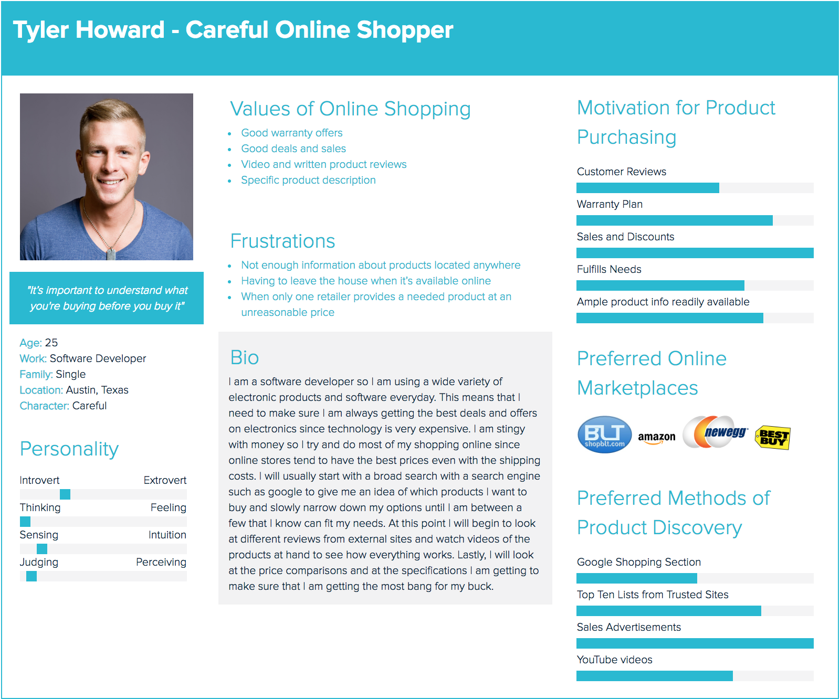

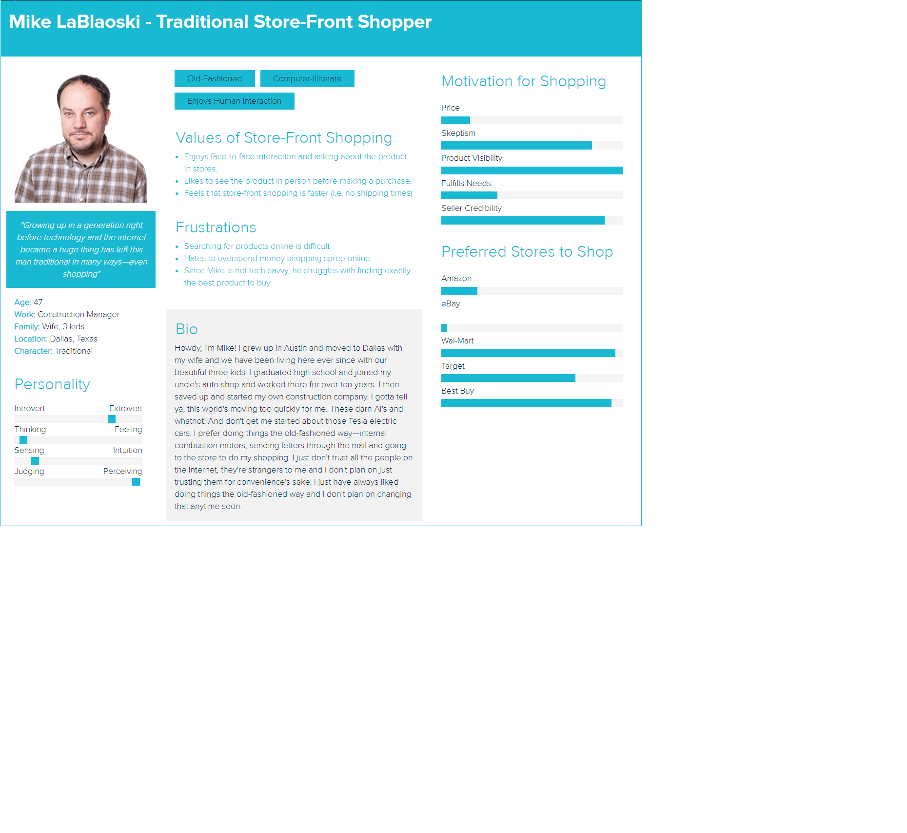

## Identifying Usability Issues Reporting Supplemental Information

## **Additional Usability Issue:**

One other usability issue that was determined, but not one of the main focuses for redesign, was the issue with the checkout form. The first issue that arises with the checkout form is the fact that there are two different checkout options, as shown in Figure 1. It may seem desirable to choose the “Secure Check Out” option, but in reality it does not matter which one of the two is picked. This can be confusing for the user and is only one of the issues that exists in this process.

**Figure 1: The checkout form when displaying the “Secure Check Out” and “Check Out” buttons.**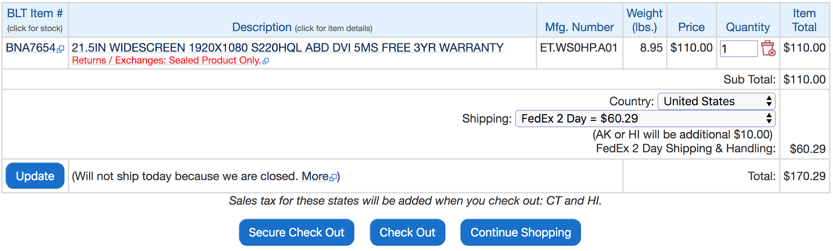

After clicking one of the checkout options, the user then has to click another button on a different page just to fill out their payment info and shipping address. The amount of time the user loses here is seemingly small, but even the smallest things are enough to irritate a user. On top of this, on the final payment form the user is required to fill in their phone number several times and provide more information than they may desire. One of the test-subjects even commented on how it was annoying to have to copy/paste some information several times and if they messed up, then they had to fill in this redundant information all over again. These small issues combined are enough criteria to make the checkout process a candidate for a redesign on shopBLT’s website.

## Usability Tasks:

### Scenario #1

You are looking to buy a new computer monitor for your desk. Word of mouth has led you to believe that you can get the best deal on a monitor through Bottom Line Telecommunications online store. Please visit “[shopBLT.com](http://www.shopblt.com)” in the browser in front of you and load the product page for a monitor on the website. Also, you also have an irrational fear of using shopping website search bars in this scenario, so please refrain from using any of shopBLT’s search bars in your quest to find a new monitor. Please describe what you are thinking aloud as you complete the task and tell us when you have think you have finished.

|  |  |
| --- | --- |
| **Goal / Output:** | - Successfully load the product page for any monitor, without using the search bar |
| **Inputs:** | - Category sequence |
| **Assumptions:** | - Item exists online  - Item is searchable without search |
| **Steps:** | 1. Open the shopBLT website (www.shopblt.com)  2. Click “Hardware” tab  3. Click/Hover over “Peripherals & Accessories” tab  4. Click/Hover over “Monitors” tab  5. Click/Hover over “Computer Monitors” tab  6. Click any of the monitors that appear on that page tab |
| **Success criteria:** | - Able to successfully load the correct product page |
| **Notes:** |  |

### Scenario #2

You have been browsing the selection of computer monitors on shopBLT and have discovered one that you would like to purchase. Given the credit card information below, please conduct the necessary steps needed to place an order for any monitor on shopBLT. You may use any navigation method without restriction.

|  |  |
| --- | --- |
| **Goal / Output:** | - Successfully reach the user information page with all fields completed and a monitor in the shopping cart |
| **Inputs:** | - Credit card information, shipping information |
| **Assumptions:** | - Item exists online  - Item is in stock  - The customer has read the “Terms of Sale and Return Policy” document  - Payment and shipping information is correct and will go through |
| **Steps:** | 1. Find an Acer monitor  2. Click “Add to Cart”  3. Check if order was added to cart after redirect  4. Click “Check Out” or “Secure Check Out”  5. Click “Proceed to Secure Order Form”  6. In “Payment Information”, input card type, credit card number, month, year, VCode, bank, and phone number.  7. In “Billing Information”, input name, address, city, state, zip code, email address, daytime and evening phone number.  8. Select “Ground” shipping method  9. Select “Review Order”  10. Stop at “PLACE ORDER” |
| **Success criteria:** | - A monitor must be in the shopping cart, the user successfully arrives at the page prior to reviewing order, and has completely filled out all information fields. User must successfully find the “PLACE ORDER” button. |
| **Notes:** | - The user will not actually place an order for an item, will stop at the last step before placing order for the product. Proctor should halt user before order is sent.  Name: Bobby Lee Tennyson  Payment info:   * Visa * Card Number: **4111111111111111** * Expiration: 1/2020 * CVC/VCode: 100 * Chase Bank * Phone Number: 949-949-9449   Shipping Info:   * Location: 1 Stanford Court, Irvine CA 92612 * Ground Shipping Wanted   Email Address:   * [bobby@lee.com](mailto:bobby@lee.com) |

### Scenario #3

The monitor you purchased has finally shipped to your address. Hooray! Unfortunately, you discover that the product you ordered is defective! To remedy this issue you are determined to contact customer service in order to gain further information regarding how you can go about exchanging the product for a new, working product. Your task is to find a way to email a message to customer service through the shopBLT website.

|  |  |
| --- | --- |
| **Goal / Output:** | - Get customer **service help for information** on exchanging a product |
| **Inputs:** | - Menu selection |
| **Assumptions:** | - User needs information and couldn’t find that exact information needed on the website |
| **Steps:** | 1. Expand the menu sidebar  2. Under the support section select “email”  3. Scroll down to the bottom of the page  4. Stop once they have found the email form |
| **Success criteria:** | - Successfully find the email contact form |
| **Notes:** | - Notice if the user attempts to use the option “Contact BLT” they will be redirected to resulting page of the “email” option.  - Timed  - User might try to find contact info and open external email program or webpage |

### Scenario #4

You recently discovered that you have a knack for understanding the mechanics behind building a personal computer. Your friend contacts you telling you that he has found a graphics card he thinks might fit his gaming needs; however he is unsure as to whether or not it will fit his motherboard. He asks you to find the dimensions for the “AREZ RADEON PHOENIX SERIES RX550 2GB” using the website “shopBLT.com”.

|  |  |
| --- | --- |
| **Goal / Output:** | - Find the dimensions of an “GRAPHICS CARD AREZ RADEON PHOENIX SERIES RX550 2GB” (using any method) |
| **Inputs:** | - Product search/Category sequence |
| **Assumptions:** | - Item exists online  - Item has info user is looking for |
| **Steps:** | 1. Search the product (search bar or categories)  2. Click on the product  3. Click “Specifications” tab  4. Scroll down to “Dimensions”  5. Read the info |
| **Success criteria:** | - Finding the correct dimensions of 12" x 8.7" x 2.2" |
| **Notes:** | - Make sure the user understands the steps |

### Scenario #5

Your grandmother just got her first laptop computer; however, she is unable to use the trackpad on the laptop effectively due to her arthritis. She has an optical mouse but is unable to use flat mousepads for the same reason she cannot use the trackpad. She has asked you to go online to her favorite website “shopBLT” and find a black mouse pad that is priced between 25$ - 35$ has that a wrist rest so she can use her new laptop to her heart’s content!

|  |  |
| --- | --- |
| **Goal / Output:** | - Find a black mouse pad, with a gel wrist rest, of any size that is priced between 25$ - 35$ (using any method). |
| **Inputs:** | - Product search/Category sequence |
| **Assumptions:** | - Item exists online  - Item has info user is looking for  - User understands what a mousepad with a wrist rest is. |
| **Steps:** | 1. Use the search bar to input basic product details (e.g “mouse pad”) or use the categories section to  2. Scroll to the bottom of the page and use advanced search settings  3. Under the price field select “Equal or Less Than”  4. Input the query “35” into the entry field  5. Click Search  6. Select a product that meets the criteria |
| **Success criteria:** | - The user successfully arrives at a product page with a mousepad that is black and has a wrist rest. |
| **Notes:** | - Make sure the user understands the steps |

## Cognitive Walkthrough Tasks:

### Scenario #1

Your grandmother just got her first laptop computer; however, she is unable to use the trackpad on the laptop effectively due to her arthritis. She has an optical mouse but is unable to use flat mousepads for the same reason she cannot use the trackpad. She has asked you to go online to her favorite website “shopBLT” and find a black mouse pad that is priced between 25$ - 35$ that has a wrist rest so she can use her new laptop to her heart’s content!

|  |  |
| --- | --- |
| **Goal / Output:** | - Find a black mouse pad, with a gel wrist rest, of any size that is priced between 25$ - 35$ (using any method). |
| **Inputs:** | - Product search/Category sequence |
| **Assumptions:** | - Item exists online  - Item has info we is looking for  - We understand what a mousepad with a wrist rest is. |
| **Steps:** | 1. Use the search bar or categories to navigate through to product listings.  2. Scroll to the bottom of the page and use advanced search settings  3. Under the price field select “Equal or Less Than”  4. Input the query “35” into the entry field  5. Click Search  6. Select a product that meets the criteria |
| **Success criteria:** | - We successfully arrives at a product page with a mousepad that is black and has a wrist rest. |
| **Notes:** | - Make sure the steps are clear |

* **Action Sequence**:
  + **Overarching goal**: Find a black mouse pad, with a gel wrist rest, of any size that is priced between 25$ - 35$ (using any method).
  + **Sub-goal:** Locate the product search bar
    - Identify the appropriate functionality that would allow one to search for the appropriate product.
  + **Sub-goal:** Apply advanced filters
    - Input the necessary criteria to condense the search results
  + **Sub-goal:** Identify product
    - Once search has been performed identify the product with the met criteria and add it to the shopping cart.
  + **Sub-goal:** Select payment preference and provide information
    - Once prompted, identify and select the preferred approach to payment. The option selected should be wire transfer, then input the remaining information required to successfully purchase the product.
  + **Sub-goal:** Successfully Complete Purchase and Confirmation
    - Identify current state of overarching goal and reflect on whether one may or may not be aware of system state in terms of completion.

### Scenario #2

You recently purchased and received a desktop computer case from shopBLT. Excited to complete your new computer tower, you open the manufacturer packaging and discover that the case suffered severe damage during the shipping process. Furious and enraged you hastily get online to go to shopBLT to fill out a request to obtain an RMA number to return the product to BLT. Your task is to find the form and fill it out with compatible information to guarantee your return.

|  |  |
| --- | --- |
| **Goal / Output:** | - Submit a **request** to **obtain an RMA number** to returna product to BLT |
| **Inputs:** | - Help Option (Taskbar Option) |
| **Assumptions:** | - Task falls within the necessary guidelines to return a product is |
| **Steps:** | 1. Select the “Help” option in the taskbar at the top of the page  2. Click on “Returns / Exchanges”  3. Read the guidelines and requirements and ensure they are in line with the task  4. Scroll down to the bottom of the page  5. Fill out the necessary information, with the information provided  6. Stop before the request has been submitted. |
| **Success criteria:** | - We successfully fill out the form with compatible information regarding product details and reason for the return that will guarantee the receival of an RMA. |
| **Notes:** | - Make sure that we understand what constitutes the conditions for a request to be accepted. |

* **Action Sequence**:
  + **Overarching goal**: Submit a **request** to **obtain an RMA number** to returna product to BLT.
  + **Sub-goal:** Locate the help button in the taskbar.
    - Identify the appropriate functionality that would allow one to seek help whenever stuck.
  + **Sub-goal:** Identify “Returns/Exchanges”.
    - Find the right functionality in order to progress to obtain the overarching goal.
  + **Sub-goal:** Confirm that the task is in line with the policies.
    - Get the right information to confirm what you need to fulfill your need to exchange or return.
  + **Sub-goal:** Fill out the necessary information, with the information provided
    - In order to get assistance, fill out information to receive help.
  + **Sub-goal:** Stop before the request has been submitted.
    - For this purpose, no need to actually submit request.

### Scenario #3

You are a part of the UCI esports team on campus. You and your team have been invited to go to a gaming convention, where you will compete against other esports teams around the area. Excited to go, you start packing all your belongings and realize that you’re missing your gaming headphones. The convention is in three days and you don’t have any headphones to take with you. Oh no! Immediately you start looking for some headsets online, knowing you don’t have time to go to any physical stores. You come across the “shopBLT” website and notice that they have high-quality, low-priced headsets with expedited shipping. Relieved that you found a solution, you start searching the website for different products. Your task is to place a FedEx 2-Day shipping order for a pair of “Logitech Wireless Headset H800” via wire transfer.

|  |  |
| --- | --- |
| **Goal / Output:** | - Find and place a FedEx 2-Day Shipping order for a "Logitech Wireless Headset H800" using the search bar. Payment information type is wire transfer. |
| **Inputs:** | - Search Bar |
| **Assumptions:** | - Item exists online  - We have the minimum viable domain knowledge about the product to accomplish the task |
| **Steps:** | 1. Use the search bar to query “Logitech Wireless Headset H800”  2. Click on the product titled "Wireless Headset 800"  3. Add the product to your cart  4. Under the field “Country” select “United States”  5. Click “Check Out” to complete purchase with BLT’s normal server (Not secure check out)  6. Click “Proceed to Secure Order Form”  7. Enter the “Payment Information”, with the information provided  8. Enter the “Billing Information”, with the information provided  9. Select “Ground” shipping method  10. Select “Review Order”  11. Stop at “PLACE ORDER” |
| **Success criteria:** | - Successfully enters the necessary information stops before placing an order for a Logitech Wireless Headset H800. There is only one product in the cart. |
| **Notes:** |  |

* **Action Sequence**:
  + **Overarching goal**: Submit a **request** to **obtain an RMA number** to returna product to BLT
  + **Sub-goal:** Locate the taskbar
    - Identify the appropriate functionality that would allow one to search for the appropriate product.
  + **Sub-goal:** Identify correct product
    - Once the search has been performed identify the correct product and add it to the cart. Reflect on whether or not the system state is clear in terms of task completion.
  + **Sub-goal:** Select Payment Preference and Shipping Method
    - Once prompted, identify and select the preferred approach to payment and shipping. The options selected should be wire transfer and FedEx 2-Day shipping.
  + **Sub-goal:** Provide Information
    - Provide all necessary information required to successfully book the preferred hotel (that adequately fulfills the disability condition requirements).
  + **Sub-goal:** Successfully Complete Purchase and Confirmation
    - Identify current state of overarching goal and reflect on whether one may or may not be aware of system state in terms of completion.

## Subsequent Usability Test Questionnaire Template:

* What is your gender? _________
* What year were you born? __________
* What’s your highest education level?
  + Elementary School
  + Middle School
  + High School
  + 1-2 years of college
  + 3+ years of college
* If at all, how satisfied are you with the tools provided to accomplish the tasks we asked you to complete?
  + Not satisfied
  + Somewhat satisfied
  + Very satisfied
  + Extremely satisfied
* If at all, how satisfied are you with the interface of the system we asked you to use?
  + Not satisfied
  + Somewhat satisfied
  + Very satisfied
  + Extremely satisfied
* How likely are you to use this system for your own personal use?
  + Not likely at all
  + Somewhat likely
  + Very likely
  + Extremely likely
* After using the product what do you think of it (any comments, questions, or recommendations)? ____________________
* Is there anything that you wish I had asked you? ____________________
* Is there anything else that you would like to say (any comments, questions, or recommendations to the system or the usability test)?

## Redesign Report Supplemental Information

## **Problem Space:**

### Screenshots: (**Search Bar Query and Results**)

# 

Figure 1: Correct query for mouse pads using a specific keyword that the algorithm processes properly.

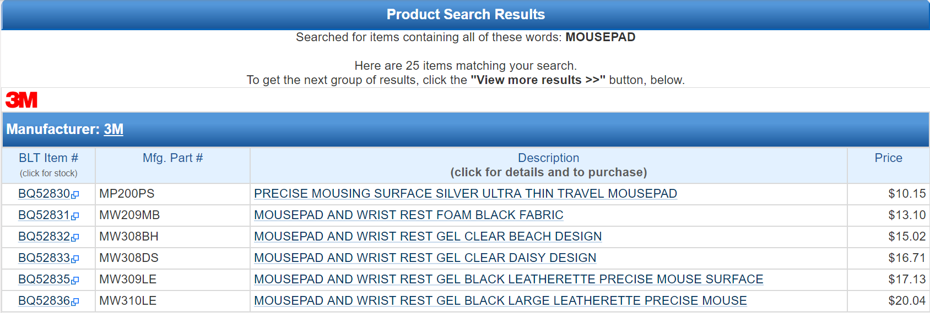

Figure 2: The resulting product listings from the query. Product listings are grouped by manufacturer and only one manufacturer is shown here.

Figure 3: Incorrect query for mouse pads using a keyword that is processed incorrectly by the indexing algorithm. Produces incorrect results.

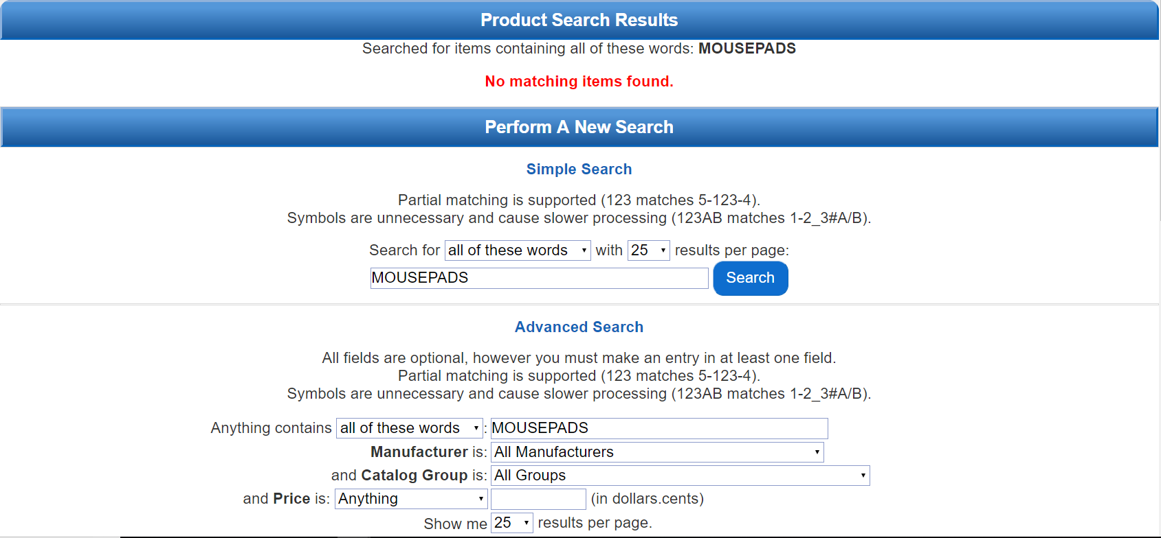

Figure 4: Resulting page for the query “mousepads”. Produces a false negative indicating that no matching product listings exist in the BLT inventory.

### Screenshots: (**Contact Information & Customer Support**)

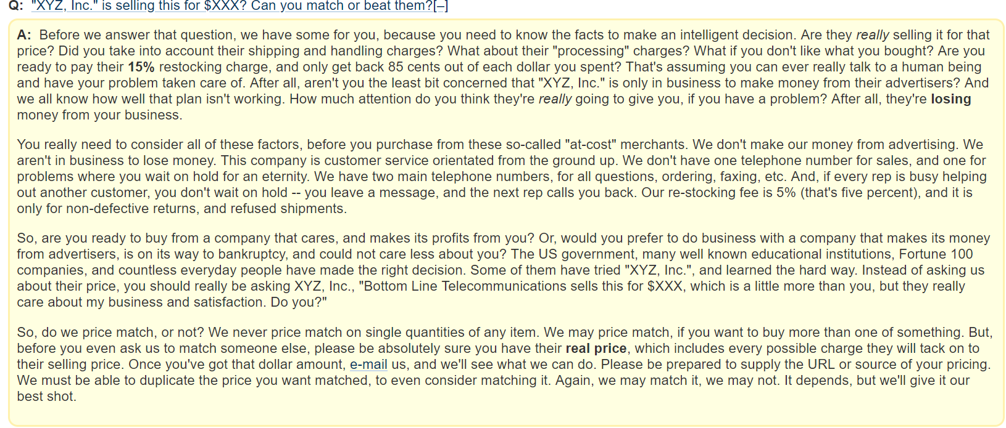

Figure 5: Depicts the frequently asked questions section. Note the excessive text to answer a question *frequently* asked by customers. The verbiage, terminology, and presentation of the answer fosters an inhospitable environment countering claims for great customer service.

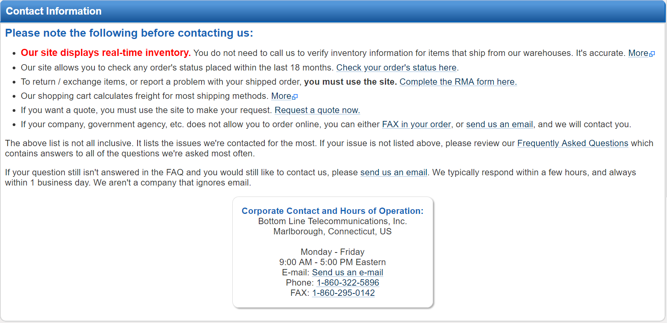

Figure 6: This is a landing page providing links to other resources for users. This page highly encourages that the user *not* contact customer service before reading all information on this page and in the frequently asked questions page. The phrasing here suggests in a less than subtle way that common customer queries are not a priority for customer service.

### Screenshots: (**Product Discovery, Visibility, and Listings**)

Note: **Product visibility** refers to actually product images and information that communicates appearance, structure, and form to the user. Important features include shape and scalable size. **Product discovery** refers to how users find and discover products that they might need or want. **Product listings** refers to the display of products from a search query or from navigation via the categories feature tool. Important features include, readability, visibility, and organization.

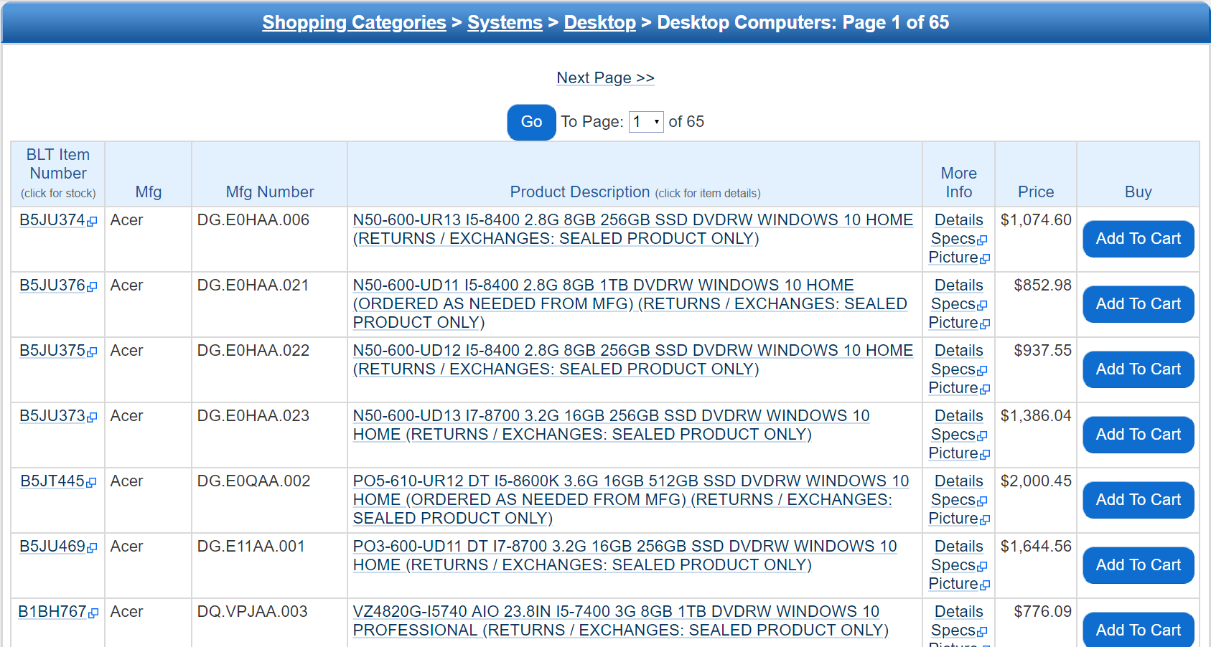

Figure 7: Relates to **product listings** and **product visibility**. Product listings are structured into a table format. The first three fields read information that is irrelevant to most users. Though the product description is centered in the frame, the listing descriptions are long and verbose. Product visibility is low here as no listing has a corresponding image.

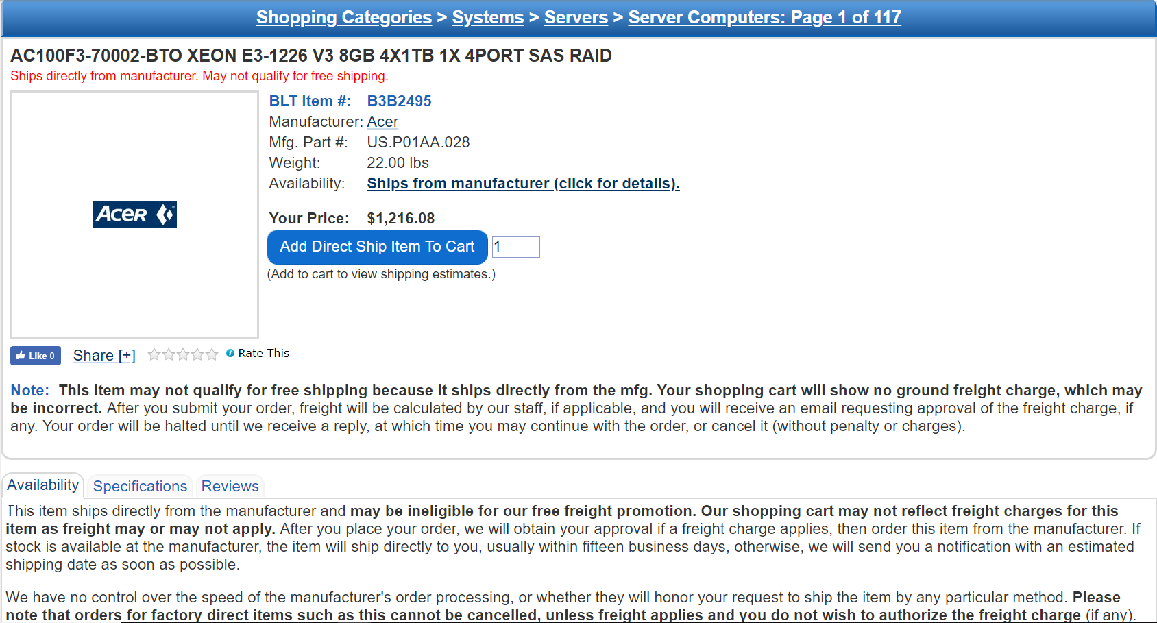

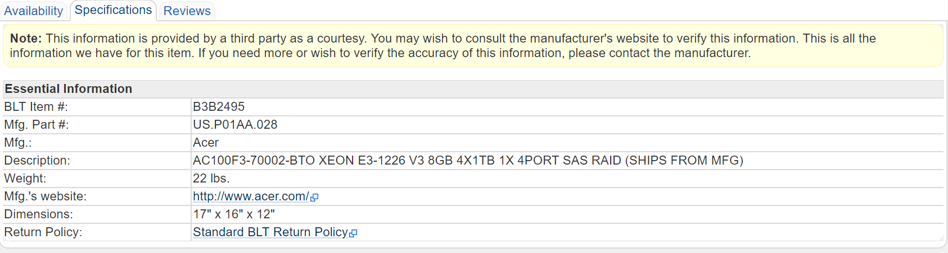

Figures 8 & 9: Relates to **product visibility**. The product page does not have an image for many associated items. The specifications tab also lacks descriptive details, which would provide the user or customer with a better idea of the product and what to expect when purchasing. Inserting images and appropriate details would improve the user experience by providing the tools to conceptualize product details and information.

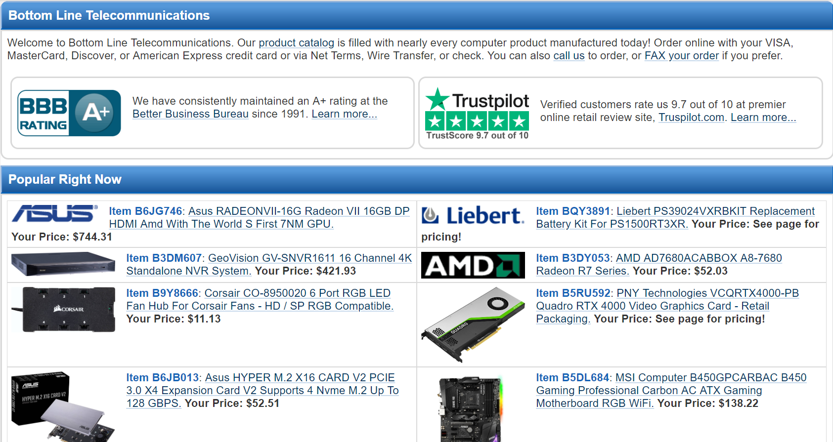

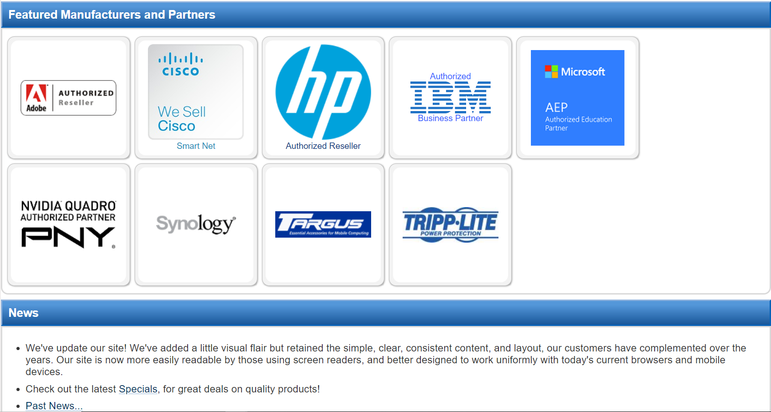

Figures 10 & 11: These images related to **Product Discovery**. The above images represent the entirety of the product listings on the homepage of shopBLT. This is one of the only sections on the website where product images are clearly displayed. Additionally, the website promotes its reputation to establish credibility. These features aside, the homepage does not allow much interactivity, nor does it entice the user or with a dynamic toolset to discover products they may want or need.

### Screenshots: (**Product Filtering**)

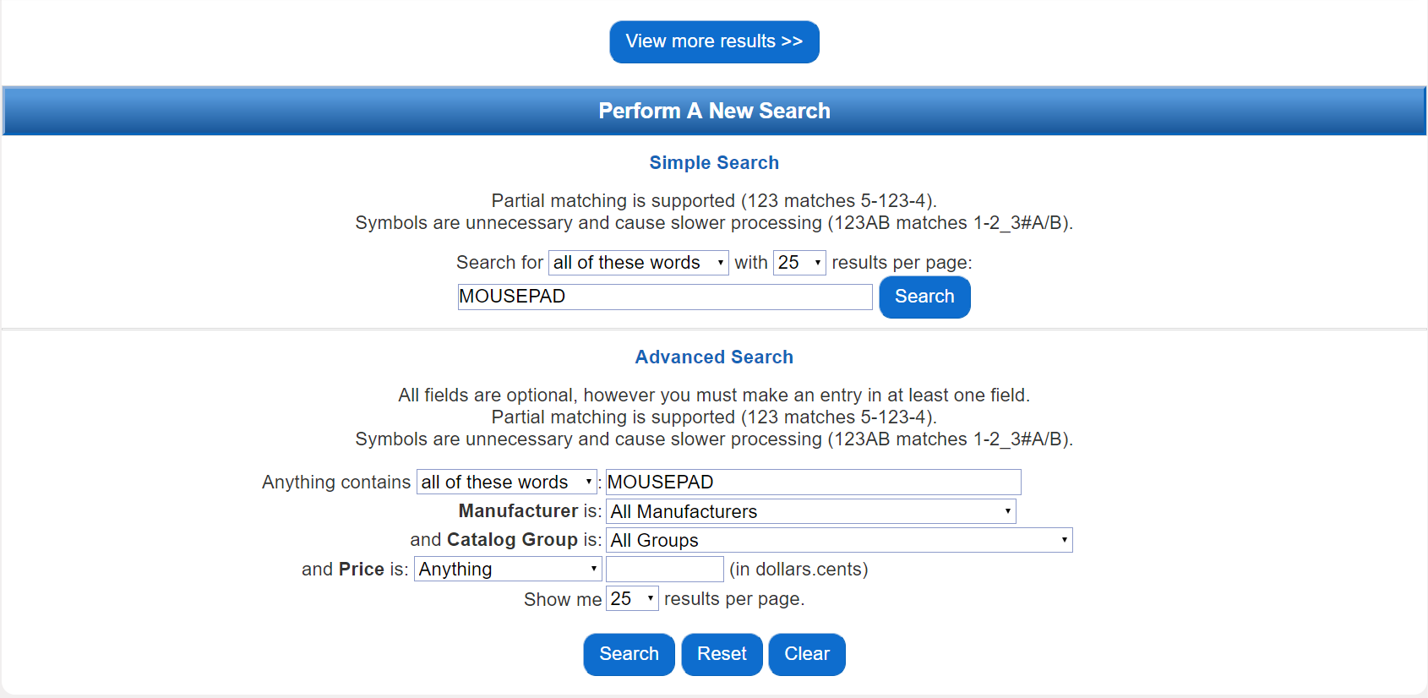

Figure 12: Represents the current product filtering feature deployed on the website. The tool is designed with metrics that are unfamiliar to most users. Furthermore, the volume of text and multiple text and drop-down fields clutter the tools interface, making it difficult to parse the necessary steps to successfully apply a filter to product search results. The positioning of this tools is also a weakness, it is located at the bottom of the page, beneath the search results. We have data supporting that user discovery of this feature is low.

### Screenshots: (**Product Check Out**)

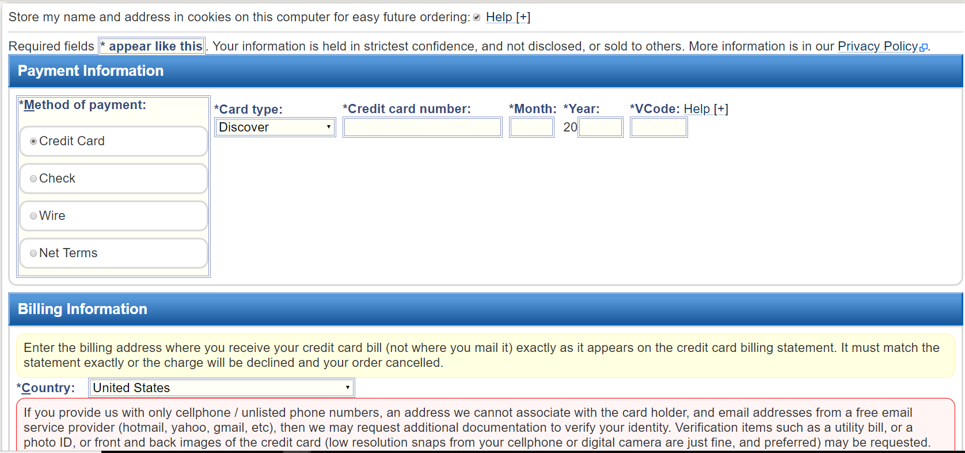

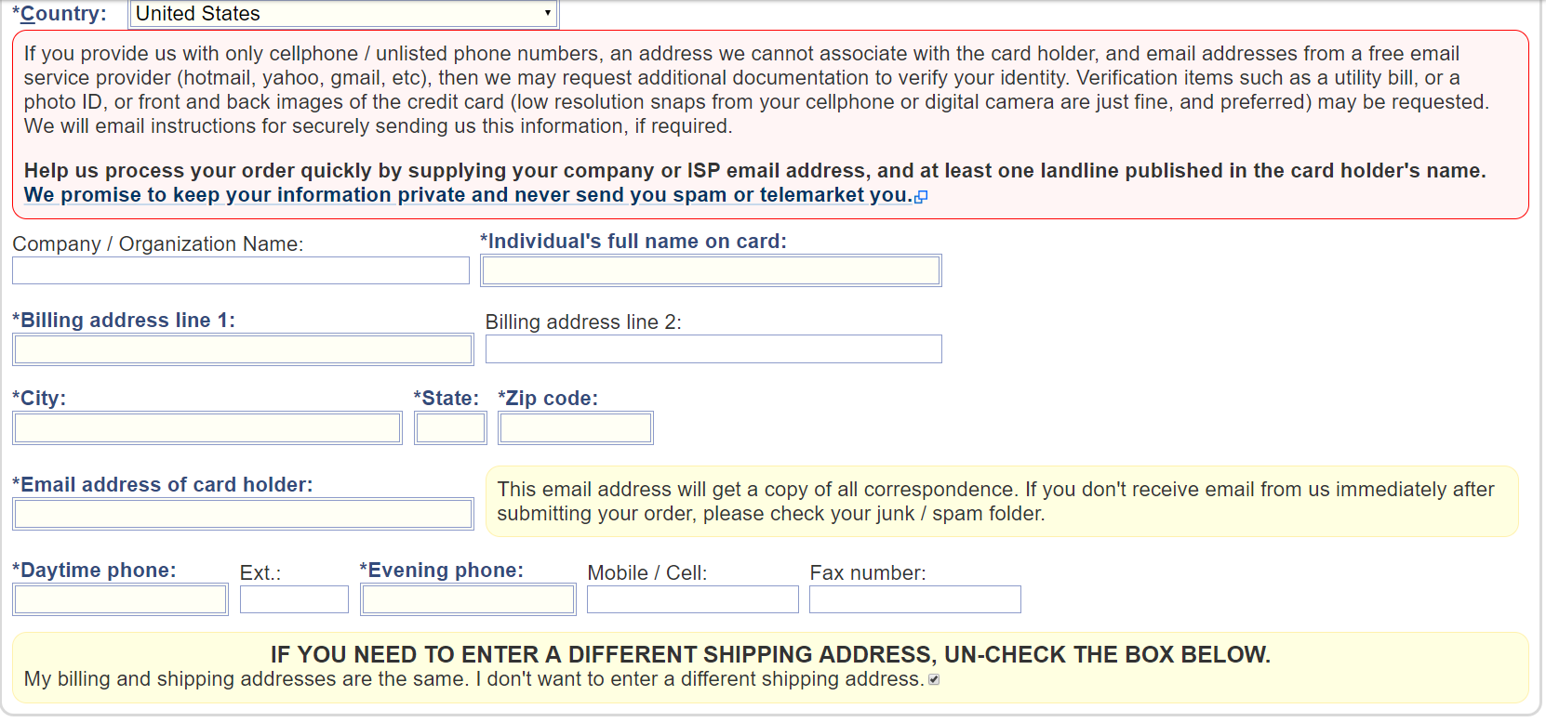

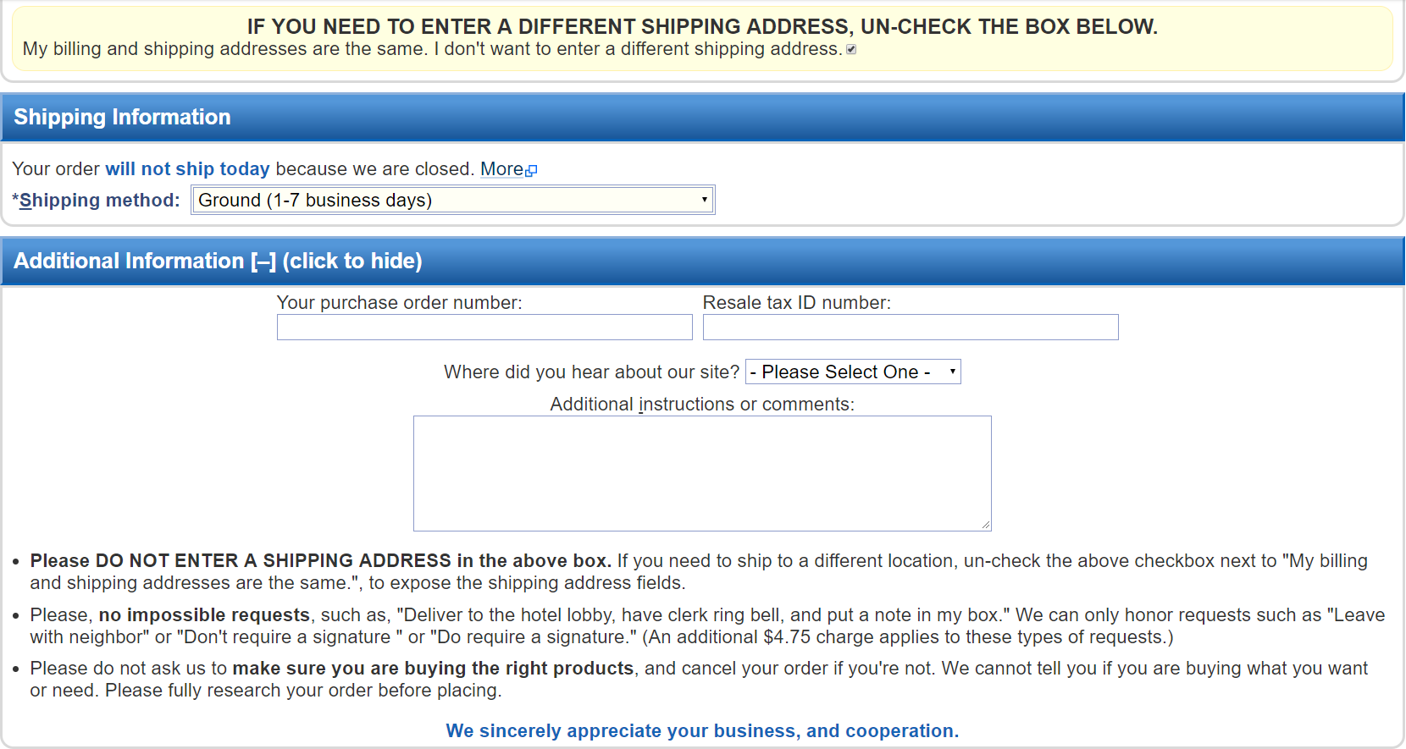



Figures (13 - 16): These images depict the entirety of the checkout process. Users data reports the interface is unnecessarily verbose and proposes too much information. Partitioning the checkout process could prove to be beneficial, as it would lessen the cognitive load on the customer and present a more streamlined user experience.

## Consolidated Designs:

Customer Service/Contact Information

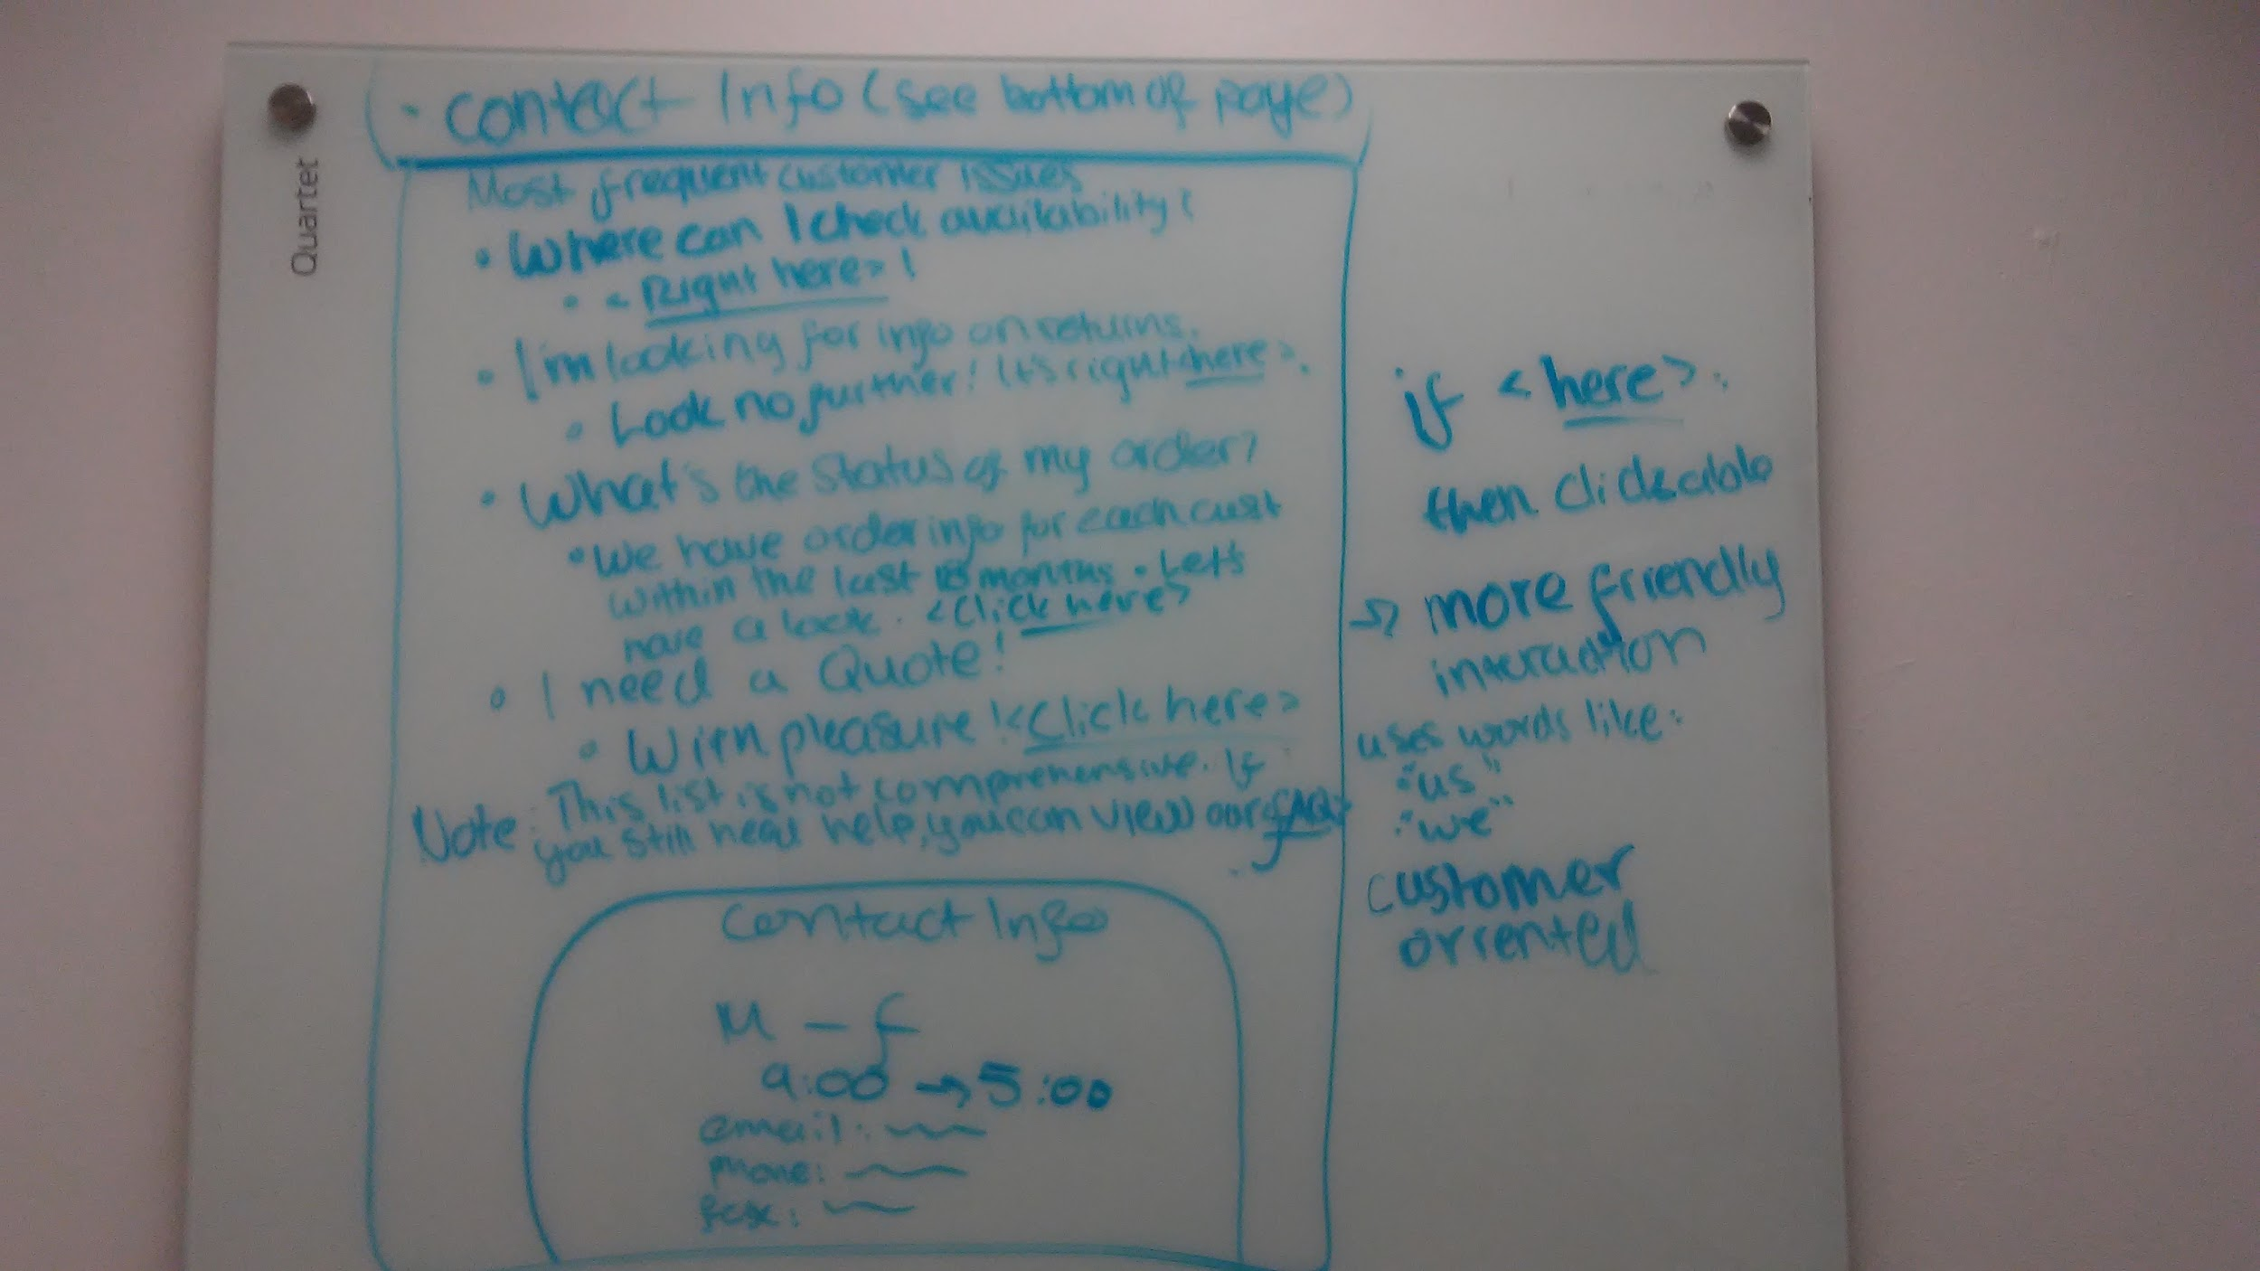

Search Bar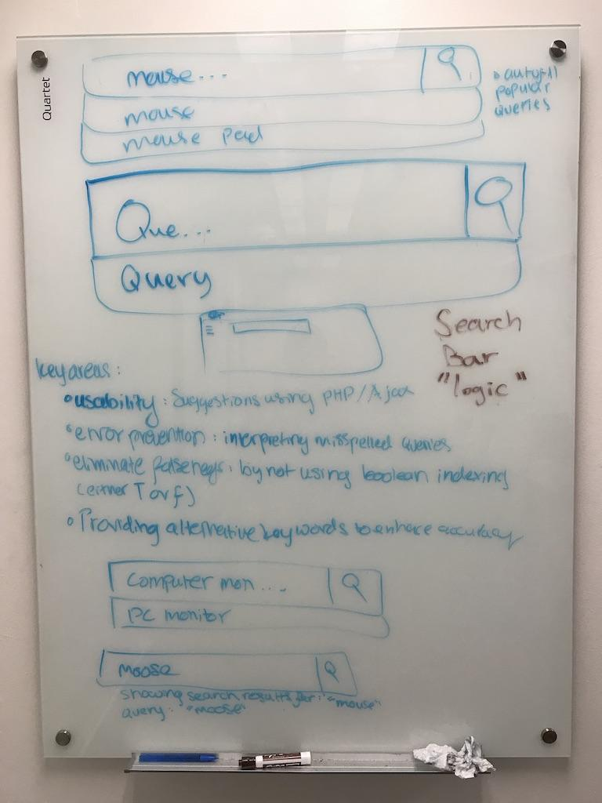

Product Visibility/Product Listings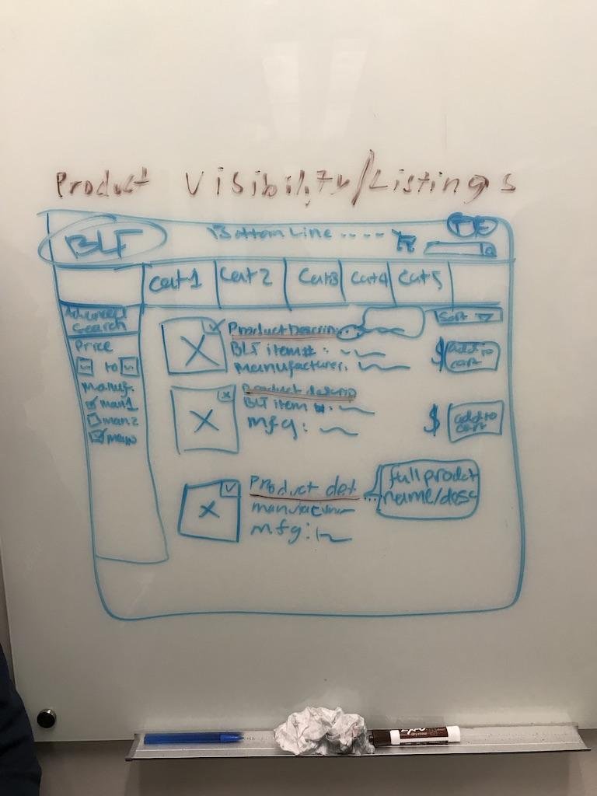Product Discovery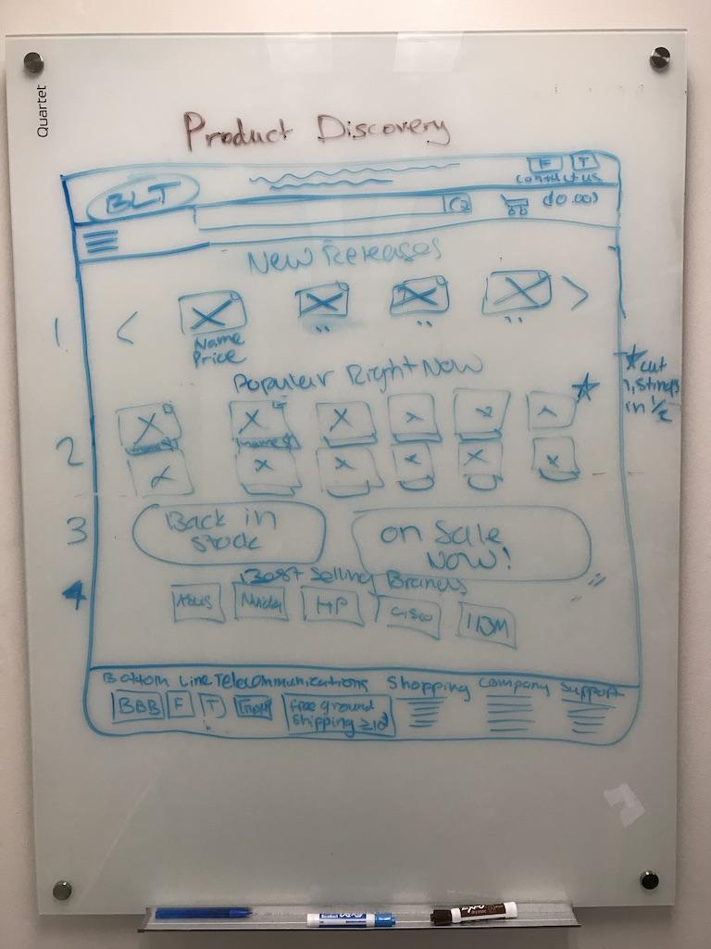

Product Check Out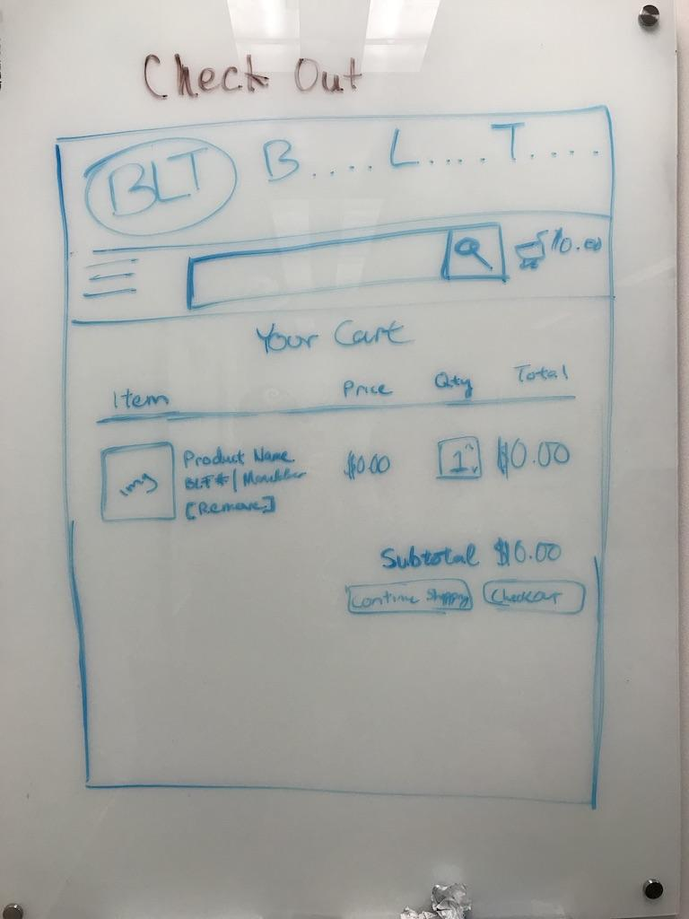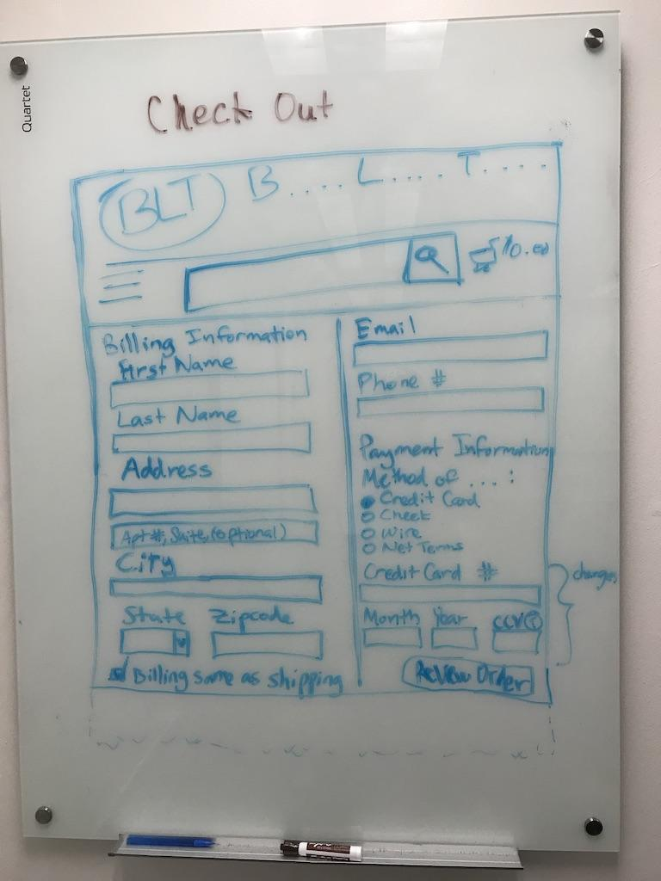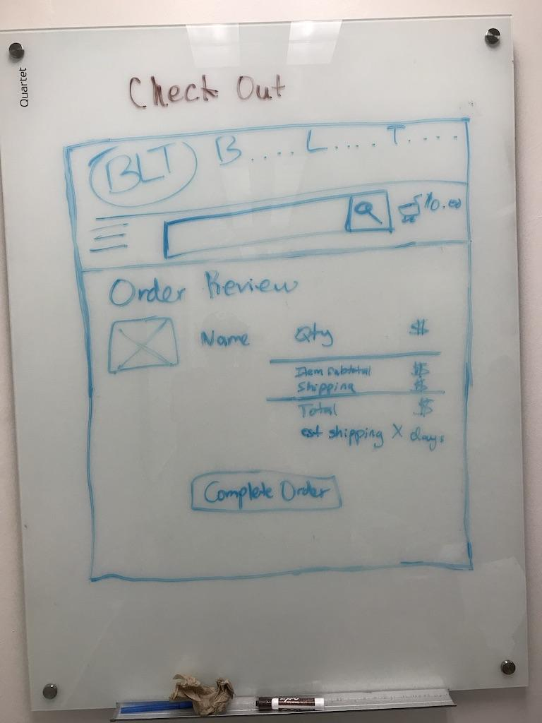

Product Filtering